DOCUMENT TYPE: Service Implementation Document

TITLE:

Service Quality Assessment Report

Protocol Monitoring

DOCUMENT STATUS SHEET
Issue | Date | Modified Items / Reason for Change
1.0 | 15.11.04 | First Version
1.1 | 19.04.05 | BrO added
TABLE OF CONTENTS
1. Introduction 4
1.1 Purpose and scope 4
1.2 Definitions, acronyms and abbreviations 4
1.3 Applicable Documents 5
2. Total Ozone Column 6
2.1 Validation of SCIAMACHY TOSOMI ozone columns with groundbased data 6
2.1.1 Abstract 6
2.1.2 Introduction 6
2.1.3 Results 6
2.1.4 Data dependences – plans for further studies 12
2.1.5 Individual comparison results. 13
2.1.6 Timeseries examples for individual stations 16
2.1.7 References 19
2.2 User response 19
3. TroposPheric Bromine Oxide 20
3.1 Assessment of total column BrO measurements 20
3.1.1 Intercomparison of satellite measurements 20
3.1.2 Comparison with ground-based measurements 22
3.2 Assessment of tropospheric BrO column determinations 24
3.2.1 Geophysical consistency 24
3.2.2 Stratospheric BrO model intercomparison 25
3.2.3 Stratospheric and tropospheric BrO columns from ground-based measurements 26
3.3 User response 27
3.4 References 27

Introduction

Purpose and scope
The Data User Programme (DUP) is an optional programme of ESA which aims at supporting Industry, Research Laboratories, User Communities as well as European and National Decision Makers to bridge the gap that exists between research at the level of pilot projects and the operational and sustainable provision of Earth Observation products at information level.

TEMIS is a project (started September 2002) in response to an Invitation To Tender from ESA in the context of ESA's Data User Programme. The aim of the project is the delivery of tropospheric trace gas concentrations, and aerosol and UV products to users.

This document contains the validation approach and results of the products for TEMIS. The current version is part of the final deliverables of the implementation phase of TEMIS.

The data products, images and reading routines can be found on the web-site www.temis.nl. A description of the products and their retrieval is presented in the Service Report.

Definitions, acronyms and abbreviations

AMF | Air-Mass Factor
AOD | Aerosol Optical Depth
ATSR | Along Track Scanning Radiometer
AATSR | Advanced Along Track Scanning Radiometer
ASCAR | Algorithm Survey and Critical Analysis Report
BIRA-IASB | Belgian Institute for Space Aeronomy
BrO | Bromine Oxide
CCD | Convective Cloud Differential
DLR | German Aerospace Centre
DOAS | Differential Optical Absorption Spectrometry
DUP | Data User Programme
ENVISAT | Environmental Satellite
ERS | European Remote Sensing Satellite
ESA | European Space Agency
ESRIN | European Space Research Institute
EU | European Union
EUMETSAT | European Organisation for the Exploitation of Meteorological Satellites
FD | Fast Delivery service
FRESCO | Fast Retrieval Scheme for Cloud Observables
GIBP | GOME Image Browse Product
GOFAP | GOME Ozone Fast Delivery and value-Added Products
GOME | Global Ozone Monitoring Instrument
IR | Infrared
ISAC | Institute of Atmospheric and Climate Sciences ( formerly ISAO )
ISCCP | International Satellite Cloud Climatology Project
KNMI | Royal Netherlands Meteorological Institute
LIDORT | Linearized Discrete Ordinate RTM
LUT | Look-Up Table
METEOSAT | Meteorological Satellite
MIPAS | Michelson Interferometer for Passive Atmospheric Sounding
MOPITT | Measurements Of Pollution In The Troposphere
MMI | Man Machine Interface
NDSC | Network for the Detection of Stratospheric Change
NO | Nitrogen Oxide
NO₂ | Nitrogen Dioxide
NO_{x} | Nitrogen Oxides (NO+NO₂)
NOAA | National Oceanic and Atmospheric Administration
NRT | Near-Real Time
O₃ | Ozone
PSD | Product Specification Document
RIVM | National Institute of Public Health and the Environment
RTM | Radiative Transfer Model
SCIAMACHY | SCanning Imaging Absorption spectroMeter for Atmospheric CartograpHY
SDD | Service Definition Document
SDP | Service Development Document
SSD | System Specification Document
SUM | Software User Manual
TBC | To Be Confirmed
TBD | To Be Defined
TEMIS | Tropospheric Emission Monitoring Internet Service
TOA | Top Of Atmosphere
TOMS | Total Ozone Mapping Spectrometer
USD | User Specification Document
URD | User Requirements Document
UV | Ultra Violet

Applicable Documents

AD-1 | Data User Programme II period 1st call For Proposal ref:EEM-AEP/DUP/CFP2001
AD-2 | User Specifcation Document, v1.4, TEM/USD/005, May 2002
AD-3 | User Requirement Document, v2.0, TEM/URD/006, October 2002
AD-4 | Algorithm Survey and Critical Analysis Report, v1.2, TEM/ASCAR/003, May 2002

Total Ozone Column

Validation of SCIAMACHY TOSOMI ozone columns with groundbased data
by Ellen Brinksma, KNMI, De Bilt, The Netherlands.

Abstract
TOSOMI is a scientific algorithm for retrieving ozone columns from SCIAMACHY spectra that was developed at KNMI. In this document, we present a comparison between one year of TOSOMI data and collocated groundbased measurements (94 instruments at 87 different geographical locations). TOSOMI ozone columns are, on average, 1.5% lower than the groundbased data, with a rms difference of 4.9% (all instruments) or 4.6% (Brewer and Dobson instruments). No clear dependence on geographical location exists.

Introduction
At KNMI, an algorithm aimed at deriving ozone column densities from Ozone Monitoring Instrument (OMI) measurements using the DOAS method was developed (Veefkind and De Haan, 2001). This algorithm has been applied to GOME data for creating scientific versions of the GOME ozone columns (“TOGOMI”, Valks et al., 2003), and was recently also applied to SCIAMACHY NRT data (“TOSOMI”). TOSOMI-SCIAMACHY data are available within 3 hours after observation from http://www.temis.nl/. Currently, data are available starting from January 1, 2003.
This document presents a first validation of the TOSOMI ozone columns, using data for 2003. An IDL toolbox was developed for the purpose of intercomparing groundbased and satellite data over groundbased sites. Satellite data options are SCIAMACHY L2 (NRT & OL) and TOSOMI ozone columns, groundbased data options are all data in the Envisat NILU database and WOUDC total ozone data. Extension to other satellite data (OMI L2 ozone and NO2 columns) is in progress.

Results
The TOSOMI 2003 ozone columns were compared to WOUDC daily averaged values of the ozone columns measured by Brewer and Dobson spectrophotometers (direct-sun as well as zenith included), and by Brewer, Dobson, DOAS, SAOZ and Filter measurements submitted to the Envisat NILU database. Figure 1 shows a map of used locations. Data present in the two databases on February 13, 2004 were included. Izaña DOAS data were multiplied by 1.092 to preliminary apply an airmass factor correction (M. Gil, 2004, personal communication).
For each of the instruments, timeseries were made of the data and the percent differences, along with TOSOMI - groundbased scatter plots.Yearly averaged bias and rms values for individual sites are presented in Figures 2 (as a function of latitude), 3, and 4 (on world maps), and tabulated along with correlation coefficients in the Appendix (Table A1). There, also examples are given of midlatitude, tropical, and polar comparisons.

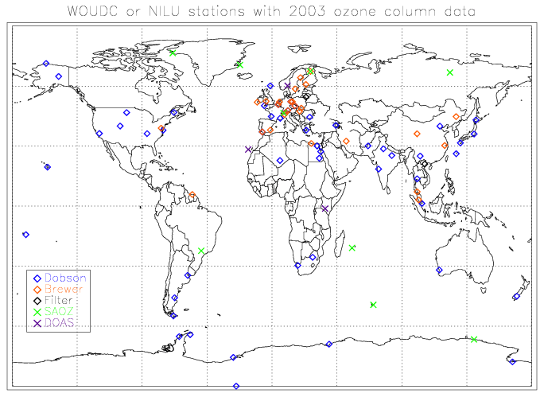
Figure 2.1: WOUDC or NILU stations with 2003 ozone column data.

The grand averages indicate that, with respect to groundbased data, TOSOMI data are offset by -1.5% with, averaged rms difference is 4.9%. The measurements by the Filter instrument at Hanoi were excluded from all averages, as they were clearly biased (20% bias, 20% rms, 10 measurements, similar results were reported from comparison to other satellites, cf. Bramstedt et al., 2002).

Figure 2.2: 2003 averages (top) and rms (bottom) of (SCIA-gb)/SCIA [%]

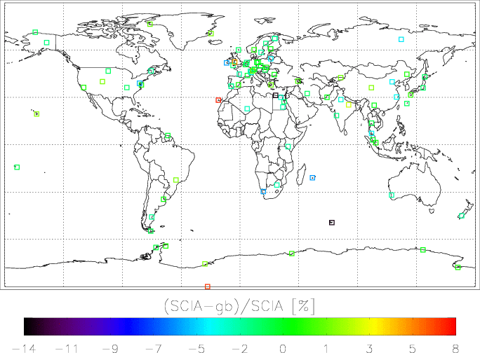

Figure 2.3: Overview of year-averaged differences (SCIA-groundbased)/SCIA [%]

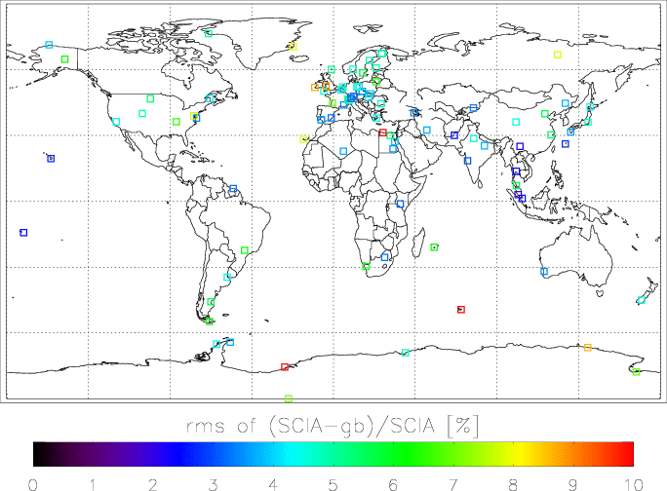

Figure 2.4: Overview of year-averaged rms of (SCIA-groundbased)/SCIA [%] – red squares denote 10% or more.
Averages were also made per latitude band (Table 2) and per instrument (Table 3). The Amundsen-Scott Dobson data were excluded from the SH polar region average, as they strongly influenced the small-number average (6 instruments) over that region.

If only Brewer and Dobson data are included in the comparisons, the grand averages do not change significantly (numbers are now offset=-1.4% and rms=4.6%). Also the averages per latitude band do not change much, except where few collocations are available (SH mid-latitudes and, to a lesser extent, NH tropics).

Table 1 – Latitude band averages (all instrument types)
Latitudes | bias | rms | #
All data | -1.5 | 4.9 | 93
Lat < -60 ¹ | +0.1 | 6.6 | 6
-60 < lat < -30 | -3.9 | 6.3 | 6
-30 < lat < 0 | -3.0 | 4.6 | 6
0 < lat < 30 ² | -0.9 | 3.6 | 15
30 < lat < 60 | -1.6 | 4.8 | 48
Lat > 60 | -1.6 | 5.6 | 11

Table 2 – Latitude band averages (Brewer & Dobson only)
Latitudes | bias | rms | #
Total | -1.4 | 4.6 | 79
Lat < -60 ¹ | +0.2 | 6.2 | 5
-60 < lat < -30 | -2.0 | 4.9 | 5
-30 < lat < 0 | -3.6 | 4.0 | 3
0 < lat < 30 ² | -1.5 | 3.3 | 14
30 < lat < 60 | -1.6 | 4.8 | 45
Lat > 60 | -1.9 | 5.0 | 6

Table 3– Results averaged per instrument type
instrument | bias | rms | #
Dobson | -1.2 | 4.4 | 52
Brewer | -2.0 | 5.0 | 27
SAOZ | -3.1 | 7.5 | 9
DOAS | +1.6 | 5.2 | 3
Other ² | -1.7 | 4.9 | 2
¹: Excluding Amundsen-Scott Dobson results
²: Excluding Hanoi Filter instrument results

Data dependences – plans for further studies

For Dobson and Brewer instruments, two measurement modes can be used – direct sun, which is more accurate but needs clear sky in the direction of the Sun for the duration of the integration, and zenith sky, which is less accurate. In the NILU database, it is not always clear whether data are direct-sun only, or a combination of direct-sun and zenith sky. When this is indicated, we always opt to use direct-sun results only. We have not yet investigated the effect of this choice on the validation outcome. In the WOUDC database, the distinction is consistently made. So far, we have only investigated the direct-sun vs. zenith dependence by comparing individual station WOUDC validations presented earlier in this document with the same results for direct-sun measurements only. They were not significantly different, but the remark should be made that relatively few data were zenith-sky, many stations by default only report direct-sun measurements. We are planning to investigate this dependence further.

Also we expect a dependence on solar zenith angle (inducing a seasonal variation) which may also lead to large errors for polar winter. During polar winter, DOAS and SAOZ instruments are expected to yield data comparable in accuracy with those from other seasons (see, e.g., Lambert et al., 1999). Preliminary comparisons of validation results per site for different solar zenith angles do not yield a clear sza dependence. It may be that one year of data (and often less) is not enough to resolve such dependencies. This will be investigated further.

Preliminary comparisons of the validation results for various cloud fractions show that TOSOMI data become positively biased for cloud fractions above 0.9. For lower cloud fractions, no clear effects are seen. Again, statistics are poor due to limited data availability.

Acknowledgement
I acknowledge the use of groundbased ozone column data from the WOUDC and ENVISAT Validation databases.

Corresponding author:
Please send comments on this document and suggestions for further validation to Ellen Brinksma, KNMI, brinksma@knmi.nl.

Individual comparison results.

Location | instr |  | lat | lon | bias | rms | corr | #
amundsen scott | Dob | W | -89.98 | -24.80 | 7.1 | 7.18 | 0.82 | 20
arrival heights | Dob | W | -77.83 | 166.67 | 0.05 | 7.01 | 0.92 | 31
halley bay | Dob | N | -75.6 | -26.8 | 1.75 | 10.92 | -0.570 | 31
Syowa | Dob | W | -69.0 | 39.58 | 0.49 | 4.79 | 0.970 | 133
dumont d’urville | SAO | N | -66.67 | 140.02 | -0.52 | 8.65 | 0.740 | 65
Vernadsky | Dob | N | -65.2 | -64.3 | -1.29 | 4.47 | 0.760 | 38
Marambio | Dob | W | -64.23 | -56.72 | 0.20 | 3.70 | 0.860 | 30
Ushuaia | Dob | W | -54.85 | -68.31 | -1.55 | 6.41 | 0.830 | 132
Kerguelen | SAO | N | -49.35 | 70.26 | -13.49 | 13.71 | 0.830 | 114
comodoro rivadavia | Dob | W | -45.78 | -67.5 | -2.64 | 5.60 | 0.800 | 132
Lauder | Dob | W | -45.03 | 169.68 | -2.82 | 4.51 | 0.750 | 43
buenos aires | Dob | W | -34.58 | -58.48 | -0.21 | 4.33 | 0.770 | 110
Perth | Dob | W | -31.92 | 115.95 | -2.97 | 3.43 | 0.840 | 57
Springbok | Dob | W | -29.67 | 17.9 | -6.06 | 6.16 | 0.770 | 60
Irene | Dob | W | -25.56 | 28.19 | -3.21 | 3.23 | 0.800 | 45
Bauru | SAO | N | -22.35 | -49.03 | 1.72 | 6.29 | 0.300 | 104
la reunion | SAO | N | -20.9 | 55.48 | -6.19 | 6.22 | 0.650 | 161
Samoa | Dob | W | -14.25 | -170.56 | -1.50 | 2.51 | 0.570 | 38
Nairobi | DOA | N | -1.23 | 36.82 | -2.93 | 3.06 | 0.710 | 179
Singapore | Dob | W | 1.33 | 103.880 | -0.06 | 2.57 | 0.690 | 99
petaling jaya | Bre | W | 3.10 | 101.650 | -0.97 | 1.84 | 0.730 | 98
Paramaribo | Bre | N | 5.81 | -55.21 | -1.14 | 3.33 | 0.700 | 113
Songkhla | Bre | W | 7.20 | 100.6 | -4.55 | 5.59 | 0.810 | 11
Bangkok | Dob | W | 13.67 | 100.61 | -1.33 | 2.41 | 0.92 | 61
Poona | Dob | W | 18.53 | 73.85 | -2.41 | 3.02 | 0.88 | 61
mauna loa | Dob | W | 19.53 | -155.57 | 2.00 | 2.71 | 0.75 | 29
Hanoi | Fil | W | 21.03 | 105.85 | -20.1 | 20.1 | 0.06 | 10
Tamanrasset | Dob | W | 22.8 | 5.52 | -3.46 | 3.68 | 0.83 | 177
Aswan | Dob | W | 23.97 | 32.78 | -3.05 | 3.47 | 0.87 | 165
Kunming | Dob | W | 25.03 | 102.68 | -0.65 | 2.18 | 0.92 | 57
Varanasi | Dob | W | 25.32 | 83.03 | 2.96 | 3.79 | 0.66 | 86
Naha | Dob | W | 26.2 | 127.68 | -1.80 | 2.71 | 0.92 | 130
Hurghada | Dob | W | 27.28 | 33.75 | -2.07 | 3.91 | 0.68 | 188
Izaña | DOA | N | 28.31 | -16.5 | 7.67 | 7.92 | 0.62 | 56
new delhi | Dob | W | 28.65 | 77.22 | -3.83 | 4.61 | 0.76 | 133
Cairo | Dob | W | 30.08 | 31.28 | -3.66 | 5.36 | 0.72 | 196
Quetta | Dob | W | 30.11 | 66.57 | -0.69 | 2.49 | 0.71 | 86
Linan | Bre | W | 30.3 | 119.73 | -4.30 | 5.47 | 0.76 | 92
marsa matrouh | Bre | W | 31.33 | 27.22 | -13.57 | 13.94 | 0.77 | 193

Location | instr |  | lat | lon | bias | rms | corr | #
Kagoshima | Dob | W | 31.58 | 130.57 | 0.52 | 3.59 | 0.81 | 129
Isfahan | Bre | W | 32.48 | 51.42 | -1.87 | 3.69 | 0.77 | 49
Tsukuba | Dob | W | 36.06 | 140.1 | -1.99 | 4.80 | 0.86 | 138
mt waliguan | Bre | W | 36.17 | 100.530 | 1.87 | 4.42 | 0.85 | 116
Nashville | Dob | W | 36.25 | -86.57 | -1.93 | 6.51 | 0.44 | 44
Hanford | Dob | W | 36.32 | -119.63 | -0.02 | 4.37 | 0.84 | 59
el arenosillo | Bre | W | 37.1 | -6.73 | -1.27 | 2.81 | 0.89 | 107
el arenosillo | Dob | W | 37.1 | -6.73 | -2.98 | 3.72 | 0.79 | 30
wallops island | Dob | W | 37.93 | -75.48 | 0.04 | 3.44 | 0.81 | 29
Athens | Dob | W | 37.98 | 23.73 | 1.43 | 4.47 | 0.94 | 11
Murcia | Bre | W | 38.0 | -1.17 | 0.02 | 3.23 | 0.86 | 64
Goddard | Bre | W | 38.99 | -76.83 | -5.65 | 7.73 | 0.59 | 56
Xianghe | Dob | W | 39.97 | 116.37 | -4.56 | 5.60 | 0.86 | 104
Boulder | Dob | W | 40.03 | -105.25 | 1.72 | 4.85 | 0.84 | 48
Amberd | Dob | W | 40.38 | 44.25 | 0.870 | 3.48 | 0.90 | 114
issyk.kul | ? | W | 42.62 | 76.98 | 1.47 | 3.39 | 0.92 | 112
Sapporo | Dob | W | 43.06 | 141.33 | -1.86 | 4.43 | 0.91 | 146
haute provence | Dob | W | 43.93 | 5.70 | -1.08 | 3.45 | 0.85 | 79
Bucharest | Dob | W | 44.48 | 26.13 | -0.530 | 4.69 | 0.85 | 139
Longfengshan | Bre | W | 44.75 | 127.6 | 0.05 | 3.70 | 0.93 | 105
Bordeaux | Dob | W | 44.84 | -0.530 | -3.10 | 7.05 | 0.62 | 33
j.r.c.ispra varese | Bre | W | 45.8 | 8.63 | -3.80 | 4.98 | 0.89 | 182
Jungfraujoch | SAO | N | 46.55 | 7.98 | -3.04 | 5.21 | 0.84 | 177
Bismarck | Dob | W | 46.77 | -100.75 | -1.85 | 5.39 | 0.80 | 68
Arosa | Bre | W | 46.78 | 9.68 | -0.64 | 3.29 | 0.90 | 172
Arosa | Dob | W | 46.78 | 9.68 | 1.63 | 3.25 | 0.90 | 159
Caribou | Dob | W | 46.87 | -68.03 | -2.87 | 4.19 | 0.51 | 5
budapest lorinc | Bre | W | 47.43 | 19.18 | -1.78 | 4.18 | 0.89 | 151
Hohenpeissenberg | Bre | W | 47.8 | 11.02 | -0.99 | 3.27 | 0.89 | 170
Hohenpeissenberg | Dob | W | 47.8 | 11.02 | -1.07 | 3.27 | 0.90 | 125
poprad-ganovce | Bre | W | 49.03 | 20.32 | -0.270 | 3.91 | 0.88 | 231
hradec kralove | Bre | W | 50.18 | 15.83 | -1.68 | 3.97 | 0.89 | 210
hradec kralove | Dob | W | 50.18 | 15.83 | -0.73 | 3.60 | 0.86 | 175
camborne | Dob | W | 50.22 | -5.32 | -2.32 | 4.63 | 0.89 | 142
uccle | Bre | W | 50.8 | 4.35 | -1.13 | 4.01 | 0.88 | 174
uccle | Dob | W | 50.8 | 4.35 | -1.38 | 4.22 | 0.88 | 127
valentia | Bre | W | 51.93 | -10.25 | -5.95 | 8.78 | 0.20 | 26
de bilt | Bre | N | 52.1 | 5.18 | -2.47 | 4.85 | 0.89 | 175
lindenberg | Bre | W | 52.21 | 14.12 | -0.81 | 3.98 | 0.89 | 196
potsdam | Bre | W | 52.22 | 13.05 | -0.66 | 4.67 | 0.84 | 54
potsdam | Dob | W | 52.22 | 13.05 | -0.75 | 4.55 | 0.89 | 46
aberystwyth | Bre | N | 52.42 | -4.05 | 5.41 | 8.87 | 0.51 | 70

Location | instr |  | lat | lon | bias | rms | corr | #
kaunas | Fil | W | 54.52 | 23.54 | -4.70 | 6.40 | 0.86 | 200
norrkoeping | Bre | W | 58.58 | 16.15 | -2.93 | 5.83 | 0.87 | 210
lerwick | Dob | W | 60.13 | -1.18 | -1.91 | 5.16 | 0.91 | 116
harestua | DOA | N | 60.2 | 10.8 | 0.17 | 4.73 | 0.88 | 179
jokioinen | Bre | N | 60.82 | 23.5 | -0.46 | 4.99 | 0.86 | 188
vindeln | Bre | W | 64.24 | 19.77 | -2.52 | 4.79 | 0.90 | 157
fairbanks | Dob | W | 64.82 | -147.87 | -2.42 | 6.31 | 0.06 | 14
zhigansk | SAO | N | 66.79 | 123.35 | -4.94 | 7.88 | 0.89 | 119
sodankyla | SAO | N | 67.37 | 26.63 | -4.62 | 6.05 | 0.90 | 171
sodankyla | Bre | N | 67.37 | 26.63 | -2.33 | 4.66 | 0.91 | 174
scoresbysund | SAO | N | 70.53 | -22.17 | 1.52 | 8.11 | 0.72 | 121
barrow | Dob | W | 71.32 | -156.6 | -1.76 | 3.94 | 0.96 | 45
thule | SAO | N | 76.5 | -68.8 | 1.28 | 5.15 | 0.94 | 69

Timeseries examples for individual stations

Midlatitude result: De Bilt Brewer
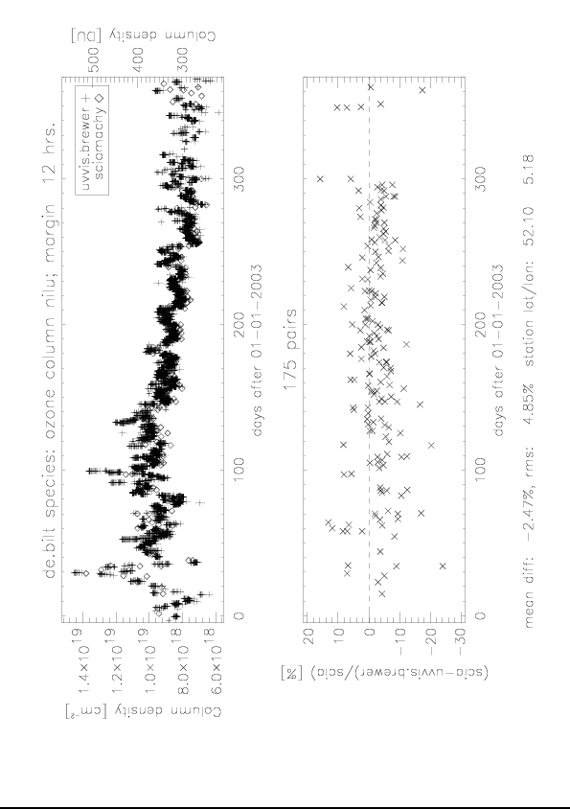
Antarctic result: Syowa Dobson
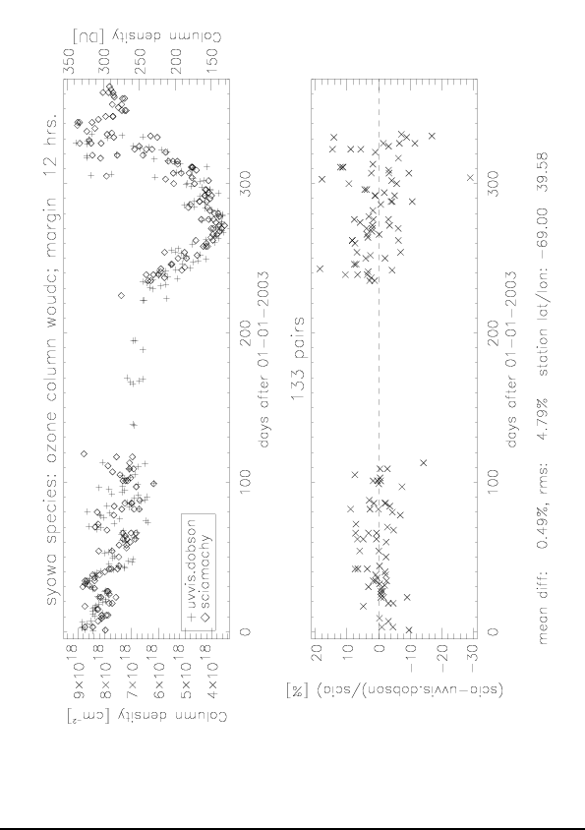
Tropical result: Paramaribo Brewer
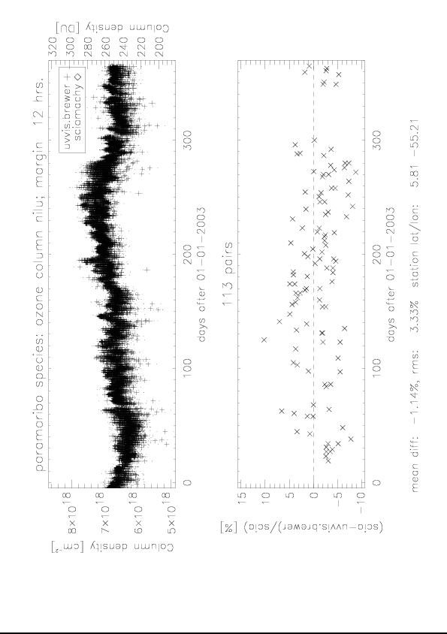

References

Lambert, J.-C., et al., Investigation of Pole-to-Pole Performances of Spaceborne Atmospheric Chemistry Sensors with the NDSC, J. Atm. Sci., 56, 1999.

Valks, P., J. P. Veefkind, J. F. de Haan, and R. van Oss, TOGOMI Algorithm Theoretical Baseline Document, TOGOMI/KNMI/ATBD/001, Issue 1.2, 01/11/2003.

Veefkind, J. P., and J. F. de Haan, Chapter 3 – DOAS Total O3 Algorithm, in OMI Algorithm Theoretical Basis Document, Volume II: OMI Ozone Products, ATBD-OMI-02, P. K. Bhartia (editor), 2002.

User response

After validation of the TEMIS product core user ECMWF concluded: “The assimilation of SCIAMACHY total column ozone data produced by KNMI leads to a pronounced improvement of the analyzed total column ozone field. Comparison with ozone sondes show that the vertical distribution of the analyzed ozone field is also improved. The impact on the forecast scores of meteorological fields is neutral. As a result of the research experiments, KNMI SCIAMACHY data will be actively assimilated in the 28r3 e-suite.” Detail results are reported in ECMWF memo R60.2/AD/77, dated July 27, 2004 from Antje Dethof.

Since Tuesday, 28 Sept 2004, ECMWF is assimilating SCIAMACHY total column ozone data (produced by KNMI) in the operational ECMWF system (28r3).

The forecast fields of total ozone fields based on the total ozone columns are also delivered on a daily basis to the following organisations (via FTP):
- German Meteorological Service (DWD), Germany
- Experimental Studies Division, Air Quality Research Meteorological, Canada
- Instituto Nacional de Meteorología (INM), Spain

TroposPheric Bromine Oxide

GOME and SCIAMACHY BrO measurements are sensitive to both stratospheric and tropospheric column contributions. In order to determine the tropospheric BrO column, the stratospheric column has to be estimated and substracted from the measured signal. As described in the Service Report, the stratospheric correction is derived using the 3D CTM SLIMCAT model. The main objective of this part is to ensure the accuracy of the tropospheric BrO estimates by a validation approach of the measurements and the stratospheric correction.

Assessment of total column BrO measurements

Intercomparison of satellite measurements

In the period from July 2002 until June 2003, GOME and SCIAMACHY were operated simultaneously so that the consistency between both instruments could be investigated. Figure 3.1 shows a comparison between BrO slant columns retrieved from GOME and SCIAMACHY for two spatially overlapping orbit files. Despite the time difference of 30 minutes between the two instruments, results display a good agreement. The larger apparent noise of SCIAMACHY retrievals is largely due to the smaller size of the SCIAMACHY pixels, leading to reduced S/N ratio on individual measurements.
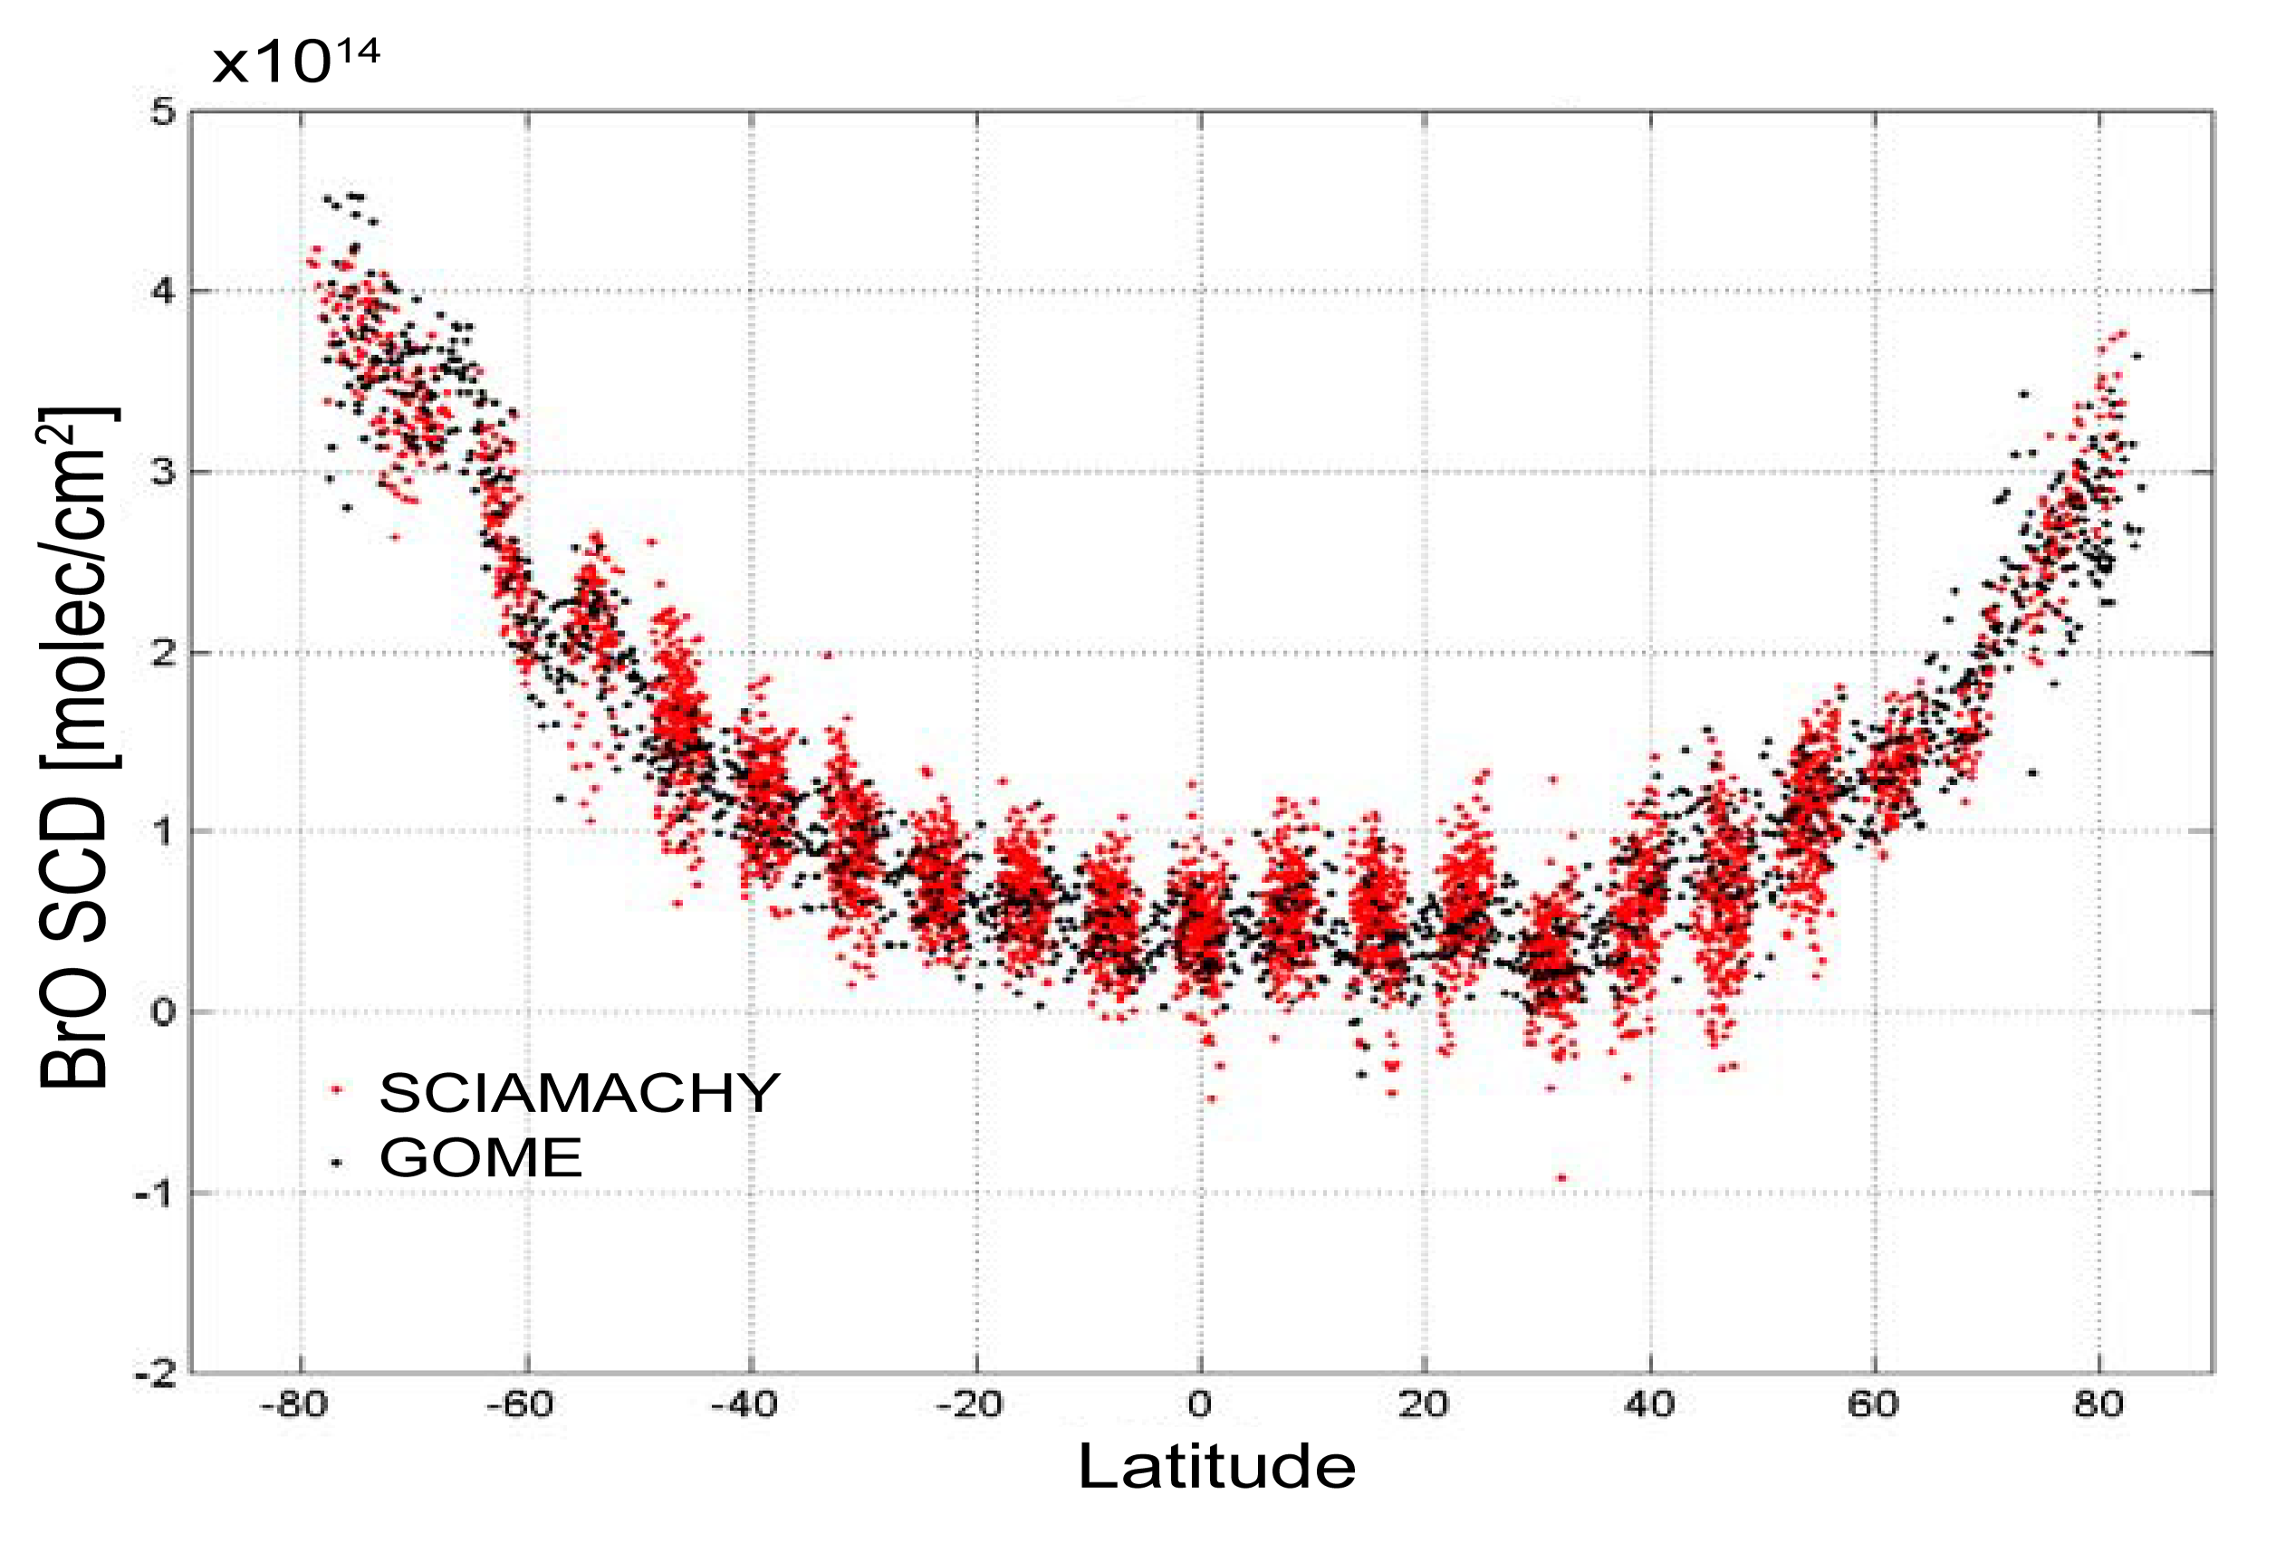
Figure 3.1- Slant column density of BrO retrieved from GOME and SCIAMACHY for two overlapping orbits recorded on 23 September 2002.

In Figure 3.2, monthly averages of BrO vertical columns derived from both instruments over the Arctic from January until May 2003 are displayed. In both cases, the conversion from slant to vertical columns was obtained using simple stratospheric air mass factors (AMFs). Although color plots show obvious differences related to the different sampling and spatial resolutions of GOME and SCIAMACHY, both instruments also show excellent consistency as to the way they capture the general features of polar spring BrO emissions.

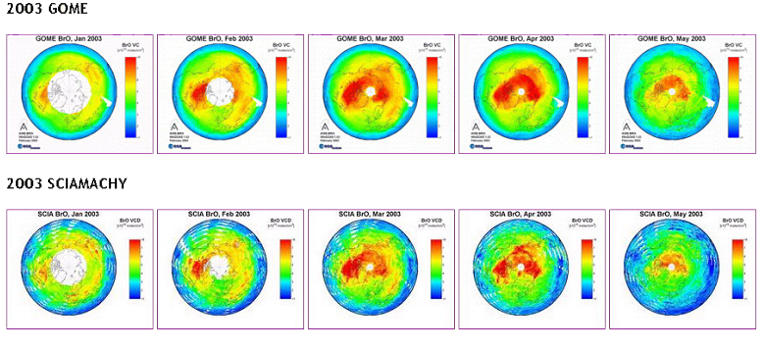

Figure 3.2- Monthly averaged BrO vertical columns over the Northern Hemisphere, derived from GOME and SCIAMACHY between January and May 2003. GOME and SCIAMACHY capture polar spring emissions in a consistent way.

Comparison with ground-based measurements

BrO slant columns observations are regularly performed at various ground-based stations worldwide, most of them being part of the international Network for the Detection of Stratospheric Change (NDSC). These observations are generally conducted at twilight in conditions where the retrieved quantities provide high sensitivity to the stratospheric BrO column around 90 degrees of solar zenith angle. In contrast SCIAMACHY and GOME observations are representative of total BrO columns (stratosphere + troposphere) around noon. Since BrO is characterised by a strong diurnal cycle and that its tropospheric content is significant not only in polar regions but likely also at mid-latitudes, the standard ground-based twilight observations cannot be easily converted to vertical columns adequate for satellite validation. Instead, ground-based measurement must be evaluated in a non-standard way in order to provide the needed noontime total columns. This represents a challenging task due to the typically low sensitivity of ground-based measurements at high sun and the strong diurnal variation of the stratospheric BrO. Hence methods are still under development. More details can be found in Van Roozendael et al. (2004).

At Harestua, ground-based BrO vertical columns were evaluated at the time of the satellite overpass using as Fraunhoffer reference a noon spectrum recorded in summer 2003 when BrO columns were at their lowest level. The residual amount of BrO in this spectrum was evaluated using a modified Langley-plot taking into account the diurnal variation of the stratospheric BrO. Resulting absolute slant columns at SCIAMACHY and GOME overpass time were converted to vertical column using AMFs accounting for 1 ppt of tropospheric BrO. The same assumption was also used for the calculation of satellite AMFs. Comparisons between these ground-based evaluations and coincident GOME and SCIAMACHY BrO VCDs are displayed in Figure 3.3, for the period from August 2002 until July 2003. Satellite data points are daily averages of all pixels falling within a radius of 200 km around the station. As can be seen, both seasonal and short-term fluctuations in the BrO VCDs are captured in the same way by all instruments including SCIAMACHY.

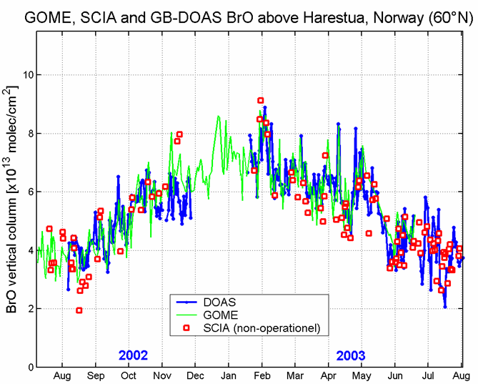

Figure 3.3 DOAS, GOME and SCIAMACHY BrO vertical columns derived above Harestua (60°N).

Assessment of tropospheric BrO column determinations

Geophysical consistency

Using the BIRA-IASB residual analysis scheme (see Service Report Bromine Monoxide), zonal averages of tropospheric BrO have been computed for all GOME measurements between 1997 and 2001 as displayed in Figure 3.4. The resulting tropospheric BrO columns show significant seasonal variations and a strong latitudinal dependence in both hemispheres. Large BrO emissions in Polar Regions in spring are also evidently displayed.

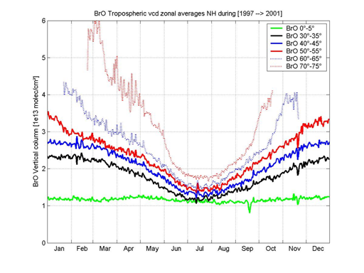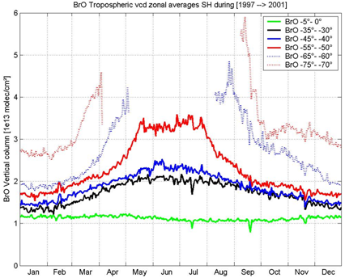

Figure 3.4- Zonal means of the GOME-SLIMCAT tropospheric BrO column averaged over 5 years (1997 to 2001) for the Northern hemisphere (left) and the Southern hemisphere (right).

A striking feature of the analysis is, that a non-zero residual tropospheric BrO content is obtained in all conditions whatever the latitude or the season, which supports the existence of a global background of free-tropospheric BrO. However, since modeled columns are currently not constrained by any observations, the possibility of a systematic underestimation of the stratospheric BrO column by SLIMCAT that would positively bias our tropospheric evaluations cannot be ruled out. Such an underestimation of modeled BrO columns could possibly results from the current neglect of several sources of inorganic bromine that may have a significant impact on the budget of the lowermost stratosphere. Additional problems may also arise due to the limited resolution of the model (5° x 7.5°), e.g.:
  - Fine structures in stratospheric bromine field not well captured by SLIMCAT may result in artifacts especially at high latitude during spring.
  - The twilight chemistry can be not adequately captured by the model output for regions close to the polar terminator.

Stratospheric BrO model intercomparison

The main issue regarding the accuracy of the tropospheric BrO estimates from GOME is the reliability of the stratospheric correction. In order to investigate the impact of using different model data on the tropospheric algorithm, a preliminary comparison between the BASCOE model (Belgian Assimilation System of Chemical Observations from Envisat, see also http://bascoe.oma.be) and SLIMCAT has been performed for one GOME orbit, see Figure 3.5. The BASCOE output is the result from a free run started on the 13 of January 2002 based on initial conditions provided by SLIMCAT.

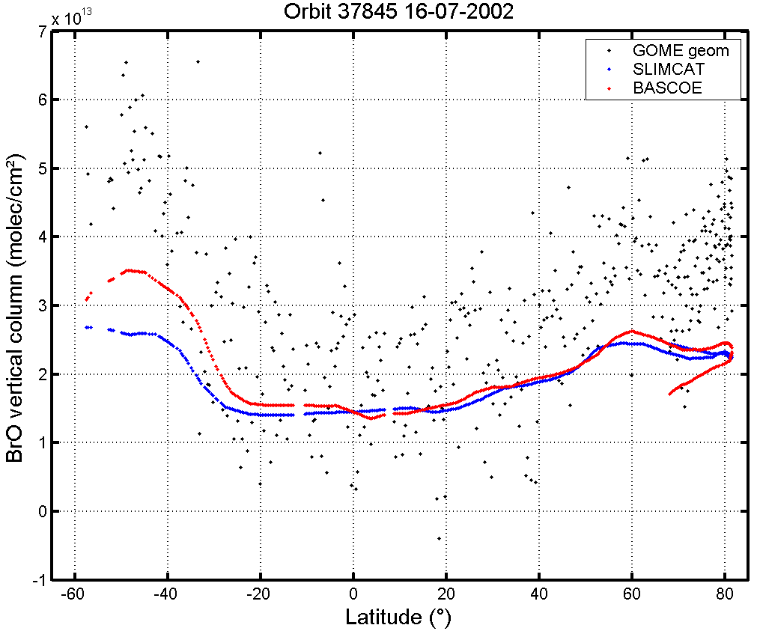

Figure 3.5 BrO vertical columns derived from BASCOE and SLIMCAT models for a GOME orbit on 16 July 2002. GOME data are also displayed for comparison.

As can be seen in Figure 5, BrO columns derived from both models are reasonably consistent. However, some significant differences are found in the southern hemisphere (for this particular orbit). More investigations are needed and currently under way to better understand the origin of these differences and in general to assess the robustness of stratospheric model calculations.

Stratospheric and tropospheric BrO columns from ground-based measurements

BrO measurements have been conducted at Reunion Island since August 2004 using a multi-axis DOAS (MAX-DOAS) system designed at BIRA-IASB. From the combined analysis of zenith-sky and off-axis measurements, stratospheric and tropospheric BrO columns can be retrieved independently.
The method to derive these quantities takes benefit of the full diurnal cycle of BrO in the stratosphere and the high sensitivity of the off-axis measurements to BrO in the troposphere. In Figure 6, BrO columns derived by the GOME residual algorithm are compared to the ground-based evaluations. Results indicate that both SLIMCAT and GOME total columns tend to be underestimated in comparison to the ground-based columns. Differences largely exceed the total uncertainty (one sigma accuracy) of the ground-based measurements, represented by vertical error bars in Figure 6. Note however that the difference between GOME and ground-based total columns lies within the uncertainty of the BrO equatorial offset correction, which is applied as part of the GOME retrieval algorithm (see Service Report). In contrast, the tropospheric BrO columns derived from the difference between GOME and SLIMCAT are consistent with the ground-based evaluations, suggesting a fortuitous error cancellation in the tropospheric BrO determination. Similar analysis of ground-based measurements performed at two other stations respectively at Northern mid-latitude (OHP, 44°N) and at 60°N (Harestua) are currently under progress and should enable the establishment of a more robust characterisation of the GOME product uncertainty.
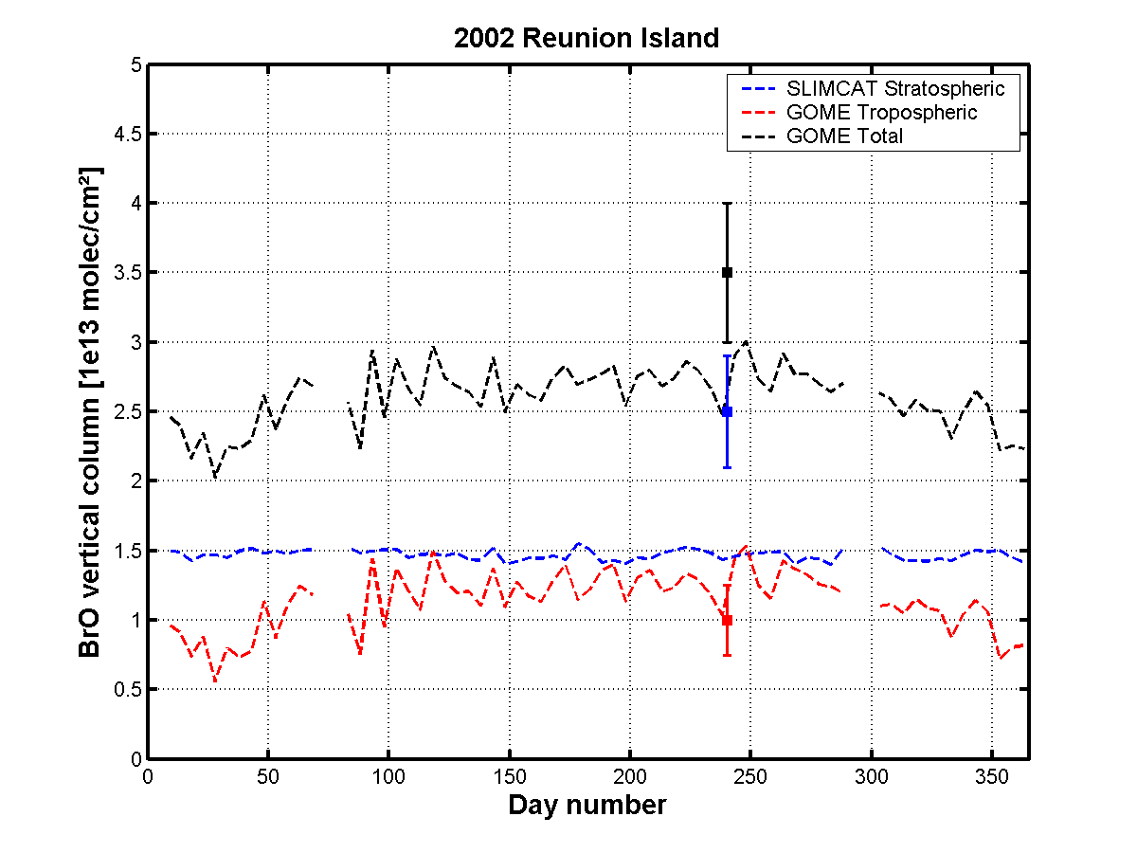

Figure 3.6- BrO vertical columns derived from the GOME algorithm using the SLIMCAT vertical columns for the year 2002 (averaged on a 5 days basis) above Reunion Island (co-location radius:500 km).
Ground-based mean BrO columns estimations (at GOME overpass) representative for the time period from August to December are also displayed.

User response

References

- Van Roozendael, M., et al, First validation of SCIAMACHY BrO columns, Proceedings, Atmospheric Chemistry Validation of ENVISAT, ESRIN, 3-7 May 2004

