OMDOAO3 Release Specific Information
Pepijn Veefkind
9 October 2007

Software Version
This information applies to the software version 1.0.5 and higher.

ECS Collection Number
The OMDOAO3 v1.0.5 is released for Collection 3.

Known Issues List

Noisy Behavior of Pixel 30
The following contains a list of known issues in the OMCLDO2 data product:
Across track 30 (0-based) is noisy for inhomogeneous scenes. The reason for this behavior is that the wavelength assignement in the Level 1B is not corrected for inhomogeneos scenes for this pixel. For pixel 30 the ProcessingQualityFlag Earth Radiance Warning (bit 3) is always set. The figure below shows the precision for pixel 30 and its neighbouring pixels.
In the next version of the 0-1B processor this behavior for pixel 30 will be resolved.
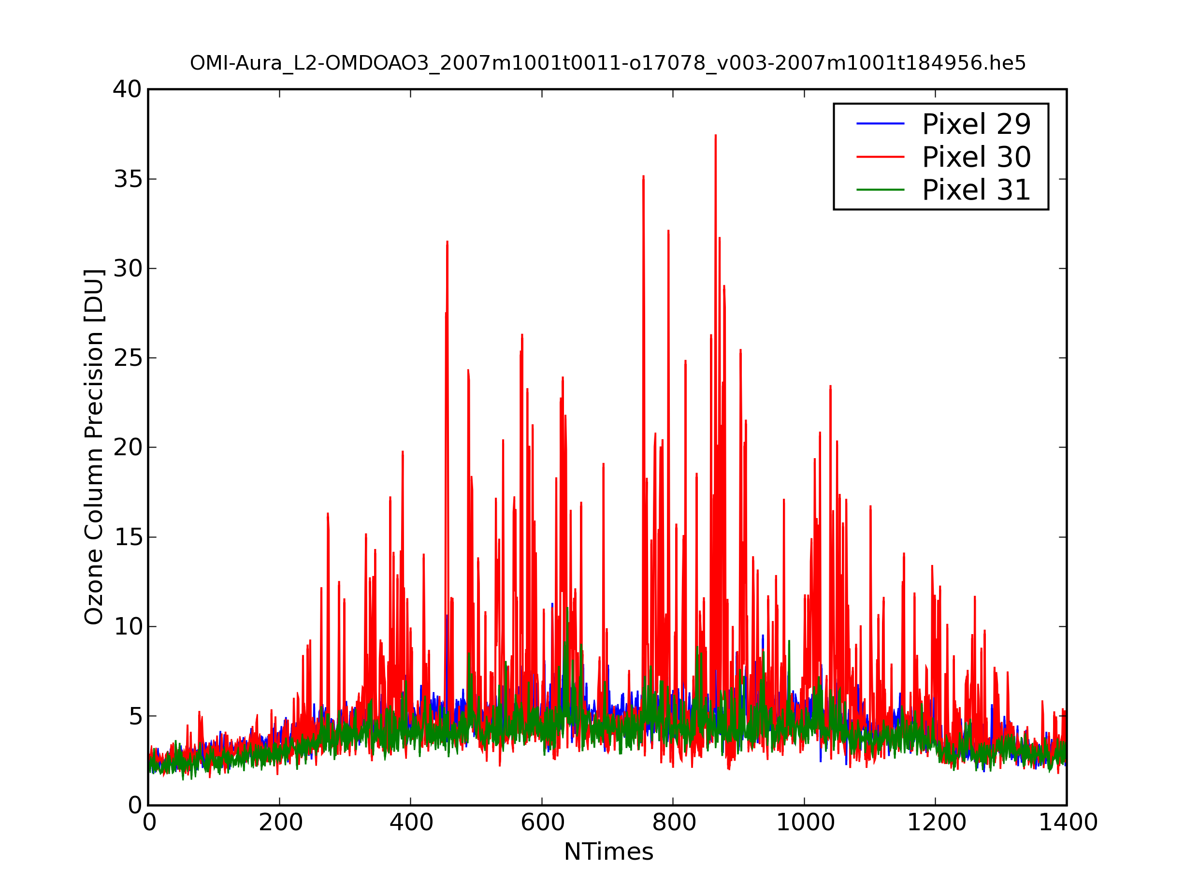
Figure showing the the precision in the ozone column for orbit 17078 for the noisy pixel 30 and its neighbouring pixels 29 and 31.

Row Anomaly of Pixels 53 and 54
Since the end of June 2007, across track pixels 53 and 54 (0-based) show anomalous behavior. These pixels show a high fitting residuals, too high ozone columns, and too low cloud fractions. This feature is probably caused by blocking of part of the incoming Earth radiance. Since the feature has been stable since the end of June it is expected that it can be corrected for in a future version of the Level 0-1B data processor. It is recommended not to use across track pixels 53 and 54 from June 2007 onwards, until the anomaly has been corrected for. The figure below shows the ozone column amount precision for pixels 53 and 54 and the neighbouring pixels 52 and 55, showing a lower precision for these anomalous pixels 53 and 54. The bottom plot shows the median of the column amount ozone for 100 measurements, showing too large values for pixels 53 and 54.
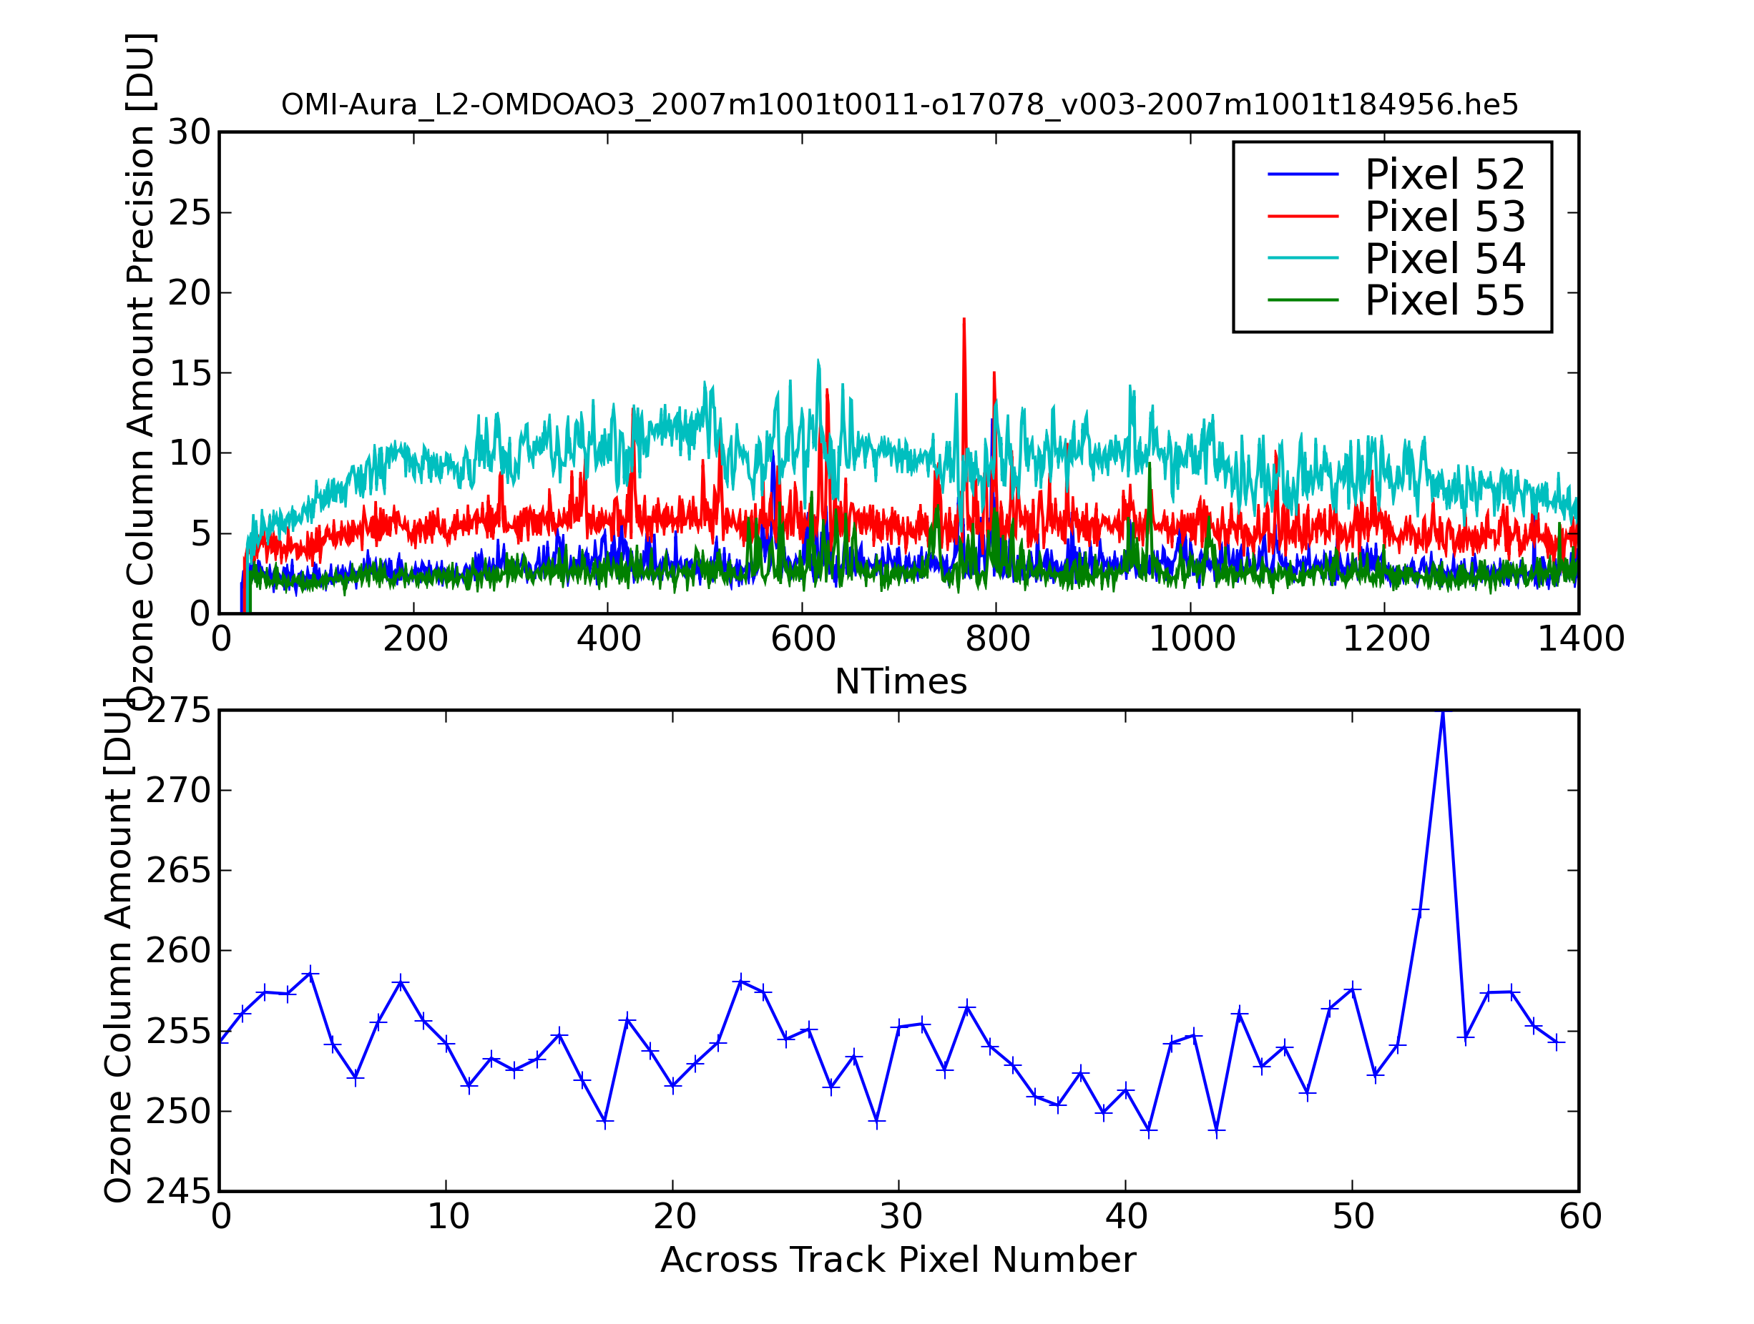
Figure showing the row anomaly for pixels 53 and 54. Top plot shows the precision of the column amount ozone for pixels 53 and 54 and their neighbours. Bottom plot show the median of the ozone column for 100 measurements in the flight direction. Pixels 53 and 54 have anomalous high ozone columns.

Release History

OMDOAO3 v1.0.5:
- Release for OMI Collection 3 data.
- The treatment of high reflective surfaces (snow/ice) has been changed. If a highly reflective surface is detected, the effective cloud fraction is set to zero, and the surface albedo is fitted instead of the cloud fraction. The reason for setting the cloud fraction to zero is that it is not possible to derive an accurate effective cloud fraction over snow/ice surfaces. Validation data from the Polar Ave campaign have shown that setting the cloud fraction to zero results in the most accurate results. It is noted that this approach is similar to what is used in the OMTO3 data product.
- The airmass factor tables ave been updated. The previous air mass factor tables were the primary cause for the Solar zenith angle dependent bias. The new air mass factor tables are based on a new set of radiative transfer calculations.
- The look-up table for the cloud radiance fraction has been updated. The radiative transfer calculations of the previous version were based on a plane-parallel atmopshere. In the new version, corrections are done for the sphericity of the atmosphere.
- A new static irradiance file has been produced by combining all the Solar irradiance data of Collection 3 for the year 2005.

OMDOAO3 v1.0.1:
The median solar irradiance file has been updated such that the Sun-normalized radiance is correct. The most important correction was done for accross track pixel 0.

OMDOAO3 v1.0.0:
- Updated the reference cross sections for O3, Sun and ring reference spectra. The main differences are a new Sun reference spectrum and updated OMI slit functions.
- Updated OMDOAO3_OPF.txt file. This file contains settings for the algorithm. The following changes were made to this file: the file version was set to 1.0, the albedo for snow surfaces was set to 0.6, and several limit values were updated.
- Changed the flagging strategy: Now level 1b pixel qflag bits 0-5 are errors, bits 6-13 are warnings and the rest are ignored. This reduces the stripes in the ozone column.
- Corrected the radiances and irradiance for Sun-Earth distance. This allows radiance and irradiance product to be more distant in time.
- The current baseline is to use a static median solar irradiance file. This reduces the stripes.
- Corrected bug in High-Sampling interpolation that appeared when flagged spectral pixels are removed from spectra.

OMDOAO3 v0.9.42
OMDOAO3 v0.9.42 is the first version to be released provisionally.

