DOCUMENT TYPE: Service Implementation Document

TITLE:

Sulphur Dioxide Monitoring
within TEMIS

The description in this document also applies to the Sulphur Dioxide Monitoring which is performed within Stage II of the PROMOTE project and its Support to Aviation Control Service. The TEMIS and PROMOTE projects are supported by the European Space Agency (ESA).



DOCUMENT STATUS SHEET
Issue | Rev. | Date | Modified Items / Reason for Change
0.9 | 0 | 29.11.06 | First Version
TABLE OF CONTENTS
1. Introduction 5
1.1 Purpose and scope 5
1.2 Document overview 5
1.3 Definitions, acronyms and abbreviations 5
1.4 Applicable Documents 6
1.5 Acknowledgments 7
2. Sulphur dioxide Monitoring within temis 8
2.1 Introduction 8
2.2 Sulphur dioxide and the TEMIS services 8
2.2.1 Air Pollution Monitoring Service 9
2.2.2 Support to Aviation Control Service 10
2.3 Data and service version history 11
2.4 Lifetime and reaction cycles of sulphur dioxide 12
3. Sulphur Dioxide slant columnS 14
3.1 Slant column retrieval 14
3.1.1 The DOAS software 15
3.2 SO₂ slant column retrieval 16
3.3 Background correction of the SO₂ slant column 17
3.4 Reference spectra for the DOAS retrieval 21
4. Sulphur Dioxide vertical columnS 22
4.1 Slant column and vertical column densities 22
4.2 Air-mass factor using a radiative transfer model 24
4.3 Air-mass factor using a chemistry transport model 24
5. data product description – preliminary data set 26
5.1 GOME and SCIAMACHY slant column data 26
6. data product description – Current data set 27
6.1 Geographic regions 27
6.2 Data product presentation 29
6.2.1 Cloud cover fraction 30
6.3 Data product delivery 31
6.4 ASCII data file specifications 31
6.4.1 Data file name 32
6.4.2 Data file format 32
6.4.3 Data flags in the ASCII data file 35
6.5 HDF data file specifications 37
6.5.1 Data file name 37
6.5.2 Data file format 37
6.6 Known issues 40
6.6.1 South Atlantic Anomaly 40
7. near-real time and alert service 42
7.1 Near-real time processing of SO₂ 42
7.1.1 Reference spectrum and background correction 42
7.1.2 Monitoring of the near-real time processing 42
7.2 Criteria for exceptional SO₂ concentrations 43
8. References 44

Introduction

Purpose and scope
The Data User Programme (DUP) is an optional programme of ESA which aims at supporting Industry, Research Laboratories, User Communities as well as European and National Decision Makers to bridge the gap that exists between research at the level of pilot projects and the operational and sustainable provision of Earth Observation products at information level.

TEMIS is a project (started September 2001) in response to an Invitation To Tender from ESA in the context of ESA's Data User Programme. The aim of the project is the delivery of tropospheric trace gas concentrations, and aerosol and UV products, derived from observations of the nadir-viewing satellite instruments GOME and SCIAMACHY.

This document contains the specifications of the SO₂ products for the TEMIS themes “Air Pollution Monitoring” and “Support to Aviation Control”; the latter service is set up in close relation with the service of the same name within Stage II of the PROMOTE project. The current version is part of the final deliverables of the implementation phase of TEMIS. The version number of the document corresponds to the version number of the SO₂ data product (cf. see section 2.3).

Document overview
Chapter 1 contains the introduction, applicable documents and acknowlegdments. Chapter 2 gives an introduction of the SO₂ monitoring services within TEMIS. Chapters 3 to 6 describe the SO₂ processing, the data product delivery and data product specifications. Chapter 7 describes issues specific for the near-real time processing the notification service of exceptional SO₂ concentrations. And chapter 8 contains the list of references for this document.

Definitions, acronyms and abbreviations

AMF | Air-Mass Factor
ASCAR | Algorithm Survey and Critical Analysis Report
BIRA-IASB | Belgian Institute for Space Aeronomy
BrO | Bromine Oxide
CH₂O | Formaldehyde
CTM | Chemistry Transport Model
DLR | German Aerospace Center
DOAS | Differential Optical Absorption Spectrometry
DU | Dobson Unit
DUP | Data User Programme
ECMWF | European Centre for Medium-range Weather Forecast
ENVISAT | Environmental Satellite
ERS | European Remote Sensing Satellite
ESA | European Space Agency
ESRIN | European Space Research Institute
FRESCO | Fast Retrieval Scheme for Cloud Observables
GOME | Global Ozone Monitoring Instrument
HCHO | Formaldehyde
H₂SO₄ | Sulphuric acid
IAVW | International Airways Volcano Watch
ICAO | International Civil Aviation Organization
KNMI | Royal Netherlands Meteorological Institute
LIDORT | Linearized Discrete Ordinate RTM
NLLS | Non-Linear Least-Squares
NO₂ | Nitrogen Dioxide
NRT | Near-Real Time
O₃ | Ozone
PROMOTE | Protocol Monitoring for the GMES Service Element: Atmosphere
RRS | Rotational Raman Scattering
RTM | Radiative Transfer Model
SAA | South Atlantic Anomaly
SACS | Support to Aviation Control Service
SCIAMACHY | SCanning Imaging Absorption spectroMeter for Atmospheric CartograpHY
SCD | Slant Column Density
SO₂ | Sulphur Dioxide
SR | Service Report
SVD | Single Value Decomposition
SZA | Solar Zenith Angle
TBC | To Be Confirmed
TBD | To Be Defined
TEMIS | Tropospheric Emission Monitoring Internet Service
USD | User Specification Document
URD | User Requirements Document
UV | Ultra Violet
VAAC | Volcanic Ash Advisory Centre
VCD | Vertical Column Density

Applicable Documents

AD-1 | Data User Programme II period 1st call For Proposal ref:EEM-AEP/DUP/CFP2001
AD-2 | User Specification Document, v1.4, TEM/USD/005, May 2002
AD-3 | User Requirement Document, v2.0, TEM/URD/006, October 2002
AD-4 | Algorithm Survey and Critical Analysis Report, v1.2, TEM/ASCAR/003, May 2002
AD-5 | Service Report Air Pollution Monitoring, v1.8, TEM/SR2/001, Nov. 2006
AD-6 | Service Report Support to Aviation Control, v1.0, TEM/SR4/001, Nov. 2006
AD-7 | Sulphur Dioxide Monitoring within TEMIS, v0.9, TEM/SO2/001, Nov. 2006

Acknowledgments

The Sulphur Dioxide Monitoring Service is set up as part of the following projects:

TEMIS -- Tropospheric Emission Monitoring Internet Service
http://www.temis.nl/

PROMOTE -- Protocol Monitoring for the GMES Service Element
http://www.gse-promote.org/

by the Belgian Institute for Space Aeronomy (BIRA-IASB, Brussels, Belgium) in collaboration with DLR (Oberpfaffenhofen, Germany) and KNMI (De Bilt, The Netherlands).

The TEMIS and PROMOTE projects are supported by the European Space Agency (ESA).

Partners

BIRA-IASB | Jos van Geffen, Michel Van Roozendael  Isabelle De Smedt, Caroline Fayt, Nicolas Theys
DLR | Pieter Valks
KNMI | Ronald van der A

We would furthermore like to thank the following people for discussions, suggestions, information and other help:

ESA-ESRIN | Claus Zehner
Météo France / Toulouse VAAC | Philippe Husson, Patrick Josse
RT Soluctions, Inc. | Rob Spurr
UK Met. Office / London VAAC | Claire Witham, Sarah Watkin
University of Maryland | Arlin Krueger
US Geological Survey | Marianne Guffanti

Sulphur dioxide Monitoring within temis

Introduction

Sulphur dioxide, SO₂, enters the atmosphere as a result of both natural phenomena and anthropogenic activities, for example:

- Combustion of fossil fuels
- Oxidation of organic material in soils
- Volcanic eruptions
- Biomass burning

Coal burning is the single largest man-made source of sulphur dioxide, accounting for about 50% of annual global emissions, with oil burning accounting for a further 25 to 30%. Sulphur dioxide reacts on the surface of a variety of airborne solid particles (aerosols), is soluble in water and can be oxidised within airborne water droplets, producing sulphuric acid. This acidic pollution can be transported by wind over many hundreds of kilometres, and is deposited as acid rain.

Changes in the abundance of sulphur dioxide have an impact on atmospheric chemistry and on the radiation field, and hence on the climate. Consequently, global observations of sulphur dioxide are important for atmospheric and climate research. In addition, SO₂ at high concentrations has negative effects on human health, in particular in combination with fog (smog).

Effects of volcanic eruptions may have an impact on air traffic, as such eruptions are important sources of ash (aerosols) and sulphur dioxide in the atmosphere. A near-real time retrieval of sulphur dioxide concentrations would enable monitoring of such events and can thus assist in aviation control. Off-line retrieval, on the other hand, is more suitable for monitoring anthropogenic pollution aspects.

Sulphur dioxide and the TEMIS services

The retrieval of SO₂ derived from measurements by satellite based instrument, such as GOME and SCIAMACHY, cannot make a unique differentiation between SO₂ related to anthropogenic activities and SO₂ from natural sources. For TEMIS, however, SO₂ from the first source falls under the Air Pollution Monitoring Service (“AMPS”), while SO₂ related to volcanic eruptions falls under the Support to Aviation Control Service (“SACS”).

The difference between these two Services lies on the one hand in the choice of the geographic regions used for monitoring the SO₂ concentrations, and on the other hand in the delivery time of the data: whereas SACS concentrates on a near-real time delivery of the data, AMPS is more of an archive service; but even for SACS an archive of data is both useful and necessary.

The SO₂ data products for both the Air Pollution Monitoring and Support to Aviation Control Services are therefore very much alike. To not unnecessarily duplicate the description of the SO₂ data products, the data formats, the data delivery, references, and other relevant aspects in the Service Reports of both Services [AD-5 and AD-6], the description is provided this separate document [AD-7].

The data products, images and a detailed up-to-date product infomration can be found on the TEMIS web-site http://www.temis.nl/

The SO₂ data is presented with two entry points: the Volcanic SO₂ Service and the Air Quality SO₂ Service. This is done in close relation with two services in Stage II of the PROMOTE project:
- The Air Quality Record Service
- The Support to Aviation Control Service (SACS)

Air Pollution Monitoring Service

Air pollution has become a global issue. Much of the anthropogenic air pollutants travel over long distances, thus affecting areas far from the emission sources. Air pollution is related to the large-scale fossil-fuel combustion and fossil-fuel related activities, but also to biomass burning and changes in land use, and it affects human health and damages flora and fauna.

To assist in monitoring of air pollution, the TEMIS project aims to supply tropospheric concentrations of the most important pollutants, in the form of global maps and concentrations at user-defined locations.
The products will be used for warning to the general public, scientific research and reporting to government or international environmental agencies.

The service supplies tropospheric products of the following trace gases :
- Ozone (O₃), which is a toxic gas caused by biomass burning and industrial smog. In the troposphere it also acts as greenhouse gas.
- Nitrogen dioxide (NO₂), which is a direct indicator of anthropogenic pollution emitted by traffic and industry. NO₂ is also a key gas in tropospheric chemistry.
- Sulphur dioxide (SO₂), which enters the atmosphere as a result of both natural phenomena and anthropogenic activities. Emission sources are combustion of fossil fuels, oxidation of organic material in soils, volcanic eruptions, and biomass burning. Coal and oil burning are the largest man-made sources of sulphur dioxide accounting for more than 75% of annual global emissions.
- Formaldehyde (CH₂O), which enters the troposphere as a result of isoprene emissions and biomass burning chemistry.
- Aerosols, which have a wide range of origins, natural (e.g. desert dust, sea spray) as well as anthropogenic (e.g. soot, industrial pollution).

In addition to these products, cloud information has been retrieved from GOME and SCIAMACHY with the FRESCO algorithm. These cloud information is important as input for most of the algorithms in this service, but it will also be presented to users within this service.

Support to Aviation Control Service

Volcanic eruptions can emit large quantities of rock fragments and fine particles (ash) into the atmosphere, as well as several gases, such as CO, SO₂, BrO, and water vapour. The rock fragments usually fall back to Earth quite quickly. The ash and the gases, however, can rise high up into the troposphere and even reach the lower stratosphere, up to 15 or even 20 km. The elevation reached by the material depends on the strength of the volcanic eruption, which in turn depends on the kind of volcano that erupts.

The ash emitted by volcanic eruptions is a major hazard to aviation. The ash can, for example, severely damage the material of the aircraft, it can clog its sensors, it can limit the view of its pilots, and it can severely scratch ("sandblast") the windows of the aircraft. And when it enters the aircraft's engines, the ash can melt (it has a melting point of about 1100°C), as a result of which the engine may fail.

Over 90 aircraft have sustained damage after flying through volcanic ash clouds. In at least 7 cases this resulted in temporary loss of power on one or more of the engines during flight. In three cases, a Boeing 747 lost all four engines (1982 and 1989); fortunately the engines could be restarted once outside the ash cloud, but meanwhile the aircraft had dropped several km. The ash emitted during the eruption of the Pinatubo volcano (1991) has damaged aircraft as far away from the volcano as 1000 km.

Every year there are about 60 volcano eruptions. On average the ash cloud of 10 of these eruptions reach flight level along major aircraft routes. The total cost of the damage sustained by aircraft due to volcanic ash clouds in the period 1982-2000 is estimate at 250 million US dollar. So far none of the incidents have resulted in fatal accidents or of people being injured.

Of the gases emitted during a volcano eruption, sulphur dioxide (SO₂) is in itself also a hazard to aircraft, as SO₂ reacts with water vapour to form sulphuric acid (H₂SO₄), which is corrosive and can therefore scratch the paint and the windows of the aircraft, and it can create sulphate deposites in the engines. Depending on the kind of eruption, the SO₂ may be inside the ash cloud, but it may also be above or below the ash cloud. In general the ash will drop due to gravity effects faster than the SO₂, so that some distance away from the volcano the ash and SO₂ clouds may be separated.

From all these considerations it is clear that the safest procedure for aircraft is to stay clear of volcanic clouds. Pilots cannot always see an ash cloud (e.g. at night) and the ash does not show up on radar. And SO₂ and H₂SO₄ are colourless gases, and therefore invisible. If it penetrates into the aircraft; sulphuric acid is noticed easily because of its strong smell; but then the aircraft is already inside the cloud. Hence, it is of major importance to know in advance where ash clouds are and what elevation they reach.

Observations by satellite based instruments can assist in this. On the one hand, some satellite instruments can detect volcanic ash directly, though this technique is still under development. On the other hand, the detection of SO₂ does not only show where SO₂ clouds are, but can also help pinpoint volcanic ash clouds.

In addition it is known that some volcanoes emit SO₂ prior to a (major) eruption. This so-called passive degassing will not send the SO₂ high up in the atmosphere, because the emissions are not explosive, and the emission will usually be only in low concentrations. It is quite difficult to detect low concentrations of SO₂ near ground level or in the lower troposphere. But if it is possible to detect these emissions, it will provide additional information for early warning systems of upcoming volcano eruptions.

The Volcanic Ash Advisory Centres (VAACs) are the official organisations to gather information on volcanic ash clouds and on the basis of that issue advices and alerts to air line and air traffic control organisations on the possible danger of volcanic clouds. The VAACs are part of an international system set up by the International Civil Aviation Organization (ICAO) called the International Airways Volcano Watch (IAVW).

To assist the VAACs in their work, the Support to Aviation Control Service (SACS) of TEMIS supplies data on SO₂ concentrations in the atmosphere, derived from the satellite based instruments GOME (onboard ERS-2) and SCIAMACHY (onboard ENVISAT) in near-real time. This data delivery is done in close relation with the service of the same name within Stage II of the PROMOTE project.

Data and service version history

The data files, and with that the SO₂ data services, have been given a version number, in order to track changes in the different parts of the processing.

The version number looks like this: A.B.C

where A.B represents the version of the slant column retrieval and the warning system, and .C the version of the AMF-based vertical columns; if C is zero or absent, no vertical columns are available. Note that the combination A.B is used as version number of the documentation.

The table below gives a brief overview of the version numbers and what was added/done for that version, and shows for which version this document is up-to-date

Version | Date | Description
0.9 | September 2006 | Start of the near-real-time processing of SO2 from SCIAMCHY for SACS; no e-mail notification yet
0.9 | June 2006 | Somewhat improved background condition and addition of FRESCO cloud cover information
0.8 | November 2005 | Improved data file header (in preparation for addition of VCD data) and a correction of the "relative azimuth angle" (error in previous version). This applies to the ASCII data files only; the HDF data files remain version 0.7.
0.7 | October 2005 | Full SO2 Archive Services set up, with an improved background correction, improved web access to the different archives, and a more extensive product information
0.6 | December 2004 | Prototype SO2 Archive Service set up, with preliminary on-line product information
-- | Up to mid 2004 | Preliminary data processing from GOME and SCIAMACHY for 2000 to mid 2004, without any correction for the background SO2 levels; these data sets and images will be replaced by new processing.

Some more details on the changes and additions per version number can be found in the on-line product information at http://www.oma.be/BIRA-IASB/Molecules/SO2archive/info/

Notes:
- Version 0.8 was the first version to be documented on paper; some product information was available via the website as of version 0.6.
- The “Preliminary” version, from before mid 2004, was initially documented in previous versions of the Service Report on the Air Pollution Monitoring Service [AD-5].

Lifetime and reaction cycles of sulphur dioxide

The lifetime of sulphur dioxide molecules in the troposphere is a few days. The amount is highly variable, above a low background concentration. It is removed from the troposphere:

- in gas phase by formation of sulphuric acid, which forms condensation nuclei for aerosols and clouds and acidifies the rain:

- directly, by way of an uptake on aerosols and clouds, which leads to dry and wet acid depositions.

Clean continental air contains less than 1 ppb of sulphur dioxide, which corresponds to a total column density < 0.2 Dobson Units (DU) in a boundary layer of 2 km.

The lifetime of sulphur dioxide molecules in the stratosphere, on the other hand, is several weeks, during which is produces sulphate aerosols. This makes sulphur dioxide from volcanoes one of the two most important sources of stratospheric aerosols.

Sulphur Dioxide slant columnS

Slant column retrieval

The technique used to retrieve total slant columns of atmospheric trace species from measurements by satellite-based instruments (such as GOME, SCIAMACHY) is the Differential Optical Absorption Spectroscopy (DOAS). Differential Optical Absorption Spectroscopy is a widely used method to determine concentrations of atmospheric species [Platt, 1994]. The DOAS analyse of broadband spectra in the UV and visible region (200-800 nm) allows the determination of concentrations of atmospheric species, which leave their absorption fingerprints in the spectra.

The DOAS technique is based on a straightforward implementation of the Beer-Lambert’s law, which describes the extinction of the solar radiation in an absorbing atmosphere:
[4.1]
where : I(λ) is the solar spectrum after absorption (earthshine radiance);
I₀ (λ) is the extraterrestrial solar spectrum (solar irradiance);
σ_{i} are the relevant cross sections of the absorbing species, with wavelength and temperature dependent structures;
c_{i} are the unknown species column densities.
The logarithm of the ratio of the irradiance spectrum (I₀ (λ)) and the earthshine spectrum (I(λ)) is denoted optical density (or optical thickness):
[4.2]

The DOAS approach is a direct application of equation 4.2. High frequency spectral structures characteristics of the various absorbing species are used to resolve the corresponding contributions to the total optical density. This is obtained using a least-square procedure where the slant column densities (SCD) of the various species are the fitted parameters. Large band contributions to the atmospheric attenuation (Rayleigh and Mie scattering) are accounted for by a low order polynomial function. Simply stated, the DOAS technique is a linear problem. This linearity is however broken down by the need to account for additional effects, namely:
- small wavelength shifts between I and I₀ spectra must be corrected using appropriate shift and stretch parameters,
- possible instrumental and/or atmospheric straylight or residual dark current signal require the introduction of an offset parameter.
In addition to shift and offset, Ring and undersampling effects have to be treated. The so-called Ring effect arises in the atmosphere due to inelastic scattering processes (mainly Rotational Raman Scattering (RRS) by molecular O₂ and N₂). Roughly speaking, it manifests itself by a broadening of the solar and atmospheric spectral features present in the satellite earthshine backscattered spectra. This broadening typically reduces the depth of thin solar and atmospheric absorption features by several percents. Hence, it has a strong impact on spectroscopic measurements using the DOAS method and requires appropriate correction to be implemented in retrieval algorithms. In DOAS, the Ring effect is usually accounted for as an absorber. Ring cross sections can be obtained from different sources [Vountas, 1998], [Chance, 1997].
The undersampling problem arises from the poor sampling ratio of the instrument which results in a lost of spectral information when interpolating earthshine spectra during the DOAS fitting process. To some extent, the problem can be corrected by using an ad-hoc cross section obtained by simulating the effect based on a high-resolution solar reference.

Consider the modified equation:
[4.3]
P is the polynomial. Undersampling cross section and Ring effect cross section are simply included as additional pseudo-absorbers.
The selection of the spectral analysis window determines which absorbers have to be included in the fitting procedure. Several cross sections of a same absorber can be fitted together (for example to account for a temperature dependency of the cross sections).
Residuals of equation 4.3 are minimised using a Marquardt-Levenberg non-linear least-squares (NLLS) algorithm. The method implements a gradient-expansion algorithm, which is based on the iterative combination of a steepest-descent method (suitable for approaching the minimum from far away) and a linearization of the fitting function. Linear parameters are determined by a Singular Value Decomposition (SVD) method embedded in the NLLS algorithm.

The DOAS software

The DOAS of spectra is performed using WinDOAS, a multi-purpose DOAS analysis software developed over the 1990s at BIRA-IASB. This software initially developed for ground-based applications has been thoroughly validated through participation at various intercomparison exercises [Hofmann, 1995], [Roscoe, 1999], [Aliwell, 2002]. For more information on the algorithm details, see the “WinDOAS 2.1 Software User Manual” [Fayt and Van Roozendael, 2001].

For use in the operational processing, the WinDOAS software has been transferred to a Linux system, after removal of the user interface, and is there called LinDOAS; the retrieval functionality of the software has not changed with this transfer.

SO₂ slant column retrieval

For SO₂, the DOAS analysis is conducted in the 315-326 nm wavelength region where this molecule presents large vibrational structures [e.g. Eisinger and Burrows, 1998].

Software: WinDOAS & LinDOAS [cf. section 3.1.1]
Analysis Method: Differential Optical Absorption Spectroscopy
Fitting interval: 315-326 nm
Molecular absorption cross-sections: SO₂ [A]
O₃ at 221K [B]
O₃ at 241K [B]
NO₂ [C]
Additional terms/corrections: Ring cross-sections [D]
Polynomial (order 3)
Offset (constant + slope)

References for the cross-sections
 | GOME | SCIAMACHY
[A] | Burrows, not published | Bogumil et al, 2000
[B] | Burrows, 1999 | Bogumil et al, 2000
[C] | Burrows, 1998 | Bogumil et al, 2000
[D] | Vountas, 1998 | Chance and Spurr 1997

The detection limit depends on both the observing conditions (time and place) and the retrieval algorithm. The strong ozone absorption in the UV can interfere with SO₂ retrieval and larger effective ozone absorption is likely to result in more background noise. The detection limit will therefore increase with ozone concentration. Figure 1 shows the cross sections of SO₂ and Ozone in the wavelength range used for the SO₂ slant column retrieval.
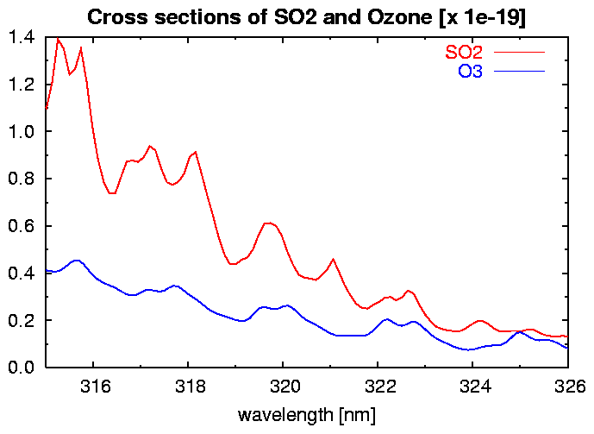
Figure 1 – Cross sections of SO₂ (red) and ozone (blue) in the wavelength range used for the SO₂ slant column retrieval.

Instrument artefacts can also add noise to the SO₂ maps. For example, the detection limit is higher in the Southern hemisphere and in some cases traces of the satellite orbits can be visible in long-term averages. Levels of noise vary from 0.2 DU (cloud free scenes, low SZA, low ozone concentration) to 1 DU (Southern hemisphere, high ozone concentration, proximity of a region of pollution...).

Background correction of the SO₂ slant column

A background correction is applied to the SO₂ slant columns retrieved with DOAS. There are two reasons to apply such a correction:

- The DOAS retrieval requires the use of a reference spectrum. For this a measurement is used from a location thought to be free of SO₂, but it can lead to an offset in the SO₂ slant column.

- At higher Solar Zenith Angels the "interference" between the SO₂ and ozone absorption – mentioned in section 3.2 – results in more negative SO₂ slant column values, with large errors.

Note
The background correction described in this section is still under development. Details of it may change in the near future, as more data is gathered to investigate the details of the correction.

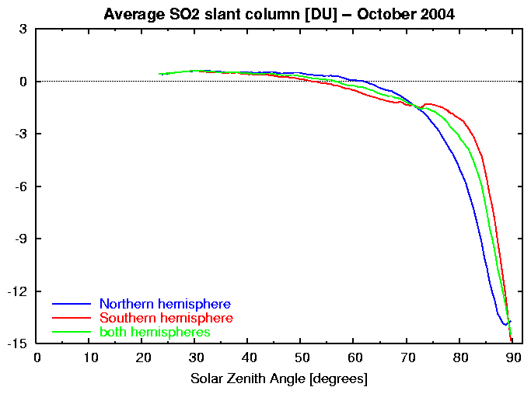
Figure 2 – Average of the SO₂ slant column as function of the SZA for October 2004 over all data (green), of only the Northern hemisphere (blue) and of only the Southern hemisphere (red). The decrease of the average SO₂ slant column at higher SZA is due to the increase in ozone absorption along the slant path with increasing SZA.

Figure 2 shows an example of the monthly average of the SO₂ slant column as function of the SZA. From this graph it is not only clear that the retrieved SO₂ slant column decreases strongly at high SZA, but also that there is a difference between the Northern and Southern hemisphere here. The reason for the latter difference is that ozone concentrations near the South Pole are much lower than near the North pole due to the presence of the "ozone hole" above Antarctica in this month. Since the ozone concentrations usually differ on the two hemispheres, it is necessary to correct the two hemispheres separately.

The monthly average SO₂ slant column represents the background level of SO₂ in the retrieval: on average, there will be not much SO₂ in the atmosphere, as SO₂ emissions are highly localised and SO₂ has a short lifetime in the atmosphere (in the troposphere up to a few days; in the stratosphere longer). Consequently, the average can be used to compensate for the effect of increasing ozone absorption with increasing SZA and for the offset (bias) caused by the use of the reference spectrum.

The monthly average of each of the two hemispheres can thus be used to correct for the average SO₂ background signal due to the offset caused by the reference spectrum. Figure 3 shows in green the average and the 1-sigma error on that as function of the SZA, and in red an 8-degree polynomial fit through the average. Clearly, at high SZA there is a large spread in SZA values. As a result of this simply using (a fit through) the average to correct for the background results in a large over-correction at high SZA.

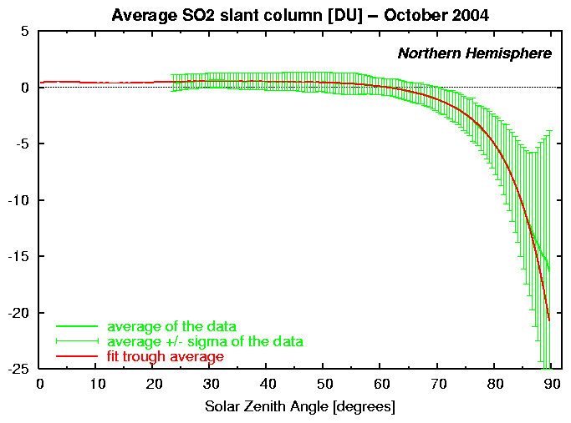
Figure 3 – The average the SO₂ slant column and the 1-sigma error on it as function of the SZA at the Northern hemisphere for October 2004 (green) and an 8-degree polynomial fit through the "average plus sigma" data (red).

The error bars in Figure 3 show that for low to medium SZA there is a "noise level" of 1 to 2 DU on the background SO₂ slant column signal. One could filter out much of that noise by way of a correction based on the "average plus sigma" values; c.f. the blue line in Figure 4. But since the background SO₂ slant column itself is of the same order, this probably filters out too much of the SO₂ signal. So for low to medium SZA the correction should be based on the average itself, as given by the left portion of the read curve in the graph above.

At high SZA, though, a correction based on the "average plus sigma" seems approprate, to compensate for the large spread in the data, although using exactly "average plus sigma" might be an overcorrection, even at very high SZA.

So in summary:

- For low SZA the background correction should be based on the average, to correct for the offset (bias) introduced by the reference spectrum.
- For high SZA it is better to have a correction closer to the "average plus sigma", to compensate for the SZA-dependent interference with the ozone absorption.

To do both corrections in one go, an SZA-dependent function is introduced for the fit: "average plus sigma*f(SZA)". This function, shown in red in the graph above, approaches the average for low SZA and is close to (but not too close to) the "average plus sigma" at very high SZA.
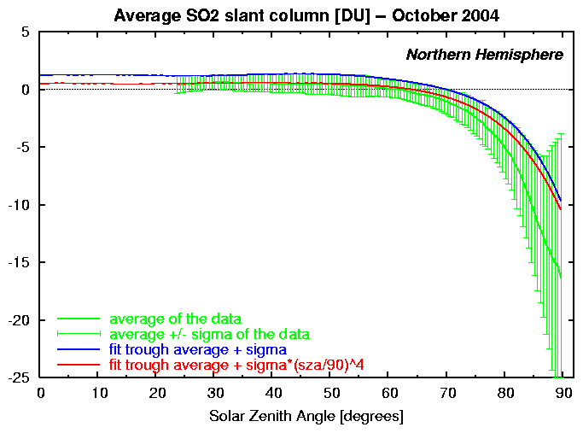
Figure 4 – The average the SO₂ slant column and the 1-sigma error on it as function of the SZA at the Northern hemisphere for October 2004 (green), an 8-degree polynomial fit through the "average plus sigma" data (blue) and a similar fit through the data using a SZA-dependent function (red).

As can be seen from Figures 2-4, the really high SZAs may still cause problems and mis-interpretation of the SO₂ slant column results. For this reason, the analysis, plotting and delivery of the data is limited to SZAs up to 85 degrees. It should be noted, however, that values between 75 and 85 degrees SZA may not be fully reliable.

In order not to pollute the average for correcting the background by including large SO₂ concentrations for real emissions, these large concentrations are omitted in the averaging. In effect this means that the averaging is done in two steps:

- An average over all data of a given month is computed, to have a first guess of the background correction.
- The average is computed again, but then only over the data points with a slant column less than 3 DU after applying the first guess background correction.

The average resulting from the second step is used for the final background correction function.

As mentioned above, there is "interference" between the SO₂ and ozone absorption, and the described background correction averages that out. But if there are large fluctuations in the ozone within one month along longitudes (in fact: along a line of equal SZA), as is often the case on the northern hemisphere in Spring, the correction does not work well. Clearly, the above described background correction needs to be improved. In some form or other the background correction should take into account the amount of ozone present in the same (slant) column.

Reference spectra for the DOAS retrieval

Both solar spectra and radiance spectra over the Indian Ocean have been used as reference in the DOAS analysis of GOME measurements. Tests showed that best results are obtained using a radiance reference spectrum. For SCIAMACHY it is – at least up till now – necessary to use a radiance reference spectrum, since the solar spectra of SCIAMACHY are insufficiently stable.

The slant column retrieval algorithm requires a reference spectrum without the presence of absorption features of the trace gas to be retrieved, since the DOAS method is based on the difference in absorption between two spectra. For the SO₂ slant column retrieval a reference spectrum without any SO₂ absorption must therefore be selected. A good geographic region to do this is around the equator above the Pacific or Indian ocean, as there are no sources of SO₂ located there. As instrument characteristics may vary over time, it is necessary to regularly update the reference spectrum with time.

For the retrieval for the SO₂ data services, a new reference spectrum is selected in principle once every month at around the middle of the month, depending on availability of the data, from a measurement south-west of the southern tip of India, at about 65 degrees East and just south of the equator.

Since the reference spectrum changes every month, the correction for the SO₂ background levels is determined for each month separately. In the off-line processing of a given month for the Archive Services, the reference spectrum and the background correction are determined from the data of that month.

Sulphur Dioxide vertical columnS

Slant column and vertical column densities

Nadir-viewing satellite based instruments, such as GOME and SCIAMACHY, measure the sunlight scattered in the atmosphere and reflected by the surface of the Earth, as function of the wavelength of the light. In other words: the instruments measure earthshine spectra. Comparing such a spectrum with the spectrum of the sunlight itself provides information on the distribution and concentration of trace gases, such as ozone and SO₂, because these gases absorb or scatter part of the incoming sunlight. Instead of using the solar spectrum for this comparison, one can also use an earthshine spectrum from a part of the atmosphere free of the trace gases under study, as is the approach in the SO₂ data services described in this document (cf. section 3.4).

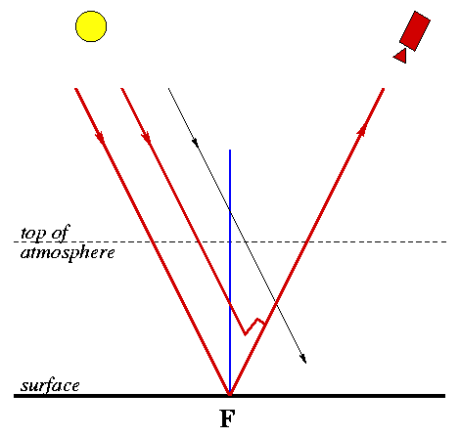
Figure 5 – Schematic representation of the slant path (thick red lines) of incoming sunlight through the earth's atmosphere to the satellite, associated with the footpoint F (the point on the earth's surface the satellite is looking at). A part of the light reaching the satellite is reflected by the earth's surface, another part is scattered higher in the atmosphere. The thick blue line represents the "vertical column" at footpoint F.

Figure 5 shows schematically the paths of sunlight reaching the satellite through the atmosphere, reflected by the earth's surface and scattered in the atmosphere. As the light follows these paths, some of the fotons are absorbed by the trace gases in the atmosphere. The spectrum of the light measured by the satellite (the sum, as it where, of the thick red lines in the graph) thus provides information on the trace gases along the entire light path. In other words, the total density of a given gas, such as SO₂, is the concentration of this gas along the entire path. This is usually called the slant column density (SCD) associated with footpoint F, the point on the earth's surface the satellite is looking at.

The SCD clearly does not provide the total concentration right above footpoint F, i.e. along the blue line in the graph. The total concentration along this line is called the vertical column density (VCD). It is this VCD that provides the most useful and directly interpretable information on the distribution and concentration of trace gases. It is therefore desirable to convert the SCD into the VCD.

As can be seen from the graph above, the VCD (along the blue line) is usually smaller than the SCD (along the red lines). The ratio between these two column densities:

AMF = SCD / VCD

is called the Air-Mass Factor. The value of the AMF depends on the length of the light path, the vertical distribution of absorbing trace gases in the atmosphere, the reflectivity (albedo) of the earth's surface, etc. The length of the light path depends on the position of the Sun (expressed in the Solar Zenith Angle, SZA) and the angle under which the satellite is looking at the atmosphere. The AMF can be pre-calculated for a variety of these quantities or computed with a chemistry transport model, and applied to the SCD to find the VCD at footpoint F.

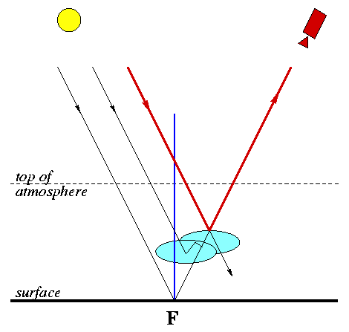
Figure 6 – Schematic representation of the slant path (thick red lines) of incoming sunlight through the earth's atmosphere to the satellite, associated with the footpoint F (the point on the earth's surface the satellite is looking at), in the presence of clouds. These clouds partly shield the satellite's view of the atmosphere above footpoint F.

If there are clouds in the atmosphere, things become more complicated. Clouds namely reflect (and scatter) incoming sunlight and thus effectively shield all that is going on below the clouds from the satellite's view; see Figure 6. Clearly, the satellite measurements provide an SCD which contains only information on the atmosphere above the clouds. To find the real VCD at footpoint F in such situations, an "effective" AMF is computed, taking the cloud fraction (which gives the percentage of the cloud cover) into account. In the presence of clouds the VCD is clearly less accurate than the VCD derived under clear-sky conditions.

There are two approaches possible to convert the SO₂ slant column density, retrieved with a DOAS technique, into a vertical column density. Both of these approaches, which are discussed briefly in the following sections, use an air-mass factor (AMF):

- The use of a radiative transfer model to determine look-up tables.
- The use of a chemistry transport model, driven by up-to-date meteorological fields.

In the SO₂ data services, the first approach will be implemented.

Air-mass factor using a radiative transfer model

The value of the AMF depends on the length of the light path, the vertical distribution of absorbing trace gas in the atmosphere, the reflectivity (albedo) of the earth's surface, etc. The length of the light path depends on the position of the Sun (expressed in the Solar Zenith Angle, SZA) and the angle under which the satellite is looking at the atmosphere. For the vertical distribution a-priori information on the SO₂ profile is used, based on realistic concentrations.

If there are clouds in the atmosphere, things become more complicated. Clouds namely reflect (and scatter) incoming sunlight and thus effectively shield all that is going on below the clouds from the satellite's view. Clearly, the satellite measurements provide an SCD which contains only information on the atmosphere above the clouds. To treat this situation, an "effective" AMF is computed, taking the cloud fraction (which gives the percentage of the cloud cover) into account. In the presence of clouds the VCD is clearly less accurate than the VCD derived under clear-sky conditions.

The AMF is pre-calculated with the radiative transfer model LIDORT in the form of a look-up table with a set of entries: the time of the year, the viewing geometry, the SZA, the surface albedo, the cloud fraction and cloud top pressure, etc. Depending on the value of the SCD of SO₂, a likely a-priori SO₂ profile is chosen and an AMF is interpolated from the look-up table.

Air-mass factor using a chemistry transport model

In this approach the retrieval of the VCD for SO₂ will be based on a combined retrieval/modelling approach, similar to the approach for some other trace gases (such as formaldehyde, HCHO). The main motivation for this new approach is to improve the accuracy of the retrieval. A chemistry-transport model (TM4), driven by high-quality meteorological fields from ECMWF, will provide best-guess profiles of SO₂, based on the latest emission inventories, atmospheric transport, photochemistry and wet/dry removal processes.

These model forecast fields will be collocated with the satellite (GOME, SCIAMACHY, OMI) observations, and the radiative transfer modelling in the retrieval will be performed based on the model trace gas profile and temperature profiles. The retrieval is coupled to cloud top height and cloud fraction retrievals derived from the satellite data, and the retrieval will be coupled to high quality albedo maps.

data product description – preliminary data set

SO₂ slant column retrieval was performed on the basis of measurements by GOME and SCIAMACHY up to mid 2004, which forms a “preliminary data set”. The adjective “preliminary” is used here to indicate that while the SO₂ slant column data itself is correct, the data:
- misses a background correction
- has no air-mass factors and vertical column data
- is presented on a very limited set of geographic regions
- is available only in the form of maps (images)
It is planned to convert this data set into the current format in the future. Until then, this chapter briefly describes the data product format of this “preliminary data set”.

GOME and SCIAMACHY slant column data

The GOME and SCIAMACHY SO₂ Level-3 Products consists of a collection of SO₂ slant column density maps (monthly, composite 3-days and daily maps) in a global projection but also in higher resolution maps over pre-defined regions known for SO₂ emission from pollution or from volcanic activity.

The maps are created from pre-calculated grids (resolution: 1° in latitude, 1° in longitude) using add-ons developed in Matlab. The length of the individual GOME and SCIAMACHY pixels and the sphericity of the earth are taken into account to distribute and weight the SO₂ Slant Columns (SO₂ SCD) in the different graticules of the grid crossed by the pixel.

Monthly maps are calculated by averaging data over a complete month; composite 3-days maps are calculated by averaging data on periods of 3 days, the minimum period necessary for GOME to achieve global coverage at the equator.

The best way to view the SO₂ maps for volcanic emissions is to look at the daily maps or the maps per 3 days, because the eruptions events are often short in duration so that a monthly average will not provide much information. For the pollution maps, it is better to look at the monthly maps, because the averaged data will contain much less noise.

The Level-3 product is available via the TEMIS website http://www.temis.nl or directly at
http://www.oma.be/BIRA-IASB/Molecules/SO2/SO2_level3.php
or by anonymous ftp (ftp.oma.be, anonymous login, in the directory dist/TEMIS/GOME/GOMESO2
and TEMIS/SCIAMACHY/SCIAMACHYSO2).

data product description – Current data set

This Chapter describes the format and presentation of the current SO₂ data set, available via the TEMIS website http://www.temis.nl or directly:
- Archive at http://www.oma.be/BIRA-IASB/Molecules/SO2archive/
- Near-real time data at http://www.oma.be/BIRA-IASB/Molecules/SO2nrt/
The current data set contains for the moment only data based on SCIAMACHY observations; other instruments will be added in the future.

Geographic regions

The SO₂ column values are presented and delivered via the website in the form of images (maps) and data files. There is no real difference between the Volcanic SO₂ and the Air Quality SO₂ Service, other than that they focus on different geographic regions. The Notification (or: Alert) Service or exceptional SO₂ concentrations of the Near-Real-Time (NRT) delivery monitors each of these regions.

The size of the regions is determined on the one hand by the wish to zoom in on sources of SO₂ emissions and on the other hand by the geographical coverage achived by the satellite instruments when passing through the region: at least one orbit should pass through a region at any day.

The regions of the two Services partly overlap one another, which means that SO₂ emissions may be detected by both Services. As the measurement itself cannot distinguish between possible sources of SO₂ anyway, this is not a big problem.

The Volcanic SO₂ Service

For the Volcanic SO₂ Service, a set of 42 geographic regions of 30 by 30 degrees covering known volcanoes has been defined – see Figure 7. On the plots of the regions shown on the website, only shows the volcanoes in that region that have erupted since the year 1800, as listed on the website of the Global Volcanism Programme (GVP).

The regions partly overlap one another, to ensure that SO₂ emissions from volcanoes near the edges of the regions are detected, whatever the wind direction.

See the ”Overview of the Volcanic SO2 Service” at the website regions for details on the regions.
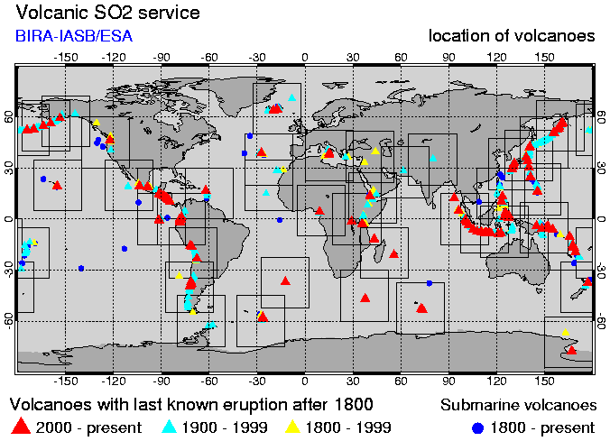
Figure 7 – Geographic regions of the Volcanic SO₂ Service.

The Air Quality SO₂ Service

For the Air Quality SO₂ Service, a set of 11 geographic regions of 40 by 40 degrees covering industrialised areas has been defined – see Figure 8.

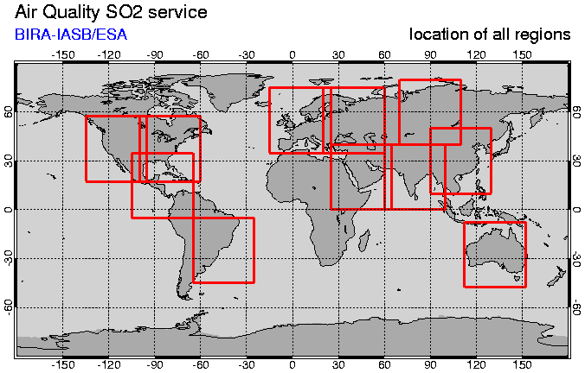
Figure 8 – Geographic regions of the Air Quality SO₂ Service.

There is no region defined for this Service over Southern America, because of the detection problems associated with the South Atlantic Anomaly.

See the “Overview of the Air Quality SO2 Service” at the website regions for details on the regions.

Data product presentation

The Service presents the data on the website in the from of global maps and higher resolution maps over pre-defined regions known for SO₂ emission from anthropogenic activity or from volcanic activity are provided as well. These maps are presented in the following ways:

- Daily data at orbit coordinates
- Daily data at grid coordinates
- Three-day composite data at grid coordinates
- Monthly average data at grid coordinates

The first one is based on the data as provided in the ASCII data files (section 6.4) and are used in both the Archive and the Near-real-time Service. The other types of maps are based on the HDF data files (section 6.5) and are used only in the Archive Service.

Daily data at orbit coordinates

This presents the SO₂ data at the coordinates of the measurements of the satellite instruments, showing only the forward scan pixels; backward scan pixels are not shown to prevent overlapping. Note that at high latitudes the forward scans of successive orbits will overlap one another, where the most recent data is plotted on top.

For SCIAMACHY pictures, at the begin and end of each nadir state the measurement time is shown in UTC; the time is not printed for states with latitudes above ±65 degrees, as orbits overlap one another there. (How showing the measurement time will be done for other instruments is to be defined.) For the Volcanic SO₂ Service, the extent of the geographic region is indicated by a thick black line.

Both the NRT and the Archive Service provides data and images for the SO₂ slant column and vertical column (if available), and where possible the cloud fraction. Each orbit has its own ASCII data file; for a given day these ASCII data files are grouped in a zip-file.

Daily data at grid coordinates

This presents the SO₂ data gridded to a latitude-longitude grid of 0.25 by 0.25 degrees (which is about 25 km at the equator). For each grid cell the average of all measurement crossing that grid cell (using forward and backward scans) is computed, using all orbit files for the given day. The result is written to one HDF data file per day.

The Archive Service provides such images for the SO₂ slant column and vertical column (if available), and where possible the cloud fraction. The Near-real-time Services does not provide this type of data.

Three-day composite data at grid coordinates

This presents the SO₂ data gridded to a latitude-longitude grid of 0.25 by 0.25 degrees. For each grid cell the average of all measurement crossing that grid cell (using forward and backward scans) is computed, using all orbit files for three days (01-03, 04-06, etc). The result is written to one HDF data file per three days.

In view of the width of the measurements (960 km), global coverage along the equator is reached in three days, hence the use of three-day composites. For GOME this is real global coverage. For SCIAMACHY there are "holes" in the orbits due to the alternation between nadir and limb measurements, and these Services can only use the nadir measurements.

The Archive Service provides data and images for the SO₂ slant column and vertical column (if available), and where possible the cloud fraction. The Near-real-time Service does not provide this type of data.

Monthly average data at grid coordinates

This presents the SO₂ data gridded to a latitude-longitude grid of 0.25 by 0.25 degrees. For each grid cell the average of all measurement crossing that grid cell (using forward and backward scans) is computed, using all orbit files for the given month. The result is written to one HDF data file per three days.

The Archive Service provides data and images for the SO₂ slant column and vertical column (if available). The Near-real-time Service does not provide this type of data.

Note that a montly average of the cloud fraction is not made: there is no cloud screening method applied to the SO₂ data, so that a monthly average cloud fraction does not provide any useful additional information.

Cloud cover fraction

As additional service to interpret the SO₂ slant (and vertical) column densities, the web pages showing images of the SO₂ data also show an image of the cloud cover fraction for the same region, taken from the same instrument. Note that currently there is no cloud screening performed on the data: all SO₂ slant column retrieval results are shown as-is.

The same cloud fraction is also used to determine the air-mass factor (AMF) when taking the AMF from look-up tables made with a radiative transfer model in order to compute the SO₂ vertical column density.

For the daily data at orbit and at grid coordinates, as well as for the 3-day composites at grid coordinates, the cloud cover fraction is presented in the same way and available in the accompanying data files. Monthly averages of the cloud fraction are not made: there is no cloud screening method applied to the SO₂ data, so that a monthly average cloud fraction does not provide any useful additional information.

The cloud fraction is a number between zero (clear-sky: no clouds) and one (fully clouded, also known as overcast). For the Volcanic & Air Quality SO₂ Services the cloud data is taken from FRESCO.

The FRESCO cloud data is either in "normal mode" or in "snow/ice mode". In the latter case, a cloud fraction of one is assumed with the cloud at ground level when determining the AMF for the SO₂ vertical column. In the datafiles, however, the cloud fraction in the "snow/ice mode" is set to '-1', and it is shown in a separate colour in the cloud fraction images.

Note that the FRESCO cloud cover data retrieval stricktly speaking is based on sunlight reflected by a combination of clouds and (reflecting) aerosols: such aerosols are effectively treated as clouds. This means that the FRESCO data product contains a (small) aerosol contribution.

Data product delivery

The SO₂ slant column data is delivered in two major forms:

- ASCII data at the coordinates of the SCIAMACHY observations, one entry per ground pixel, one level-2 file per level-1 file – this data product is generated for both the Archive and the NRT Service.
- HDF data at a rectangular latitude-longitude grid for daily data (i.e. all orbit starting at one date put together), three-day composites, and monthly averages – this data product is generated only for the Archive Service.

The format of these data files is specified in the following sections.

The data product files mention, among others, version number (see section 2.3) and the files have been given a product status, for a quick-look indication on the status of the data product.

Status | Description
NRT data | for slant column data delivered via the Near-Real-Time Service (only for ASCII data files)
Preliminary data | for data delivered via the Archive Service, either just the slant column, or including a preliminary vertical column
Archive data | for slant column and vertical column data delivered via the Archive Service

ASCII data file specifications

The daily data at coordinates of the measurements by the satellite instrument are delivered in the form of ASCII files, one for each orbit file with spectral data. Measurements of SCIAMACHY and GOME come in principle as one file per orbit, but it happens quite often that files span only a part of an orbit, or even the end of one orbit and the beginning of the next. The data files are delivered via the website as zip-files containing all orbit files of a given day.

Data file name

For a given day, the orbits treated are those orbits that have a start time during that day; this is the time mentioned in the name of the data file. The name of the SO₂ data files contains the orbit date YYYYMMDD and the start time HHMMSS, both taken from the name of the original measurement file:

so2cdYYYYMMDD_HHMMSS.dat

where so2cd stands for "SO2 column density". These files contain the SO₂ slant column data (SCD) and – if available – the SO₂ vertical column density (VCD) derived with an appropriate air-mass factor, and the cloud cover fraction. The ASCII file can also be read with many plot programs, such as IDL and MatLab.

Data file format

Each data file has a header with comment lines (starting with the # mark), giving orbit and analysis information, as well as a list of the data columns. A typical data file header for data files looks as follows. Some remarks regarding the entries in the file header are given further down.

# SO2 column density for TEMIS / PROMOTE
# --------------------------------------
#
# Product status : preliminary data
# Process version : 0.9.0
#
# Instrument : SCIAMACHY
# Orbit date/time : 20050401_115628
# Orbit number : 16138
#
# Analysis date : 2006/06/02
# Cloud cover data: FRESCO
# AMF & VCD values: no
#
# Data columns [format]
#
# --- Ground pixel data
# 1 = measurement date as YYYYMMDD [a8]
# 2 = measurement time as HHMMSS.SSS [1x,a10]
# 3 = pixel id: 0=foreward, 3=backscan [i4]
# 4-7 = pixel corner latitudes [4f9.3]
# 8 = pixel center latitude [f9.3]
# 9-12 = pixel corner longitudes [4f9.3]
# 13 = pixel center longitude [f9.3]
# 14 = solar zenith angle (SZA) at TOA [f9.3]
# 15 = viewing zenith angle (VZA) at TOA [f9.3]
# 16 = relative azimuth angle (RAA) at TOA [f9.3]
#
# --- Slant column data
# 17 = SO2 slant column density SCD (in DU) [f9.3]
# with background correction
# 18 = retrieval error on the SCD (in DU) [f9.3]
# 19 = chi^2 of the slant column fit (x 1e-6) [f9.3]
# 20 = slant column value index (SVI) [i4]
# 0 : SO2 SCD ≤ 1.5 DU
# 1 : SO2 SCD > 1.5 DU, no alert issued
# 2 : SO2 SCD > 1.5 DU, alert issued for state
#
# --- Vertical column data
# 21 = AMF quality index (AQI) [i4]
# = -1 : no AMF calculation selected
# = 0 : successful AMF calculation
# = +1 : no cloud cover data available
# > +1 : error computing AMF
# 22 = Air-mass factor AMF [f9.3]
# 23 = SO2 vertical column density VCD (in DU) [f9.3]
# 24 = Error on VCD from column 18 (in DU) [f9.3]
# 25 = AMF profile shape number (1,2,3) [i4]
#
# --- Cloud and Surface data
# 26 = cloud cover index (CCI) [i4]
# = 0 : no cloud cover data
# = 1 : clear sky mode
# = 2 : normal FRESCO mode
# = 3 : snow/ice FRESCO mode
# = 4 : missing or invalid FRESCO data
# 27 = cloud fraction [f9.3]
# 28 = cloud top pressure (in hPa) [f9.3]
# 29 = cloud top albedo (fixed value) [f9.3]
# 30 = surface pressure (in hPa) [f9.3]
# 31 = surface elevation (in m) [f9.3]
# 32 = surface albedo [f9.3]
#
# --- Additional gound pixel data
# 33 = sciamachy state_index [i4]
# 34 = sciamachy state_id [i4]
#
#
# Full data format: (a8,1x,a10,i4,16f9.3,2i4,3f9.3,2i4,6f9.3,2i4)
#
#

Which is followed by two lines spanning all columns and giving a header to each column. Then follow the data lines themselves. The very end of the file is marked by:

#
# --- end of file.

If no vertical column densities (VCDs) have been computed, then:

- the AMF & VCD values comment line near the top of the file says no (as in the above example);
- the AMF quality index (AQI) in column 21 is set to -1;
- all data entries concerning the AMF and VCD are given the "no data" value (-99).

If no cloud cover information has been included, then:

- the Cloud cover data comment line near the top of the file says none ;
- the cloud cover index (CCI) in column 26 is set to 0;
- all data entries concerning the cloud cover, the AMF and VCD are given the "no data" value (-99).

and no AMFs or VCDs can be computed.

Remarks

- On the right of the list of data columns and below the list is the format with which the data can be read in the notation used, for example, in Fortran and IDL.
- Column 3 gives the type of ground pixel. For SCIAMACHY data there is only a distiction between forward and backward scan pixels. For GOME data the forward pixels pixels come in three types, for which the number 0, 1 and 2 are used.
- The zenith and azimuth angles (columns 14, 15 and 16) are given at the top-of-atmosphere (TOA) for the centre of the ground pixel.
- The error value given in column 18 is the error following from the DOAS slant column retrieval. Its value is based on the RMS of the fit between the measured and the fitted spectrum. The chi-square in column 20 is also a measure of the quality of the fit. In fact, these three quantities are all interlinked: chi-square = RMS * RMS, and the relationship between the slant column error and the RMS is assumed to be linear. To assist data users in their analysis, both the slant column error and the chi-square are written to the data file.
- The "slant column value index" (SVI) in column 20 is meant to give the user a quick look facility on the SO₂ slant column value. For more information, see the chapter on the criteria for the notifications on exceptional SO₂ concentrations.
- If an AMF and VCD have been computed, the "AMF quality index" (AQI) in column 21 indicates success of the AMF computation. If an AMF could be calculated, then a VCD = SCD/AMF is given. The relevant AQI values are listed in the file header; more details are given in the next subsection.
- If cloud cover data is included, the "cloud cover index (CCI)" in column 26 indicates success of this inclusion. The relevant CCI values are listed in the file header; some more details are given in the next subsection.
- Data fields for which no value was (successfully) computed are given the "no data" value -99.

Data flags in the ASCII data file

The ASCII data files of the SO₂ service contain some flags (see section 6.4.2):

- AMF quality index (AQI)
- Cloud cover index (CCI)

The meaning of the values of these flags is listed below.

AMF quality index (AQI)

The AMF quality index (AQI) flags the determination of

- data needed by the AMF, such as surface height, surface albedo and geometrical AMF
- the actual AMF computation

AQI | Description | Allowed range
main flags
-1 | no AMF computation wanted  ===> only step 'a' mentioned above is performed | --
0 | computation of AMF successful | --
initialisation errors
1 | No cloud cover information available  ===> no match with FRESCO data found, or insufficient data available (this combines with CCI = 4; see below) | --
2 | Error in surface height array indexing | --
3 | Error in surface albedo array indexing | --
error computing geometrical AMF
4 | Solar zenith angle out of range  ===> should never occur, as the analysis limits the pixels to SZA ≤ 85 deg | 0. ≤ solZen < 88.
5 | Viewing zenith angle out of range  ===> it is unlikely that this will occur | abs(viewZen) < 40.
error computing cloud radiance weight
6 | Error in wavelength | 300. ≤ wavelNm ≤ 3000.
7 | Error in surface pressure | 200. ≤ pSfc ≤ 1500.
8 | Error in cloud-top pressure | 10. ≤ pCld ≤ 1500.
9 | Error in surface albedo | 0. ≤ aSfc ≤ 1.
10 | Error in cloud albedo | 0. ≤ aSfc ≤ 1.
11 | Error in mu0 = cos(solZen) | 0. ≤ mu0 ≤ 1.
12 | Error in mu = cos(abs(viewZen)) | 0. ≤ mu ≤ 1.
13 | Error in relative azimuth angle | 0. ≤ dphi ≤ 180.
14 | Error in cloud fraction | 0. ≤ c ≤ 1.
15 | Error in loop over pressure | --
16 | Error in radiance weight | 0. ≤ radWeight ≤ 1.
error computing clear-sky and cloudy SO2 AMF
17 | Error in interpolation for clear-sky AMF | --
18 | Error in interpolation for cloudy AMF | --
Notes:
- Flags 2, 3 and 6 - 18 should not occur; if any of these does occur, something is wrong in the code.
- Flags 6 - 18 cannot occur if no AMF computation is wanted (i.e. if only step 'a' is performed).

Cloud cover index (CCI)

This flags the cloud cover data used.

CCI | Description
0 | no cloud cover data
1 | clear sky mode  ===> the cloud-top pressure set to 1013.0 hPa, the value used internally for the sea-level pressure, and the cloud fraction is set to 0.0
2 | normal FRESCO mode
3 | snow/ice FRESCO mode  ===> for the AMF calculation the cloud fraction is set to +1 and the cloud-top pressure is set to the surface pressure; in the output the cloud fraction is set to -1.0
4 | missing or invalid FRESCO data  ===> if the AMF is calculated, this combines with AQI = 1 (see above)

Two adjustments are made to the FRESCO data without any warning or flagging:

- If the cloud fraction is < 0.05, the cloud-top pressure is set to 800.0 hPa, as is done in other applications.
- The cloud-top pressure is made to lie in this range:
minimum pressure ≤ cloud-top pressure ≤ surface pressure
where the surface pressure depends on the coordinates and the minimum pressure is given by the
AMF look-up table (which currently is 372.42 hPa).

HDF data file specifications

HDF data files provied at a rectangular latitude-longitude grid for daily data (i.e. all orbit starting at one date put together), three-day composites, and monthly averages. For the moment the spacing of the latitude-longitude grid is 0.25 by 0.25 degrees.

Data file name

The name of the HDF file depends on the data period covered by the file and is constructed as follows:

so2cdYYYYMMDD.hdf | File with data for a single day; the name contains the orbit date YYYYMMDD
so2cdYYYYMMDFDL.hdf | File with data for a 3-day composite; the name contains the year, the month and the first (DF) and last (DL) day  Here: DFDL = 0103, 0406, 0709, ...., 2527, for February followed by 2828 or 2829, for other months followed by 2830 and 3131 if the month has 31 days
so2cdYYYYMM.hdf | File with data for a monthly average; the name contains the year and month

Data file format

Simply said, an HDF file has the following structure:

- File header, with the file attributes – these specify the product name, data, version, units, etc.
- Data sets:
  - SO₂ slant column field
  - Error in the slant column field – from the slant column retrieval
  - SO₂ vertical column field
  - Error in the vertical column field – from the slant column error
  - Cloud cover fraction

If the SO₂ vertical column is not available, data sets 3 and 4 are missing. If the cloud cover fraction is not available, data set 5 is missing.

The following table gives as an example the header of the HDF file of the daily slant column data of 10 December 2005.

Global Attribute | Type | Value
Product | string | SO2 slant column [DU]
Data_version | string | 0.9.0
Creation_date | string | 24 May 2006
Product_status | string | preliminary
SO2_field_date_1 | integer | 2004, 12, 10
SO2_field_date_2 | integer | 2004, 12, 10
Data_begin | integer | 2004, 12, 10, 2, 19, 54
Data_end | integer | 2004, 12, 11, 0, 54, 56
Date_format | string | year, month, day, hour, minute, second (UTC)
Instrument | string | SCIAMACHY (ENVISAT)
Cloud_fraction | string | Taken from FRESCO (made by KNMI)
Authors | string | Jos van Geffen & Michel Van Roozendael
Affiliation | string | BIRA-IASB (Belgian Institute for Space Aeronomy)
E-mail | string | Jos.VanGeffen@bira-iasb.be &  Michel.VanRoozendael@bira-iasb.be
Number_of_longitudes | integer | 11440
Longitude_range | real | -179.875, 179.875
Longitude_step | real | 0.25
Number_of_latitudes | integer | 720
Latitude_range | real | -89.875, 89.875
Latitude_step | real | 0.25
Iscd_field | string | SO2 slant column = Iscd_field/1000 [DU]
Iscd_error | string | Error on SO2 slant column = Iscd_error/1000 [DU]
Iccf_field | string | Cloud cover fraction = Iccf_field/1000 [-]
No_data | string | Entries with -99.0 DU represent "no data"
Product_code | string | ssfdap
Data set | Type | Rank → dimensions
Iscd_field | integer | 2 → 1440 x 720
Iscd_error | integer | 2 → 1440 x 720
Iccf_field | integer | 2 → 1440 x 720

Remarks regarding some of the attributes in the file header:

Product
This attribute gives so to say the title of the product. In the example it says that the file has SO₂ slant column data for one day.
- For 3-day composites " – 3-day composite" is added.
- For monthly averages " – monthly average" is added.
- ... etc.
If the file contains slant column as well as vertical column densities, the main title is "SO₂ column densities [DU]".

Data_version
The coding for this is described in section 2.3.

Product_status
This can be "preliminary" or "archive".

SO2_field_date_1 & SO2_field_date_2
These two attributes give the period for which the data applies in whole days (UTC). In the example above this is one day; for longer time periods they give the first and last day.

Data_begin & Data_end
These two give the date and time of the very first and the very last measurement included in making the gridded data.
Measurements of SCIAMACHY and GOME come in principle in files at one file per orbit. The data included is from al data files which have a start time in the given period. The last orbit of a given day can, of course, continue into the next day. In that case "Data_end" shows the beginning of the next day, as in the above example.

Cloud_fraction
If no cloud cover fraction is included, the value of this attribute is "None included" and there is no 'ccf' data set.

Longitude & latitude ranges and steps
These are given in degrees, with negative values for West longitudes.

Product code
This is for internal use, to ease post-processing.

Data sets
The above example is for a file which contains the slant column density and the cloud cover fraction, with 'scd' and 'ccf' in the name of the data set. Files with also vertical column densities have two extra data sets, with 'vcd' in the name of the data set (e.g. "Ivcd_field"), given between the 'scd' and 'ccf' data sets.
Note that the error values given in the HDF files are an average over the error values given in the orbit data files; they include no "standard deviation" of the averaging itself.

Known issues

This section describes some issues to keep in mind when using the data products, in addition to the remarks made above.

South Atlantic Anomaly

The Van Allen radiation belts are doughnut-shaped regions of high-energy charged particles trapped by the earth's magnetic field. The inner radiation belt, discovered by James Van Allen in 1958 with the Explorer 1 and 3 missions of NASA, occupies a relatively compact region above the equator roughly between 40 degrees north and south.

The earth's magnetic dipole field is offset from its centre by about 500 km. As a result of this, the inner Van Allen belt is on one side closer to the earth's surface. This region is named the South Atlantic Anomaly (SAA) and it covers a part of South America and the southern Atlantic Ocean: it lies roughly between latitudes 5 and 40 degrees South, and between longitudes 0 and 80 degrees West -- the precise strength, shape and size of the SAA varies with the seasons.

This dip in the earth's magnetic field allows charged particles and cosmic rays to reach lower into the atmosphere. Low-orbiting satellites, such as ERS-2 and ENVISAT, pass daily through the inner radiation belt in the SAA-region. Upon passing the inner belt, charged particles may impact on the detector, causing higher-than-normal radiance values, which in turn decreases the quality of the measurements (i.e. the signal-to-noise ration, of earthshine spectra), notably in the UV.

This reduction of the signal-to-noise also affects the retrieval of SO₂ slant columns: in the SAA region the variation in slant column values is much higher than elsewhere. This shows up clearly, for example, in the monthly average. The decreased signal-to-noise may result in artifacts in the SO₂ slant columns.

Because of these artifacts in the SO₂ data, neither the Volcanic SO₂ nor the Air Quality SO₂ Service has a geographic region defined in the area of the South Atlantic Anomaly for which plots are made and shown on the website. To benefit the analysis and to help avoid issuing false notifications of an exceptional SO2 concentration due to the SAA, a "dummy region" of 40 by 40 degrees, centred around (-45.0,-25.0), is defined and monitored hidden from data users. This "SAA-region" overlaps with regions "Northern Chile" and "Central Chile" of the Volcanic SO₂ Service. As the following picture show, the "SAA-region" covers only the central part of the SAA, but for the moment this seems good enough.

near-real time and alert service

On 27 September 2006 the near-real-time processing of SO₂ slant column data based on SCIAMACHY observations for both the Volcanic & Air Quality Services was made available. Links to these data sets are given above. The system to send notifications (or: alerts) of exceptional SO₂ concentrations by email is not yet available.

This NRT service provides data and images to the website. For this service, only data files and images with the data on satellite orbit coordinates are provided. The software processes incoming SCIAMACHY level-1 files in near-real-time. On a given day, the processing will involve only measurements of that day and the day before: processing older data is not very useful for the notification system. By far most SCIAMACHY orbits are processed within about 5 hours after observation.

Near-real time processing of SO₂

Most aspects of the NRT processing of SO₂ slant and vertical columns are the same as those for the Archive service, and are described in the preceeding chapters. The following lists a few things that are (in some cases necessarily) different from the processing for the Archive.

Reference spectrum and background correction

For the near-real-time SO₂ processing, selecting a reference spectrum from the current month is, of course, not possible. For that reason the NRT service uses the reference spectrum from the most recent month for which the offset has been determined.

The ozone distribution can vary considerably from month to month, and therefore the SZA-dependent interference with the ozone absorption varies from month to month. Hence, it is not a good idea to use the correction for this from one or two months ago. Instead, it is better to use the SZA-dependent part of the correction from the same month one year ago: the ozone distribution does not vary too much on a yearly basis.

Once all data of the month is alvailable, the month is reprocessed for the off-line Archive Service, using an appropriate reference spectrum and background correction.

Monitoring of the near-real time processing

The processing is currently done at BIRA-IASB. The service is run on a best-effort basis, without much process monitoring, as the service is still in an experimental stage.

At a later stage, the processing may be transferred to KNMI, where process monitoring can be done more rigorously. It is expected that running the processing at KNMI will also make the data a little faster available.

Criteria for exceptional SO₂ concentrations

The near-real-time processing will issue a notification of exceptional SO₂ concentrations by email to users and other interested parties.

[To be described]

References

Aliwell, S.R., Van Roozendael, M., Johnston, P.V., Richter, A., Wagner, T., et al.: "Analysis for BrO in zenith-sky spectra - An intercomparison exercise for analysis improvement," J. Geophys. Res., 107, D140, doi:10.1029/2001JD000329, 2002.

Bogumil, K., Orphal, J. and Burrows, J.P.: 2002, "Temperature dependent absorption cross sections of O3, NO2, and other atmospheric trace gases measured with the SCIAMACHY spectrometer," in Looking down to Earth in the New Millennium, Proceedings of the ERS-ENVISAT Symposium, 16-20 October 2000, Gothenburg, Sweden, ESA publication SP-461 (CD-ROM).

Burrows, J.P., et al.: GOME FM data set, not published.

Burrows, J.P., Dehn, A., Deters, B., Himmelmann, S., Richter, A., Voigt, S. and Orphal, J.: “Atmospheric Remote Sensing Reference Data from GOME: 1. Temperature-Dependent Absorption Cross Sections of NO₂ in the 231-794 nm Range", JQSRT, 60, pp. 1025-…, 1998.

Burrows, J.P., Richter, A., Dehn, A., Deters, B, Himmelmann, S, Voigt, S, and Orphal, J.: “Atmospheric Remote Sensing Reference Data from GOME: 2. Temperature-Dependent Absorption Cross Sections of O3 in the 231-794 nm Range,” JQSRT, 61, pp. 509-517, 1999.

Chance, K. and Spurr R.J.D.: “Ring effect studies: Rayleigh Scattering, including molecular parameters for Rotational Raman Scattering, and the Fraunhofer Spectrum,” Appl. Opt., 36, pp. 5224-5230, 1997.

Eisinger, M. and Burrows, J.P.: “Tropospheric Sulphur Dioxide observed by the ERS-2 GOME Instrument,” Geophys. Res. Lett., No. 25, pp. 4177-4180, 1998.

Fayt, C. and Van Roozendael, M.:WinDOAS 2.1 Software User Manual, 2001,
http://www.oma.be/BIRA-IASB/Molecules/BrO/WinDOAS-SUM-210b.pdf.

Hofmann, D.J., Bonasoni, P., De Mazière, M., Evangelisti, F., Francois, P., Giovanelli, G., Goldman, A., Goutail, F., Harder, J., Jakoubek, R., Johnston, P., Kerr, J., McElroy, T., McKenzie, R., Mount, G., Pommereau, J.-P., Simon, P., Solomon, S., Stutz, J., Thomas, A., Van Roozendael, M., and Wu, E.: ”Intercomparison of UV/Visible Spectrometers for Measurements of Stratospheric NO2 for the Network for the Detection of Stratospheric Change,” J. Geophys. Res., 100, 16,765-16,791, 1995.

Platt, U.: “Differential optical absorption spectroscopy (DOAS), Air monitoring by Spectroscopic Techniques (M. Sigrist, ed.)”, John Wiley & Sons, Inc., pp. 27–84, 1994.

Roscoe, H.K., Johnston, P.V., Van Roozendael, M., Richter, A., Roscoe, J., et al.: "Slant column measurements of O3 and NO2 during the NDSC intercomparison of zenith-sky UV-visible spectrometers in June 1996," J. Atmos. Chem., 32, pp. 281-314, 1999.

Vountas, M., Rozanov, V.V. and Burrows, J.P.: “Ring effect: Impact of Rotational Raman Scattering on Radiative Transfer in Earth’s Atmosphere,” JQSRT, 60, pp. 943-961, 1998.

Text taken from the introductory chapter of the Service Report of the Air Pollution Monitoring Service [AD-5].
Text taken from the introductory chapter of the Service Report of the Support to Aviation Control Service [AD-6].
Text taken from Section 4.1.1 of the Service Report of the Air Pollution Monitoring Service [AD-5].

