DOCUMENT TYPE: Service Implementation Document

TITLE:

Service Report

Air Pollution Monitoring

DOCUMENT STATUS SHEET
Issue | Date | Modified Items / Reason for Change
1.0 | 03.06.03 | First Version, includes description FRESCO
1.1 | 29.10.03 | Description aerosol (chapter 10) added
1.2 | 05.11.03 | Description NO2, SO2 and ozone added
1.3 | 22.01.04 | Correction FRESCO format description table
1.4 | 04.05.04 | Corrected format description of tropical tropospheric ozone data
1.5 | 10.11.04 | Correction FRESCO format description table  Including of global tropospheric ozone section
1.6 | 26.11.04 | Section on regional NO2 added
1.7 | 01.03.05 | Section on regional aerosol added
1.8 | 29.11.06 | Section 8 on SO2 updated  Minor corrections to sections 1.1, 4.1.1
TABLE OF CONTENTS
1. Introduction 5
1.1 Purpose and scope 5
1.2 Document overview 5
1.3 Definitions, acronyms and abbreviations 5
1.4 Applicable Documents 6
2. Air pollution Monitoring service 8
3. FRESCO 9
3.1 Description of method and implementation 9
3.1.1 Retrieval method 9
3.1.2 Treatment of snow covered surfaces 11
3.1.3 References 12
3.2 Detailed product description 13
4. GloBAL NO2 15
4.1 Description of method and implementation 15
4.1.1 Retrieval method slant columns 16
4.1.2 Retrieval method tropospheric columns 18
4.1.3 Error analysis 20
4.1.4 Averaging kernels 21
4.1.5 References 21
4.2 Detailed product description 23
5. Regional NO2 26
5.1 Description of method and implementation 27
5.1.1 Trajectory calculation and source region visualisation 27
5.1.2 DOAS Method 29
5.1.3 Interpretation of satellite data 30
5.2 Detailed product description 35
5.2.1 Image of satellite data within the region of interest 35
5.2.2 Gridded GOME/SCIAMACHY data 35
5.2.3 Trajectory plots of potential source regions 36
5.2.4 NO2 PBL column in the Bologna area 37
5.3 References 37
6. Tropical Ozone 39
6.1 Introduction 39
6.2 Description of method and implementation 39
6.2.1 Retrieving total ozone from GOME measurements 39
6.2.2 Implementation of the FRESCO cloud algorithm 41
6.2.3 GOME-CCD method 41
6.2.4 GOME retrieval efficiency 43
6.2.5 References 44
6.3 Detailed product description 46
7. Global Tropospheric Ozone 47
7.1 Description of method and implementation 47
7.1.1 Ozone retrieval 47
7.1.2 Chemical data assimilation 47
7.1.3 Tropospheric products 48
7.1.4 References 48
7.2 Detailed product description 48
8. Sulphur Dioxide 49
8.1 Introduction 49
8.2 SO₂ data and the Air Pollution Monitoring Service 49
9. Aerosol from ATSR-2 and AATSR 51
9.1 Introduction 51
9.2 Description of method and implementation 51
9.3 Detailed product description 52
9.4 References 53
10. Aerosol from GOME and Sciamachy 54
10.1 Description of method and implementation 54
10.1.1 Level 1 Data pre-processing 54
10.1.2 Aerosol clear sky retrieval method over ocean 55
10.1.3 Aerosol retrieval methods over dark vegetation surface using SCIAMACHY 56
10.1.4 References 57
10.2 Detailed product description 58
10.2.1 Global Aerosol Level 2 Product 58
10.2.2 Global Aerosol Level 3 Product 58

Introduction

Purpose and scope
The Data User Programme (DUP) is an optional programme of ESA which aims at supporting Industry, Research Laboratories, User Communities as well as European and National Decision Makers to bridge the gap that exists between research at the level of pilot projects and the operational and sustainable provision of Earth Observation products at information level.

TEMIS is a project (started September 2001) in response to an Invitation To Tender from ESA in the context of ESA's Data User Programme. The aim of the project is the delivery of tropospheric trace gas concentrations, and aerosol and UV products, derived from observations of the nadir-viewing satellite instruments GOME and SCIAMACHY.

This document contains the specifications of the products for TEMIS the “Air Pollution Monitoring” and “Support to Aviation Control”. The current version is part of the final deliverables of the implementation phase of TEMIS.

Document overview
Section 1 contains the introduction and applicable documents. Section 2 presents an overview of the service and section 3 to 10 give detailed descriptions of the algorithms and products of the service.

Definitions, acronyms and abbreviations

AMF | Air-Mass Factor
AOD | Aerosol Optical Depth
ATSR | Along Track Scanning Radiometer
AATSR | Advanced Along Track Scanning Radiometer
ASCAR | Algorithm Survey and Critical Analysis Report
BIRA-IASB | Belgian Institute for Space Aeronomy
BrO | Bromine Oxide
CCD | Convective Cloud Differential
CH₂O | Formaldehyde
CH₄ | Methane
CO | Carbon Monoxide
DLR | German Aerospace Centre
DOAS | Differential Optical Absorption Spectrometry
DUP | Data User Programme
ENVISAT | Environmental Satellite
ERS | European Remote Sensing Satellite
ESA | European Space Agency
ESRIN | European Space Research Institute
EUMETSAT | European Organisation for the Exploitation of Meteorological Satellites
FD | Fast Delivery service
FRESCO | Fast Retrieval Scheme for Cloud Observables
GOFAP | GOME Ozone Fast Delivery and value-Added Products
GOME | Global Ozone Monitoring Instrument
ISAC | Institute of Atmospheric and Climate Sciences (formerly ISAO)
ISCCP | International Satellite Cloud Climatology Project
KNMI | Royal Netherlands Meteorological Institute
LIDORT | Linearized Discrete Ordinate RTM
LUT | Look-Up Table
METEOSAT | Meteorological Satellite
NDSC | Network for the Detection of Stratospheric Change
NO | Nitrogen Oxide
NO₂ | Nitrogen Dioxide
NO_{x} | Nitrogen Oxides (NO+NO₂)
NOAA | National Oceanic and Atmospheric Administration
NRT | Near-Real Time
O₃ | Ozone
OClO | Chlorine Dioxide
PROMOTE | Protocol Monitoring for the GMES Service Element: Atmosphere
PSD | Product Specification Document
RIVM | National Institute of Public Health and the Environment
RTM | Radiative Transfer Model
SCIAMACHY | SCanning Imaging Absorption spectroMeter for Atmospheric CartograpHY
SDD | Service Definition Document
SDP | Service Development Plan
SO₂ | Sulphur Dioxide
SR | Service Report
TBC | To Be Confirmed
TBD | To Be Defined
TEMIS | Tropospheric Emission Monitoring Internet Service
TOA | Top Of Atmosphere
TOMS | Total Ozone Mapping Spectrometer
URD | User Requirements Document
USD | User Specification Document
UV | Ultra Violet

Applicable Documents

AD-1 | Data User Programme II period 1st call For Proposal ref:EEM-AEP/DUP/CFP2001
AD-2 | User Specification Document, v1.4, TEM/USD/005, May 2002
AD-3 | User Requirement Document, v2.0, TEM/URD/006, October 2002
AD-4 | Algorithm Survey and Critical Analysis Report, v1.2, TEM/ASCAR/003, May 2002
AD-5 | Service Report Air Pollution Monitoring, v1.8, TEM/SR2/001, Nov. 2006
AD-6 | Service Report Support to Aviation Control, v1.0, TEM/SR4/001, Nov. 2006
AD-7 | Sulphur Dioxide Monitoring within TEMIS, v0.9, TEM/SO2/001, Nov. 2006

Air pollution Monitoring service

Air pollution has become a global issue. Much of the anthropogenic air pollutants travel over long distances, thus affecting areas far from the emission sources. Air pollution is related to the large-scale fossil-fuel combustion and fossil-fuel related activities, but also to biomass burning and changes in land use, and it affects human health and damages flora and fauna.

To assist in monitoring of air pollution, the TEMIS project aims to supply tropospheric concentrations of the most important pollutants, in the form of global maps and concentrations at user-defined locations.
The products will be used for warning to the general public, scientific research and reporting to government or international environmental agencies.

The service supplies tropospheric products of the following trace gases :
- Ozone (O₃), which is a toxic gas caused by biomass burning and industrial smog. In the troposphere it also acts as greenhouse gas.
- Nitrogen dioxide (NO₂), which is a direct indicator of anthropogenic pollution emitted by traffic and industry. NO₂ is also a key gas in tropospheric chemistry.
- Sulphur dioxide (SO₂), which enters the atmosphere as a result of both natural phenomena and anthropogenic activities. Emission sources are combustion of fossil fuels, oxidation of organic material in soils, volcanic eruptions, and biomass burning. Coal and oil burning are the largest man-made sources of sulphur dioxide accounting for more than 75% of annual global emissions.
- Formaldehyde (CH₂O), which enters the troposphere as a result of isoprene emissions and biomass burning chemistry.
- Aerosols, which have a wide range of origins, natural (e.g. desert dust, sea spray) as well as anthropogenic (e.g. soot, industrial pollution).

In addition to these products, cloud information has been retrieved from GOME and SCIAMACHY with the FRESCO algorithm. These cloud information is important as input for most of the algorithms in this service, but it will also be presented to users within this service.

The data products, images and reading routines can be found on the web-site http://www.temis.nl. The validation of these products is presented in the Service Quality Assessment Report.

FRESCO

Description of method and implementation
Clouds influence the depth of gaseous absorption lines, particularly if the trace-gas concentration is high in the troposphere. Therefore, for accurate trace-gas column density retrievals, the presence of clouds must be taken into account. This can be done by exploiting cloud properties derived from the O₂ A band measurements from Sciamachy. The most important cloud parameters needed to correct trace-gas column density retrievals for the presence of clouds are cloud fraction, cloud optical thickness and cloud top pressure [Koelemeijer and Stammes, 1999]. However, it is almost impossible to derive uniquely both cloud fraction and cloud optical thickness from the measured spectral reflectivity of a single Sciamachy pixel. This is because cloudy scenes with the same cloud top pressure may possess different cloud fractions and cloud optical thicknesses, which give rise to nearly the same reflectivity in and around the oxygen A band. For cloudy scenes differing in this sense, however, cloud effects on the ozone column density retrieval are almost the same. Therefore, it is useful and necessary to introduce an effective cloud fraction, which is the cloud fraction derived from the satellite measurements, assuming an a priori chosen cloud optical thickness or cloud albedo. Then, the most relevant cloud parameters for trace-gas column density retrieval reduce to effective cloud fraction and cloud top pressure. Alternatively, separation of cloud fraction and cloud optical thickness could be done using PMD information, although ambiguity remains to some extent in that approach too.

The FRESCO method was originally developed for near-real-time ozone column retrieval from GOME [Piters et al., 1999]. The FRESCO method for GOME is described in the following papers. In [Koelemeijer et al., 2001], the FRESCO method is described together with a sensitivity study and validation using ATSR-2 data. In [Koelemeijer et al., 2002], a comparison is made between cloud top pressures and effective cloud fractions of FRESCO and ISCCP on a monthly average basis. The reader is referred to these papers for a general description of the method and validation. Here an overview of FRESCO is given and several improvements are described.

Retrieval method
Information on cloud top pressure and effective cloud fraction is derived from the reflectivity R in and around the oxygen A band. The reflectivity is given by

$R(λ)=\frac{πI(λ)}{μ_{0}E_{0}(λ)}$, (1)

where I is the Earth's reflected radiance [Wm⁻²nm⁻¹sr⁻¹] measured by Sciamachy, E₀ the incident solar irradiance at the top of the atmosphere through a horizontal surface unit [Wm⁻²nm⁻¹] measured by Sciamachy, and μ₀ the cosine of the solar zenith angle. Due to instrument temperature variations in orbit, the wavelength-grid of the radiances and irradiances may be different for different measurements. Therefore, to calculate the reflectivity, the measurements of I(λ) and E₀(λ) are interpolated to a common grid, the so-called reference wavelength grid, which is also used in the simulations. The reference wavelength grid was taken from the TNO-TPD OPTEC-5 calibration data. If temperature variations are shown to give rise to significant wavelength variations in orbit, multiple reference wavelength grids could be used for the simulations, and the wavelength grid closest to the actual measurements could be used for a particular retrieval.

To simulate the spectrum of a partly cloudy pixel, a simple atmospheric transmission model is used, in which the atmosphere above the ground surface (for the clear part of the pixel) or cloud (for the cloudy part of the pixel) is treated as a purely absorbing, non-scattering, medium. Reflection occurs only at the surface or cloud top. The surface is assumed to be Lambertian, the cloud is assumed to reflect either Lambertian or with a BRDF based on Doubling-Adding and Mie calculations. The reflectivity R(λ; θ; θ₀) at a wavelength λ, for a viewing zenith angle θ, and a solar zenith angle θ₀ is then given by

R(λ; θ; θ₀) = (1 - c ) T(λ; z_{s}; θ; θ₀) A_{s} + c T(λ; z_{c}; θ; θ₀) A_{c}; (2)

where c is the effective cloud fraction, z_{s} the surface height, A_{s} the surface albedo, z_{c} the cloud top height, and A_{c} the cloud albedo. T(λ; z; θ; θ₀) is the direct atmospheric transmittance for light entering the atmosphere from the solar direction, propagating down to a level with height z, and then propagating to the top of the atmosphere in the direction of the satellite. The transmittance calculations were performed in two steps. First, based on spectroscopic parameters from the HITRAN'96 database [Gamache et al., 1998], oxygen A band absorption cross sections were calculated, which yielded line-by-line transmittances. Second, the line-by-line transmittances were convoluted with the Sciamachy slit function (TNO-TPD OPTEC-5 data). In the transmittance calculations the effect of the Earth's sphericity is taken into account. Temperature and pressure profiles were assumed for a mid-latitude summer atmosphere [Anderson et al., 1986].

The surface height, surface albedo, and cloud albedo have been chosen a priori. The surface height is taken from the GTOPO30 database (made by the U.S. Geological Survey's EROS Data Center in Sioux Falls, South Dakota), downgraded to 0.5ºx0.5º resolution. The surface albedo is deduced from a global surface Lambert-equivalent reflectivity (LER) database that was generated from GOME data of June 1995 - December 2000. This database was generated as follows. For each GOME measurement the LER was determined, using the Doubling-Adding KNMI radiative transfer code [De Haan et al., 1987; Stammes, 2000]. The LER is the calculated Lambertian surface albedo required to match the observed reflectivity at the top of the atmosphere, assuming a Rayleigh scattering atmosphere. The LERs were binned by month and in grid-cells of 1 by 1 degree. The LER of the surface was then determined as the minimum LER in each grid-cell and each month. Effects of persistent clouds over ocean were corrected by replacing the values in such grid-cells by a weighted average of adjacent grid-cells. The spectral dependence of the surface LER is taken into account by linearly interpolating surface LER values at 758 and 772 nm. The cloud albedo is fixed to 0.8; only when the measured reflectivity outside the oxygen A band exceeds this value, the measured value outside the band is used as cloud albedo. It is important to stress that the effective cloud fraction derived using FRESCO thus pertains to an optically thick cloud (the cloud optical thickness that pertains to a spherical albedo of 0.8 is ~33). The choice for a cloud albedo of 0.8 is based on several considerations. First, the choice A_{c}=0.8 is optimized for ozone air mass factor calculations in the UV, when a ghost-column is added to the derived vertical column density to correct for ozone below the cloud. Second, in the FRESCO method we assume that absorption below the cloud may be neglected, which can be justified for optically thick clouds. Choosing a high cloud albedo ensures that the model assumptions are internally consistent.

The depth of the oxygen A band depends on the absorption optical thickness, above the cloud, which is linear in cloud top pressure. However, for practical reasons, the height z is used rather than the pressure P as the height variable in the model simulations and retrieval. Since the pressure-height relation in the model is generally different than in the real atmosphere, the retrieved cloud top height is converted back to cloud top pressure using the same atmospheric profile as was used in the simulations to yield the correct cloud top pressure. In FRESCO, a polynomial expansion is used to describe the height dependence of the transmission T

$T(λ,z,θ,θ_{0})=\sum_{i=1}^{N}{α_{i}(λ,θ,θ_{0})z^{i}}$, (3)

where N = 4 was chosen to give negligible interpolation errors. The advantages of this approach are that (1) the LUTs can be much smaller, and (2) the derivative of the reflectivity with respect to height can be obtained analytically (useful for Levenberg-Marquart fitting). Currently, in FRESCO, three ~1-nm-wide wavelength windows are used, namely, 758-759 nm (continuum, no absorption), 760-761 nm (strong absorption), and 765-766 nm (moderate absorption). Each window comprises five Sciamachy wavelengths. It is important to note that the reflectivities in these three wavelength windows contain nearly all independent information that is available in the O₂ A band for instruments with the spectral resolution of GOME and Sciamachy [Kollewe et al., 1992]. With minor modifications, however, it is possible to use the whole spectrum in the 758-772 nm range. The retrieval method is based on minimizing the difference between a measured and a simulated spectrum, using the Levenberg-Marquart method,

$χ^{2}=\sum_{i=1}^{N}{{\left[\frac{R_{\text{meas}}(λ_{i})−R_{\text{sim}}(λ_{i})}{ε(λ_{i})}\right]}^{2}}$, (4)

where ε = ε_{meas} + ε_{sim} is the sum of the measurement and simulation errors, respectively. The summation is over the measurement points used by FRESCO in the wavelength interval between 758 and 766 nm, which comprises N=15 wavelengths. The free parameters in the fit are the effective cloud fraction and cloud top height. The errors are calculated as the square root of the diagonal elements of the covariance matrix. The cloud top pressure error is determined as ΔP=max( |P_{c}-P(z_{c} - Δz)|,|P_{c}-P(z_{c} + Δz)| ), with Δz the error in cloud top height.

Treatment of snow covered surfaces
It can easily be shown that the derived effective cloud fraction becomes very sensitive to errors in A_{s} when A_{s} approaches A_{c}, which may occur for surfaces covered by snow. Hence, in that case it is almost impossible to accurately derive an effective cloud fraction (and hence cloud top pressure). Therefore, the measurements are then fitted to the function

R_{sim}(λ) = T(λ; z; μ; μ₀) A, (5)

and solving for A and z, which are the albedo and height of the ”lower reflecting boundary" of the atmosphere.

Presently, information on snow coverage is obtained from the global database of UV surface LER values, which was derived by Herman and Celarier [1997] from 14.5 years of Total Ozone Mapping Spectrometer (TOMS) data at 340 and 380 nm. According to their database, snow-free land and ocean have surface LER values in the UV smaller than ~0.2. Therefore, snow coverage is assumed for a Sciamachy pixel when the Herman and Celarier database for that area and month gives a UV LER exceeding 0.2, and also when the LER at 758 nm is equal to or larger than the assumed cloud albedo. It is unlikely that snow coverage is assumed whereas in reality the scene is free of snow. On the other hand, it may occur that in reality snow coverage is present where no snow coverage is assumed. In that case, reflection by the surface is disguised by reflection by a low-level cloud layer. However, for the purpose of ozone column correction, this should have the same effect. Another approach may be to use analyzed fields of snow coverage from e.g. the ECMWF model.

References

Anderson, G. P., S. A. Clough, F. X. Kneizys, J. H. Chetwynd, and E. P. Shettle, AFGL atmospheric constituent profiles, Tech. Rep. AFGL-TR-86-0110, Air Force Geophys. Lab., Hanscom AFB, Mass., 1986.

De Haan, J. F., P. B. Bosma, and J. W. Hovenier, The adding method for multiple scattering calculations of polarized light, Astron. Astrophys., 183, 371-391, 1987.

Gamache, R. R., A. Goldman, and L. S. Rothman, Improved spectral parameters for the three most abundant isotopomers of the oxygen molecule, J. Quant. Spectrosc. Radiat. Transfer, 59, 495-509, 1998.

Herman, J. R. and E. A. Celarier, Earth surface reflectivity climatology at 340-380 nm from TOMS data, J. Geophys. Res., 102, 28,003-28,011, 1997.

Koelemeijer, R. B. A., and P. Stammes, Effects of clouds on ozone column retrieval from GOME UV measurements, J. Geophys. Res., 104, 8281-8294, 1999.

Koelemeijer, R. B. A., P. Stammes, J. W. Hovenier, and J. F. de Haan, A fast method for retrieval of cloud parameters using oxygen A band measurements from GOME, J. Geophys. Res., 106, 3475-3490, 2001.

Koelemeijer, R. B. A., P. Stammes, J. W. Hovenier, and J. F. de Haan, Global distributions of effective cloud fraction and cloud top pressure derived from oxygen A band spectra measured by the Global Ozone Monitoring Experiment: comparison to ISCCP data, J. Geophys. Res., 107(D12), 4151, doi: 10.1029/2001JD000840, 2002.

Kollewe, M., W. Cordes, and J. Fischer, Measurement and interpretation of the sunlight backscattered from clouds within the oxygen-A absorption band, in Proceedings of the Central Symposium of the International Space Year, Munich, Germany, 30 March - 4 April 1992, ESA SP-341, Noordwijk, pp. 311-315, 1992.

Piters, A. J. M., P. J. M. Valks, R. B. A. Koelemeijer, and D. M. Stam, GOME ozone fast delivery and value-added products algorithm specification document, Tech. Rep. GOFAP-KNMI-ASD-01, 23 pp., R. Neth. Meteorol. Inst., De Bilt, Netherlands, 1999.

Stammes, P., Spectral radiance modelling in the UV-visible range, in: Proceedings of the International Radiation Symposium 2000: Current problems in Atmospheric Radiation, eds. W. L. Smith and Y. M. Timofeyev, A. Deepak Publ., Hampton, 2000.

Detailed product description

The fresco data files are in ASCII format, where the data for each groundpixel is given on a single line. On each line the following output parameters can be found :

date,time,pixid,lat1,lat2,lat3,lat4,clat,lon1,lon2,lon3,lon4,clon,esm,th0,cc,zc,ac,asavg,zs,chisq,flag,pc,ps

( with FORTRAN format: 'a8,a11,i2,4f8.3,f9.4,4f9.3,f10.4,2f8.3,5f8.4,e10.3,i2,2f9.3’ )

The meaning of the parameters can be found in Table 1.

Table 1: FRESCO OUTPUT PARAMETERS

PARAMETER | TYPE | RANGE | DESCRIPTION
date | char*8 |  | year/month/day (YYYYMMDD) e.g. 19980831 for 31 Aug. 1998
time | char*10 |  | hour/minutes/seconds (HHMMSS.SSS)
pixid | integer | [0,1,2,3] | pixel type
lat1 | real | [-90 - 90] | latitude of corner 1 [degree]
lat2 | real | [-90 - 90] | latitude of corner 2 [degree]
lat3 | real | [-90 - 90] | latitude of corner 3 [degree]
lat4 | real | [-90 - 90] | latitude of corner 4 [degree]
clat | real | [-90 - 90] | latitude of pixel center [degree]
lon1 | real | [0 - 360] | longitude of corner 1 [degree]
lon2 | real | [0 - 360] | longitude of corner 2 [degree]
lon3 | real | [0 - 360] | longitude of corner 3 [degree]
lon4 | real | [0 - 360] | longitude of corner 4 [degree]
clon | real | [0 - 360] | Longitude of pixel center [degree]
esm | real | [-90,90] | viewing zenith angle relative to zero mirror position [degree]
xth0 | real | [0,180] | solar zenith angle at top-of-atmosphere [degree]
cc | real | [0 – 1] | effective cloud fraction
zc | real | [0 – 15] | cloud top height [km]
ac | real | [0 – 1] | cloud albedo
asavg | real | [0 – 1] | wavelength averaged assumed albedo
zs | real | [0 – 8] | surface height [km]
chisq | real |  | chi square fit error
flag | integer | 0/1/2/3/4/5 | error flag (see Table 2)
pc | real | [0 - 1050] | cloud top pressure [hPa]
ps | real | [0 - 1050] | assumed surface pressure [hPa] within FRESCO

Table 2: FRESCO ERROR-FLAGS

flag | description
0 | default mode, fitting of cloud cover fraction and cloud-top pressure
1 | snow/ice mode, fitting of surface albedo and surface-top pressure
2 | FRESCO failure, input reflectivity out of range
3 | FRESCO failure, viewing angle out of range
4 | FRESCO failure, solar zenith angle out of range
5 | FRESCO failure, missing data

GloBAL NO2

Description of method and implementation
Nitrogen oxides play a central role in tropospheric chemistry, and there are several reasons why an improved knowledge of the global tropospheric distribution of NOx (NO+NO2) is important:
- NOx and volatile organic compounds are emitted in large quantities due to human activities such as traffic and industry. In the summer months this mixture produces photochemical smog.
- The chemical budget of ozone in the troposphere is largely determined by the concentration of NOx. The knowledge of the ozone distribution and its budgets is strongly limited by a severe lack of observations of NO and NO2 in the troposphere.
- The variability of NOx concentrations in the lower troposphere in industrialised areas and near biomass burning sites is very large. The few available point observations of NOx, on the ground or from aircraft measurements, are therefore difficult to translate to regional scale concentrations. The residence time of NOx in the lower troposphere is short. Therefore observations of boundary layer NOx contain important information on the emissions of nitric oxide, and the trends in these emissions.
- The free troposphere is also of great importance for the ozone budget, and for CH4 and CO oxidation processes. Again these budgets are uncertain due to a limited knowledge of NOx. The degree of NOx transfer from the boundary layer is difficult to model, and NOx emissions from lightning are very uncertain.
Formaldehyde (CH2O) is a major intermediate gas in the oxidation of methane and many other hydrocarbons. The lifetime of formaldehyde is short, and the photolysis reactions and reaction with OH form a major source of CO. Because of the short lifetime of several hours, the presence of formaldehyde signals hydrocarbon emission areas. Formaldehyde is important, since it is a measure of the total amount of oxidised hydrocarbons, and together with NOx quantifies the chemical ozone production. The presence of elevated levels of CH2O is related to the release of hydrocarbons (ethene, isoprene, and methane) by forests, biomass burning, traffic and industrial emissions.
An important step in filling the gap in our knowledge of tropospheric NOx and CH2O has been made by the GOME instrument on ERS-2. The prime advantage of satellites is their capability of providing a full global mapping of the atmospheric composition. After cloud filtering, GOME provides global coverage tropospheric NO2 and CH2O maps roughly every week. SCIAMACHY provides less coverage, but detects more detailed information due to its better spatial resolution than GOME. SCIAMACHY observations of tropospheric pollution are envisaged to contribute to model predictions of the chemical state of the atmosphere (chemical weather forecasting).
Column amounts of NO2 can be derived from the detailed spectral information provided by GOME and SCIAMACHY in the wavelength range 420-450 nm. Good signal-to-noise ratios (of about 20) are obtained for GOME NO2 with the Differential Optical Absorption Spectroscopy (DOAS) retrieval technique. This is related to the absence of strong other absorbers (e.g. ozone) in this spectral interval. GOME has also, demonstrated the ability to observe boundary layer NO2 [i.e. Leue et al., 2001]: on top of a stratospheric background enhanced column NO2 amounts are observed that correlate well with known industrialised areas. GOME has also detected NO2 plumes originating from biomass burning events and enhanced CH2O concentrations over forests [Palmer et al., 2001]. Furthermore, there are signatures of lightning-produced NO2 in the GOME data set [Beirle et al., 2003].
There is a suit op papers describing retrieval techniques for total and tropospheric column NO2 [Velders et al., 2001, Martin et al., 2002, Lauer et al., 2002 and Richter and Burrows, 2002] and CH2O [Chance et al., 2000]. The method described here differs from most papers in the sense that a data-assimilation technique is used to estimate the stratospheric part of the NO2 column, which is an essential step in determining quantitatively accurate tropospheric and total NO2 columns. The reader is referred to Eskes et al. [2003] and Boersma et al. [2003] for more detailed information on this retrieval aspect. The technique used to determine CH2O will be quite similar as described in Palmer et al. [2001] and will not be discussed in more detail here. Below, an overview of the NO2 retrieval technique is given together with improvements over previous retrievals.

The first step in retrieving tropospheric NO2 is performed by BIRA-IASB and covers the spectral fitting of SCIAMACHY Lv1 data to generate so-called slant column densities (scd’s) of NO2. These scd’s will then be matched to KNMI FRESCO cloud parameters to obtain a pre-processed input dataset for the complete retrieval scheme.

Retrieval method slant columns
The technique used to retrieve total slant columns of atmospheric trace species from measurements by satellite-based instruments (such as GOME, SCIAMACHY) is the Differential Optical Absorption Spectroscopy (DOAS). Differential Optical Absorption Spectroscopy is a widely used method to determine concentrations of atmospheric species [Platt, 1994]. The DOAS analyse of broadband spectra in the UV and visible region (200-800 nm) allows the determination of concentrations of atmospheric species, which leave their absorption fingerprints in the spectra.

The DOAS technique is based on a straightforward implementation of the Beer-Lambert’s law, which describes the extinction of the solar radiation in an absorbing atmosphere:
[4.1]
where : I(λ) is the solar spectrum after absorption (earthshine radiance);
I₀ (λ) is the extraterrestrial solar spectrum (solar irradiance);
σ_{i} are the relevant cross sections of the absorbing species, with wavelength and temperature dependent structures;
c_{i} are the unknown species column densities.
The logarithm of the ratio of the irradiance spectrum (I₀ (λ)) and the earthshine spectrum (I(λ)) is denoted optical density (or optical thickness):
[4.2]

The DOAS approach is a direct application of equation 4.2. High frequency spectral structures characteristics of the various absorbing species are used to resolve the corresponding contributions to the total optical density. This is obtained using a least-square procedure where the slant column densities (SCD) of the various species are the fitted parameters. Large band contributions to the atmospheric attenuation (Rayleigh and Mie scattering) are accounted for by a low order polynomial function. Simply stated, the DOAS technique is a linear problem. This linearity is however broken down by the need to account for additional effects, namely:
- small wavelength shifts between I and I₀ spectra must be corrected using appropriate shift and stretch parameters,
- possible instrumental and/or atmospheric straylight or residual dark current signal require the introduction of an offset parameter.
In addition to shift and offset, Ring and undersampling effects have to be treated. The so-called Ring effect arises in the atmosphere due to inelastic scattering processes (mainly Rotational Raman Scattering (RRS) by molecular O₂ and N₂). Roughly speaking, it manifests itself by a broadening of the solar and atmospheric spectral features present in the satellite earthshine backscattered spectra. This broadening typically reduces the depth of thin solar and atmospheric absorption features by several percents. Hence, it has a strong impact on spectroscopic measurements using the DOAS method and requires appropriate correction to be implemented in retrieval algorithms. In DOAS, the Ring effect is usually accounted for as an absorber. Ring cross sections can be obtained from different sources [Vountas, 1998], [Chance, 1997].
The undersampling problem arises from the poor sampling ratio of the instrument which results in a lost of spectral information when interpolating earthshine spectra during the DOAS fitting process. To some extent, the problem can be corrected by using an ad-hoc cross section obtained by simulating the effect based on a high-resolution solar reference.

Let us consider the modified equation:
[4.3]
P is the polynomial. Undersampling cross section and ring effect cross section are simply included as additional pseudo-absorbers.
The selection of the spectral analysis window determines which absorbers have to be included in the fitting procedure. Several cross sections of a same absorber can be fitted together (for example to account for a temperature dependency of the cross sections).
Residuals of equation 4.3 are minimised using a Marquardt-Levenberg non-linear least-squares (NLLS) algorithm. The method implements a gradient-expansion algorithm, which is based on the iterative combination of a steepest-descent method (suitable for approaching the minimum from far away) and a linearization of the fitting function. Linear parameters are determined by a Singular Value Decomposition (SVD) method embedded in the NLLS algorithm.

The DOAS Software
The DOAS of spectra is performed using WinDOAS, a multi-purpose DOAS analysis software developed over the nineties at BIRA-IASB. This software initially developed for ground-based applications has been thoroughly validated through participation at various intercomparison exercises [Hofmann, 1995], [Roscoe, 1999], [Aliwell, 2002]. For more information on the algorithm details, see the “WinDOAS 2.1 Software User Manual” [Fayt and Van Roozendael, 2001]

Overview SCIAMACHY NO₂ Slant Columns Retrieval

Software: WINDOAS [Fayt and Van Roozendael, 2001]
Analysis Method: Differential Optical Absorption Spectroscopy
Fitting interval: 426.3 - 451.3 nm (channel 3, cluster 15)
Molecular absorption cross-sections: NO₂ at 243K [Bogumil et al., 1999]
O₃ at 223K [Bogumil et al., 1999]
O₄ [Greenblatt et al., 1990]
H₂O [Rothman, 1992]
Additional terms/corrections: Calculated ring spectrum [Vountas, 1998]
Polynomial (order 2)
Offset (constant + slope)

A radiance reference spectrum over Indian Ocean is used, where the tropospheric NO₂ is supposed to be almost zero. A stratospheric correction is applied afterwards, taking into account the SZA of the reference spectrum and the stratospheric NO₂ VCD in this region (1.5x10¹⁵) [Lambert, 2002].

Retrieval method tropospheric columns
The retrieval approach for tropospheric columnar NO2 in TEMIS is the DOAS method. This method consists of two steps:

(1) The retrieval of slant columns as described above in section 4.1.1.

(2) The application of an air mass factor to convert the slant column into a vertical column. For practical applications of DOAS it is important that the trace gas under investigation has a small absorption optical thickness in the predefined spectral window. For example, NO2 has a typical slant optical thickness of 0.005.

The method described above is principally used for total column retrievals. However, NO2 permanently resides in the stratosphere, and shows significant amounts in the troposphere near source areas. Our retrieval method first separates the stratospheric and tropospheric part of the column, and subsequently a tropospheric air mass factor is applied to the tropospheric slant column:

$x_{\text{tr}}=\frac{N_{s}−N_{s,\text{st}}}{M_{\text{tr}}(x_{a}\text{,b})}$ [4.4],

where N_{s} denotes the slant column density as obtained from step 1 as described above, N_{s,st} is the stratospheric component of the slant column, and M_{tr} represents the tropospheric air mass factor. The tropospheric air mass factor depends on the a priori profile shape x_{a} and the set of model parameters b.

One of the innovations of the retrieval method applied in the TEMIS project is that the stratospheric part of the slant column is determined by data assimilation of observed slant columns in a chemistry-transport model proposed and described in Eskes et al., [2003]. Shortly summarized, SCIAMACHY slant column observations are assimilated in TM3 as follows:
- A priori NO2 profiles are convolved with the averaging kernel (obtained with the DAK radiative transfer model [Stammes, 2000]) to give the model predicted slant column densities (N_{s,m} = A · x_{a} /M, with N_{s,m} the model predicted slant column, and A the averaging kernel).
- The differences between the observed and modelled columns are used to force the modelled columns to generate an analysed state based on the model forecast and GOME observations. This forcing depends on weights (from observation representativeness and model errors) attributed to both modelled and observed columns. Observed columns are attributed a low weight if the model predicts large tropospheric columns. This reflects the uncertainty in the averaging kernel, and minimises the influence of slant columns contaminated by tropospheric signals. The forcing equation is solved with the statistical interpolation method, involving a covariance matrix operator that incorporates the assumed 3-D correlation of NO2 differences. The most important characteristics of this forecast covariance matrix are; (1) the conservation of model profile shapes, i.e. differences between modelled and observed quantities are not vertically redistributed but rather scaled in the forcing equation, and (2) the horizontal correlation model function is assumed to follow a Gaussian shape with a 1/e correlation length of 600 km.
- The forecast field is subsequently replaced by the analysis. This cycle is repeated for all available orbits.
The advantage of the approach is that slant column variations due to stratospheric dynamics are now accounted for. The aim is to decrease the accuracy threshold of tropospheric columns that can be retrieved. An additional advantage is that the assimilation scheme provides a statistical estimate of the uncertainty in the stratospheric slant column.

The tropospheric air mass factor M_{tr} is obtained by multiplying the elements of the troposphere-only a priori NO2 profile x_{a} derived from chemistry-transport model TM3 with the elements of the altitude dependent air mass factor m_{l} as follows:

$M_{\text{tr}}=\frac{\sum_{l}{m_{l}(b)⋅x_{a,l}}}{\sum_{l}{x_{a,l}}}$ [4.5],
and where the elements of the altitude dependent air mass factor depend on the set of model parameters b including cloud fraction, cloud height and surface albedo.

Error analysis
The previous section illustrated the most important dependencies of NO2 retrieval. Accurate quantitative estimates are needed for instance for quantitative regional air pollution monitoring, pollution trend studies and budget calculations, and realistic quantitative estimates of the columns and their errors are essential and should be given for every individual retrieval. Furthermore, this type of retrieval method is relatively young, and usually not validated. One step in convincing users that tropospheric columns are quantitative and accurate, is to provide realistic uncertainty estimates along with the columns.

For a detailed discussion on the error analysis approach taken in the TEMIS project, the reader is referred to Boersma et al. [2003]. Below a short summary is given of the current knowledge of the most important error sources in the retrieval of tropospheric NO2 columns:
- Errors in the slant column density (step 1). These are estimated from the uncertainty on the fit parameter for NO2 in the SCIAMACHY DOAS retrieval. A systematic error in N_{s} is expected as a consequence of the use of an Earthshine spectrum instead of a Solar irradiance spectrum but in first order, this is corrected for.
- Errors in the stratospheric slant column density. These errors are estimated from the standard deviation of the differences between model forecast and observed stratospheric NO2. Note that if a systematic error is present in N_{s}, that this will also be present in N_{s,st}, and thus cancels in the determination of the tropospheric part of the slant column (N_{s} -N_{s,st}).
- Errors in the tropospheric air-mass factor. In our method, there are four contributions to the overall uncertainty in the tropospheric air mass factor; cloud fraction, cloud height, surface albedo, and a priori profile shape. Cloud errors are very important since clouds shield near-surface NO2 from the satellite’s view. The tropospheric air mass factor is very sensitive to clouds and even small cloud fractions (up to 20%) have a major impact. The tropospheric air mass factor is also very sensitive to the surface albedo especially when little clouds are present. The last and least understood error source is the a priori profile shape (and representativeness errors). Given the lack of measured tropospheric NO2 profile shapes, predictions by a CTM are currently the best option. CTM TM3 contains arguably realistic emission estimates as well as chemistry, and is equipped with vertical and horizontal transport derived from ECMWF meteorology. Nevertheless, there are some important uncertainties related to the predicted profile shapes, such as the undersampling of the model (2.5º x 2.5º, i.e. 250 x 200 km² at mid-latitudes) relative to the SCIAMACHY pixel size of (30 x 60 km²), leading to representativeness errors.

In summary, the TEMIS total and tropospheric NO2 products will be provided with error estimates based on the error sources discussed above. Error estimates will be given on a quantitative and pixel-to-pixel basis. However, in order to fully understand the retrieved quantitative columns, we note here that a thorough validation effort is required. Repeatedly measured NO2 profile shapes will be of great use in determining the impact of the a priori profile shape in the retrieval approach.

Averaging kernels
In section 4.1.2 as well as in section 4.1.3, the importance of the a priori profile shape was extensively discussed. It was shown that the tropospheric air mass factor critically depended on the a priori profile shape and that the choice for a particular profile is an important source of error. Within the TEMIS project, averaging kernels are provided. Kernels describe how the retrieved vertical column is related to the a priori profile x_{a}, i.e.

$N_{v}=A⋅x_{a}$ [4.6],

or, written differently, how the measured slant column is related to the true profile x_{t}:

$N_{s}=m_{l}(b)⋅x_{t}$ [4.7].

Furthermore, the kernels are crucial for a detailed understanding of individual observations. The elements of the averaging kernel itself are written out as follows:

$A_{l}=\frac{m_{l}(b)}{M(x_{a})}$ [4.8],

or, in words, the elements of the averaging kernel vector are equal to the elements of the altitude dependent air mass factor divided by the total air mass factor. These averaging kernel elements are given in the TEMIS data product.

Applications of the averaging kernel include
- Validation: equation 4.7 allows a direct comparison of measured NO2 profiles x to satellite measured slant columns N_{s}.
- Data-assimilation: here too the averaging kernel has the function of observation operator to translate a model predicted NO2 profile x to an apparent ‘modelled’ observation N_{s}.

References
Aliwell, S.R., M. Van Roozendael, P. V. Johnston, A. Richter, T. Wagner, et al., "Analysis for BrO in zenith-sky spectra - An intercomparison exercise for analysis improvement," J. Geophys. Res., 2002 (in press).

Beirle, S., U. Platt, M. Wenig, and T. Wagner, NOx production by lightning estimated with GOME, accepted for publication in Adv. Space Res., 2003.

Boersma, K. F., H. J. Eskes, and E. J. Brinksma, Error Analysis for Tropospheric NO2 Retrieval from Space, submitted to J. Geophys. Res., 2003.

Bogumil, K., J. Orphal and J. P. Burrows: Reference Spectra Of Atmospheric Relevant Trace Gases Measured With The Sciamachy Pfm Satellite Spectrometer; Proc. 5th Colloquium "Atmospheric Spectroscopy Applications (Asa), Reims, France, 1999.

Chance, K. V., P. I. Palmer, R. J. D. Spurr, R. V. Martin, T. P. Kurosu, and D. J. Jacob, Satellite observations of formaldehyde over North America from GOME, Geophys. Res. Lett., 27, 3461-3464, 2000.

Chance, K. and R.J.D. Spurr, Ring effect studies : Rayleigh Scattering, including molecular parameters for Rotational Raman Scattering, and the Fraunhofer Spectrum, Appl. Opt., 36, 5224-5230, 1997.

Eskes, H. J. et al., GOME assimilated and validated Ozone and NO2 fields for Scientific Users and Model Validation, Final Report (http://www.knmi.nl/goa), European Commission, Fifth Framework Programme, Environment and Sustainable Development, 1998-2002, April 2003.

Eskes, H. J., and K.F. Boersma, Averaging kernels for DOAS total-column satellite retrievals, Atmos. Chem. Phys., 3, 1285-1291, 2003.

Fayt, C. and Van Roozendael, M.:WinDOAS 2.1 Software User Manual, 2001,
http://www.oma.be/BIRA-IASB/Molecules/BrO/WinDOAS-SUM-210b.pdf.

Greenblatt G. D., J.J. Orlando, J.B. Burkholder, and A.R. Ravishankara: Absorption measurements of oxygen between 330 and 1140 nm, J. Geophys. Res., 95, 18577-18582, 1990.

Hofmann, D., et al.:Intercomparison of UV/Visible Spectrometers for Measurements of Stratospheric NO2 for the Network for the Detection of Stratospheric Change, J. Geophys. Res., Vol. 16, pp. 16,765-16,791, 1995.

Lambert,J.C.: Ground-based comparisons of SCIAMACHY NRT O3 and NO2 Columns, Envisat Validation Workshop, ACVT, GBMCD, 2002.

Lauer, A., M. Dameris, A. Richter, and J.P. Burrows, Tropospheric NO2 columns: a comparison between model and retrieved data from GOME measurements, Atmos. Chem. Phys., 2, 67-78, 2002.

Leue, C., M. Wenig, T. Wagner, O. Klimm, U. Platt and B. Jaehne, Quantitative analysis of NOx emissions from GOME satellite image sequences, J. Geophys. Res., 106, 5493-5505, 2001.

Martin, R.V., K.Chance, D. J. Jacob, T. P. Kurosu, R. J. D. Spurr, E. Bucsela, J. F. Gleason, P. I. Palmer, I. Bey, A. M. Fiore, Q. Li, R. M. Yantosca, and R. B. A. Koelemeijer, An improved Retrieval of Tropospheric Nitrogen Dioxide from GOME, , J. Geophys. Res., 107, D20, 4437, 10.1029/2001JD001027, 2002.

Palmer, P. I., D. J. Jacob, K. Chance, R. V. Martin, R. J. D. Spurr, T. P. Kurosu, I. Bey, R. Yantosca, A. Fiore, and Q. Li, Air-mass factor formulation for spectroscopic measurements from satellites: application to formaldehyde retrievals from GOME, J. Geophys. Res., 106, 14,539-14,550, 2001.

Platt, U., “Differential optical absorption spectroscopy (DOAS), Air monitoring by Spectroscopic Techniques (M. Sigrist, ed.)”, John Wiley & Sons, Inc., 1994, pp. 27–84.

Richter, A., and J. P. Burrows, Tropospheric NO2 from GOME measurements, Adv. Space Res., 29, 1673-1683, 2002.

Roscoe, H.K., P.V. Johnston, M. Van Roozendael, A. Richter, J. Roscoe, et al., "Slant column measurements of O3 and NO2 during the NDSC intercomparison of zenith-sky UV-visible spectrometers in June 1996," J. Atmos. Chem., Vol. 32, 281-314, 1999.

Rothman, L.S.: The HITRAN data base, J. Quant. Spectrosc. Radiat. Transfer, 48, 5, 6, 1992.

Stammes, P., Spectral radiance modelling in the UV-Visible range, in "IRS2000: Current Problems in Atmospheric Radiation", Eds. W.L. Smith and Y.M. Timofeyev, A. Deepak Publishing, Hampton (VA), 2000.

Velders, G. J. M., C. Granier, R. W. Portmann, K. Pfeilsticker, M. Wenig, T. Wagner, U. Platt, A. Richter, and J. P. Burrows, Global tropospheric NO2 column distributions: Comparing three-dimensional model calculations with GOME measurements, J. Geophys. Res., 106, 12,643-12,660, 2001.

Vountas, M., V.V. Rozanov and J.P. Burrows, Ring effect: Impact of Rotational Raman Scattering on Radiative Transfer in Earth’s Atmosphere, JQSRT, 60, 943, 1998.

Detailed product description
TEMIS columnar NO2 will be made available in HDF4. The HDF files will contain NO2 data for one day, and are organised as follows:
- SDS global attributes, containing information on the file.
- Vdata, i.e. the actual data

The SDS global attributes (meta data) is described in more detail in the following table:

Product Specification Table : SDS global attributes
Attribute name | Type | Description
Version | string | Version number of the software used for generating the data.
Author | string | Name of the person responsible for the data.
Affiliation | string | Affiliation of the author
Email | string | E-mail address of the author
Data_created_by | string | The assimilation code that produced the fields.
Field_column | integer | A brief description of the content of the field
Field_std | integer | A brief description of the error of the field
Units | string | The units of the fields
Note | string | A brief description how the arrays are stored in the file SDS Global Attributes Name Value

The Vdata contain the data product, and consists of one generic and 3 repeating data fields:
- Pressure grid (the generic field)
- NO2_ymmddttt (contains the main NO2 retrieval data for one SCIAMACHY state)
- GEO_ ymmddttt (contains all geometric data associated with the retrievals in this state)
- ANC_ ymmddttt (contains all ancillary data associated with the retrievals in this state)

The Vdata contains only one generic pressure grid field. This table defines the pressure grid at which the averaging kernel is provided. The Vdata table attribute also provides the recipe to convert the level constants, a_lev, b_lev, and surface pressure p_surf into the hybrid level pressures p (in Pascal). The equation is:

$$p=a_{\text{lev}}+p_{\text{surf}}⋅b_{\text{lev}}$$

and the variable p_surf is stored in NO2_ymmddttt: the surface pressure is provided for each individual SCIAMACHY pixel.

The VData may contain as many as 120 (maximum number of SCIAMACHY states in one day – 15 orbits times 8 states) pieces of NO2_ymmddttt, GEO_ymmddttt and ANC_ymmddttt. The array NO2_ymmddttt is accompanied by a VData Table Attribute that contains the name of the state, and the start- and end time (year, month, day, hour, minutes, and seconds) as follows:

Name Value
_____________________________________________
track_identifier 30101071
start_time 2003, 1, 1, 7, 5, 59
end_time 2003, 1, 1, 7, 35, 3

The main data table is NO2_ymmddttt and it contains 15 fields. They are summarized below and commented on.

Product Specification Table : HDF - Data Fields
Name | Type | Range | Description
date | char*8 |  | Date of SCIAMACHY retrieval (yyyymmdd) e.g. 20030101 for 1 Jan. 2003
time | char*8 |  | Time of SCIAMACHY retrieval (hhmmsshu) e.g. 07055900 for 7:05’59”00
lon | real | [0.0 – 360.0] | Centre longitude of pixel [degree]
lat | real | [-90.0 – 90.0] | Centre latitude of pixel [degree]
vcd | real | [0.0 – 500.0] | Retrieved total vertical column density [10¹⁵ molec. cm⁻²]
sigvcd | real | [0.0 –1e3] | Error in the total vertical column density [10¹⁵ molec. cm⁻²]
vcdtrop | real | [-5.0 – 5e2] | Retrieved tropospheric vertical column density [10¹⁵ molec. cm⁻²]
sigvcdt | real | [0.0 –1e3] | Error in the tropospheric vertical column density [10¹⁵ molec. cm⁻²]
vcdstrat | real | [0.0 – 6.0] | Retrieved stratospheric vertical column density [10¹⁵ molec. cm⁻²]
sigvcds | real | - | Error in the stratospheric vertical column density [10¹⁵ molec. cm⁻²]
fltrop | integer | [-1,0] | Flag that indicates whether tropospheric retrieval was meaningful, 0 =yes, -1 = no.
psurf | float | - | Surface pressure of the pixel (in Pa)
sigvcdak | float | - | Error in total vertical column density when averaging kernel information is used in 10¹⁵ molec. cm⁻² (without profile error contribution)
sigvcdtak | float | - | Error in tropospheric vertical column density when averaging kernel information is used in 10¹⁵ molec. cm⁻² (without profile error contribution)
kernel | float | - | Averaging kernel vector, corresponding to the kernel values at the pressure levels as defined above

Product Specification Table : HDF - Geolocation Fields
Name | Type | Range | Description
sza | real | [0.0 – 85.0] | Satellite solar zenith angle
vza | real | [0.0 – 32.0] | Satellite viewing zenith angle
raa | real | [0.0 – 360.0] | Satellite relative azimuth angle
ssc | real | [0,3] | SCIAMACHY subset counter 90 = forward scan, 3 = backscan)
loncorn | 4*real | [0.0 – 360.0] | Longitudes of the four corners of the pixel
latcorn | 4*real | [-90.0 – 90.0] | Latitudes of the four corners of the pixel

Additional retrieval data is provided by the ancillary data table ANC_ymmddttt, and it contains 10 columns:

Product Specification Table : HDF – Ancillary Data
Name | Type | Range | Description
scd | real | [0.0 – 100.0] | Slant column density, in 10¹⁵ molec. cm⁻² (from IASB, derived for 220 K)
amf | real | [2.0 – 15.0] | Total air mass factor used to compute vcd (=scd/amf)
amftrop | real | [0.1 – 15.0] | Tropospheric air mass factor used to compute vcdtrop (=[scdstr-scd]/amftrop)
amfgeo | real | [2.0 – 25.0] | Geometrical air mass factor
scdstr | real | [1.0 – 8.0] | Stratospheric slant column density (amfgeo*vcdstrat)
clfrac | real | [-1, 0.0-1.0] | Cloud fraction from FRESCO, -1 = snow or ice covered
cltpress | real | [1.05e5 – 1.3e4] | Cloud top pressure from FRESCO, 1.3e4 corresponds to tropopause cloud
albclr | real | [0.0 – 1.0] | Surface albedo for clear part of the pixel from TOMS/GOME database
crfrac | integer | [0.0-100.0] | Cloud radiance fraction, i.e. percentage of the light coming from cloudy part of the scene
ltropo | integer | [18-22] | TM3 pressure level in which tropopause occurs
ghostcol | float | - | Vertical column between surface and cloud level derived from TM3 (10¹⁵ molec. cm⁻²)

Monthly mean data of NO2 is available in ASCII-TOMS format and ESRI-ASCII grid format.

Regional NO2

NO₂ is a key species for photochemical air pollution and a precursor for ozone. Primary emitted is mostly NO, which reaches a photochemical equilibrium with NO₂ within minutes. At some distance from the immediate source, the bulk of planetary boundary layer NOx (=NO+NO₂) is constituted by NO₂. Thus the knowledge of NO₂ distribution is highly relevant for air quality related applications. Both the background and the peak load of NO₂ are relevant to access the air pollution situation and possible political measures to confine the pollution. For the interpretation of the NO₂ as observed from GOME and SCIAMACHY (data provided by the work package “Global NO₂ fields”) the meteorological conditions are essential.

Here, for the “Regional NO₂ fields”,

- the NO₂ satellite observation is edited to a user friendly format (ascii) easily to be downloaded together with meteorological transport information and a quality flag derived from the cloud parameters provided

- a potential source region is provided to each particular case of observed NO₂ based on meteorological transport modelling by Lagrangian trajectories

- the height analysis of the trajectories gives hints in which height the bulk of observed NO2 may reside in the troposphere. This is of importance when the satellite derived NO2 is desired to be used for estimation of boundary layer NO2 concentrations.

- auxiliary information on lightning events/intensity, wind and PV fields are provided as link to relative maps obtained by the Wetterzentrale archive and by the BOLAM model. This is of importance to identify natural production of NO2 in thunderstorm (instead of human activity) and to roughly estimate the hot spot spread from source regions.

This detailed modelling based on numerical weather prediction wind fields requires a large amount of computing time and storage, thus it is done here for the European region only where user requirements focus. In principle, the method can be applied globally.

Regional NO2 fields are provided also with simultaneous measurements of the NO₂ column in the Planetary Boundary Layer (PBL_NO2_C) obtained with two UV/VIS spectrometers installed in Bologna (Po valley area) and Mt. Cimone (northern Apennines). In fact ground based observations could help to perform a constant validation of the satellite measurements and also contribute to its correct interpretation.

Description of method and implementation
The combination of satellite tropospheric NO₂ column densities with transport models such as air mass trajectories is motivated by following observations:
(1) high values of NO₂ detected from space (clear sky case) are found to be a mixture of local emissions and advected NO₂ (Weiss et al., 2002). Here, transport models can be used as auxiliary data to evaluate the representativity of GOME/SCIAMACHY NO₂ columns for the local ground near pollution.
(2) high tropospheric NO₂ amounts are occasionally detected from space even though clouds shield the highly polluted boundary layer (overcast case). Backward trajectories showed that pollution originally residing near the ground was advected to higher tropospheric levels by a passing weather front and have located the potential source regions (Schaub et al., 2004).
In other studies, GOME measurements were successfully combined with transport models to observe intercontinental transport events of nitrogen dioxide (Spichtinger et al., 2001; Wenig et al., 2003; Stohl et al., 2003).

Comparing the ground based NO₂ measurements with DOAS systems it has been demonstrated (Petritoli et al., 2004) how they can be used to validate and provide a correct interpretation to the NO₂ tropospheric column observed by satellite sensors. Here we performed daily measurements of NO₂ column in the PBL (42 m – 2165 m) by comparing simultaneous zenith sky observation with two DOAS spectrometers. With this method is possible to obtain an accurate estimation of the NO₂ amount in the lower troposphere because the stratospheric part is eliminated by subtraction in a similar approach to that of the satellite tropospheric observations. Auxiliary meteorological observations/simulations and lightning maps are also necessary to study cases where the NO₂ observed column is not due to local human emission but to transport and/or production in thunderstorm.

Trajectory calculation and source region visualisation

From the provided trajectory analysis, the potential source regions of NO₂ pollution and the potential ground contact of elevated air masses can be deduced.

Backward trajectories are calculated for every high quality GOME/SCIAMACHY column in the region of interest (alpine area from 5°E to 14°E and 44°N to 49°N). The retrieved columns are defined to high quality if the following criteria are fulfilled:

- The flag “fltrop” in the KNMI data has to indicate a meaningful tropospheric retrieval (fltrop=0)
(clear sky case), or
- The cloud fraction from FRESCO (“clfrac” in the KNMI data) exceeds a critical value of 0.75 (overcast case).

Because of the complicated interpretation of intermediate cloud cover, i.e. more than about 10-15% cloud fraction (decision criterion fltrop=-1) or less than 75% cloud fraction (clfrac≤0.75), it was abstained from trajectory calculation.

As the NO₂ distribution within the GOME/SCIAMACHY columns is unknown, the backward trajectory arrival points cover the columns both horizontally and vertically in order to account for its whole tropospheric volume (Tab. 1). In the vertical, 11 height levels between 950 hPa and 450 hPa in 50 hPa steps are used. This vertical resolution allows distinguishing cases where boundary layer air has been transported into the middle troposphere from cases where no such transport is expected and thus the tropospheric NO₂ amount can be assumed to linger in the lower layers. In this trajectory analysis, the possibility of air above 450 hPa which experienced ground contact is not covered, but this is unlikely to occur when up to 450 hPa no single trajectory had ground contact. Further, the NO₂ produced by lightening is not accounted for. If NO₂ production by lightening has to be considered, reference to lightening archives (e.g., http://www.wetterzentrale.de/topkarten/tkbeoblar.htm) is suggested.

Tab. 1: Distribution of the backward trajectory arrival
points in the GOME/SCIAMACHY NO2 columns

Number of trajectory arrival points … | GOME column | SCIAMACHY column
… across track | 12 | 3
… along track | 3 | 3
… in the vertical | 11 | 11
Total | 396 | 99

The trajectories are calculated with analysed wind fields with a six hour temporal and 1° × 1° geographical resolution provided by the model of the European Centre for Medium-Range Weather Forecast (ECMWF). Three dimensional kinematic 4-day backward trajectories are calculated with the software package “Lagranto” (Wernli and Davies, 1997). The arrival time point is chosen to be on 9:00 UTC.

From the trajectories, the potential source region maps are derived corresponding to each height level. The trajectories are plotted point wise in the horizontal projection and indicate the geographical region which has contributed ground near air to the tropospheric column of interest. As the first arrival height of the trajectories (950 hPa) is often in the planetary boundary layer anyway, only the trajectories from the levels above (900 – 450 hPa) are investigated for their ground contact. The ground distance of the trajectories is colour coded. Red marks the most ground near trajectory points (ground distance < 50 hPa), green points have a ground distance 50-100 hPa and blue have a ground distance of 100-150 hPa. Points of trajectories with a higher ground distance are omitted.

For sake of clarity, only every 4 hours a point of the trajectory is plotted. When the density of points is high, a rather stagnant air mass is indicated. On the other hand, scattered points indicate high wind velocities. Occasionally, very high wind velocities lead to an apparent periodical point distribution when the trajectory starting points all exhibit similar trajectories. This artefact of periodicity should be kept in mind when interpreting such maps. Another artefact of displaying the trajectory information may occur when the trajectories of the different starting points stay rather coherent. Then the points associated to the different trajectories can align thread-like. Both artefacts could be eliminated by choosing to plot the trajectory points more than every 4 hours, on the expense to obscure the image for slower velocities. With the above explanation of artefacts the current trade-off should not lead to misinterpretations. The trajectory files from which the potential source regions have been constructed can be ordered at EMPA.

DOAS Method

Satellite observations of atmospheric composition need to be validated with independent measurements in order to be usable for air pollution monitoring. Validation, in this sense, means not only comparing numbers of homogeneous quantity (NO₂ tropospheric column for example) but also give a correct interpretation to the satellite measurements. Often, the discrepancy between the two independent measurements (satellite and ground-based) are due to the fact that they are measuring different air masses. The extension of ground pixels of GOME (320 km x 60 km) and SCIAMACHY (60 km x 30 km) cause the retrieval to perform a sort of average of the NO₂ column present within the field of view (see Petritoli et al., 2004). Thus often the comparison between the space and the ground-based measurements give a clue on the horizontal distribution of the NO₂ in the ground pixels.
Here we provide NO2 PBL column measurements (PBL_NO2_C) performed in Bologna between March and September 2003. The PBL_NO2_C is obtained by comparing simultaneous total column measurements of NO₂ obtained with two GASCOD (Gas Analyser Spectrometer Correlating Optical Differences) installed in Bologna (44.3N, 11.2 E, 50 m asl) and in the Mt. Cimone research station (44.2N, 10.7E, 2165 m asl). The NO₂ slant column is obtained using DOAS (Differential Optical Absorption Spectroscopy) methodology and the PBL_NO2_C is retrieved by comparing the simultaneous measurements. A typical plot provided is similar to that shown in figure 5.1 where:
- Left plot:
→ Black squares = Mt. Cimone slant column measurements
→ Red squares = Mt. Cimone slant column measurements interpolated at Bologna measurement time
→ Continuous black line = cloud cover
- Right plot:
→ Grey area = NO2 tropospheric slant column (PBL_NO2_C)
→ Continuous bold black line = hourly average of Grey area
→ Black squares = in situ measurements of NO₂ at the ground (right scales in ppbv and 10¹⁰molec/cm³)
→ Dashed coloured lines = PBL_NO2_C simulated with the PROMSAR multiple scattering model for a
NO₂ vertical layer extension up to 1500 m (lower right corner) and different
constant values (colour scales)
→ Grey arrows = wind intensity and direction.

Meteo information and in situ ground measurements have been kindly provided by the ARPA Emilia Romagna.

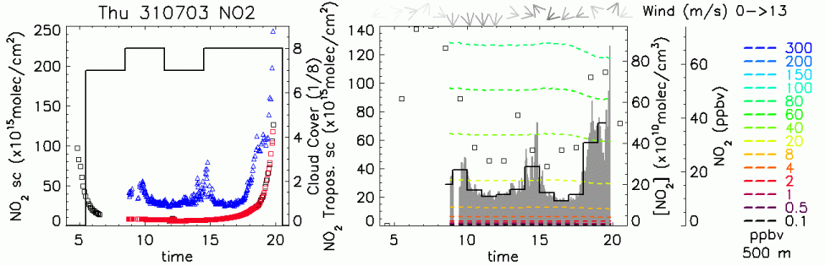
Figure 5.1: NO2 PBL column measured with DOAS methodology at Bologna. For each available satellite overpass we provide (if available) also links to maps of measurements or simulations of lightning occurrence, cloud cover, PV, wind and T fields.

Interpretation of satellite data
with potential source regions, ground measurements and DOAS

Together with the plots of NO₂ PBL columns, meteorological and lightning maps a few case studies have been provided through the web-page. The goal of such particular events we report thereafter is to suggest a sort of very simple guide on how to use the different information to give a correct interpretation to the satellite tropospheric column measurements. Such examples includes

Lightning (31st July 2003)

Figure 1 shows the NO₂ tropospheric column measured by SCIAMACHY on the 31st July 2003. It is clear a very high NO₂ spot over the Ligurian Sea with values up to 30x10¹⁵molec/cm².

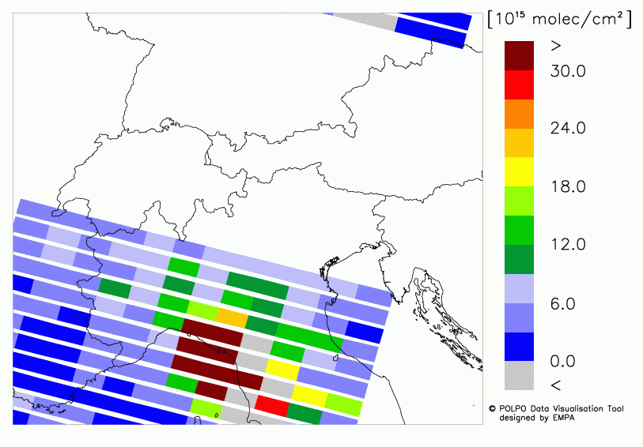  Figure 1: NO2 tropospheric column measured by SCIAMACHY on the 31st July 2003. | 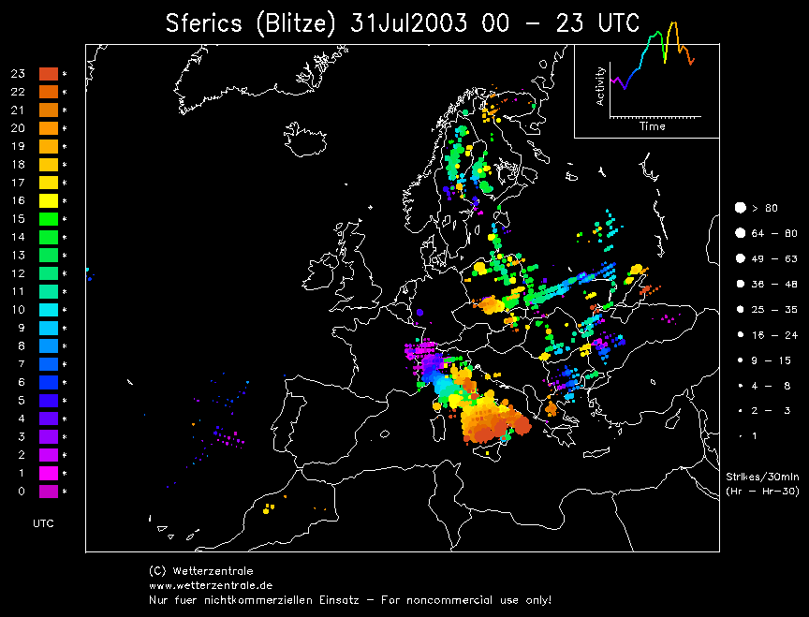  Figure 2: Lightning events on the 31st July 2003.
Figure 3: NO2 tropospheric column measured by GASCOD on the 31st July 2003.

The geographic location of the hot spot let us conclude that the NO₂ is not due to local anthropogenic production. The lightning map (Figure 2) shows instead a strong activity for the same day in the hot spot area. Also the ground based column measurements with DOAS instruments (Figure 3) reported high NO2 values in Bologna mainly during the late afternoon when the lightning activity reached also the area of Bologna (about 80x10¹⁵molec/cm² 6-7 PM).

Off shore transport (13 October 2003)

On the 13th October 2003 SCIAMACHY observations (Figure 4) reported high tropospheric column of NO2 in the Po valley area and off shore along the Adriatic sea from Trieste down to Ravenna. The wind direction at 850 mbar (see Figure 5) show a transport of air masses from the Venice-Mestre area eastward that could justify the NO₂ presence over the Adriatic Sea. The BOLAM analysis (Figure 6) indicates the presence of clouds all over the observed area giving thus two possible interpretations to the observed NO₂ columns:
- The NO₂ is situated above the clouds.
- The NO₂ is still present between the ground and the cloud layer but the real column amount is much more higher since clouds hide to satellite measurements the great part of the NO₂ amount.
Actually the real situation could have been a mix of the two hypotheses.

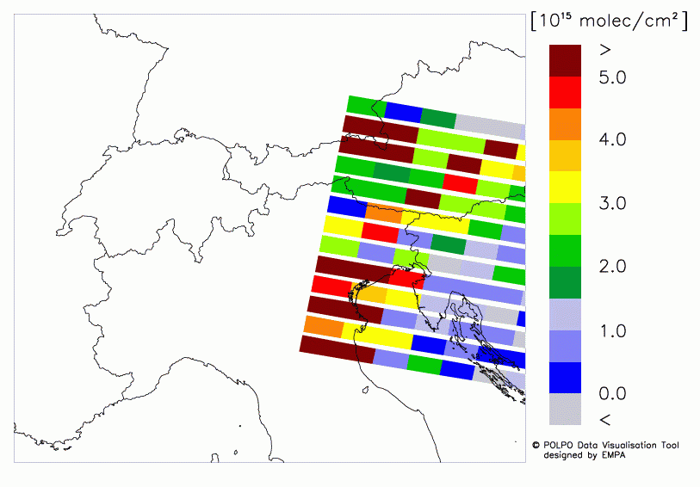  Figure 4: NO2 tropospheric column measured by SCIAMACHY on the 13th October 2003. | 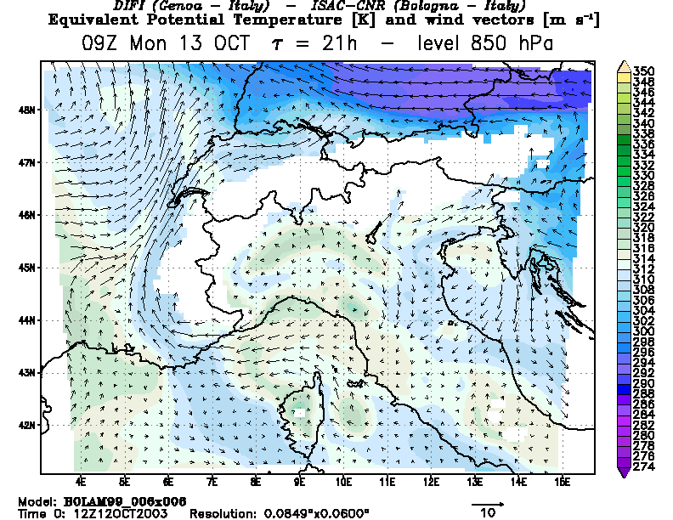  Figure 5: PT and wind @ 850 hPa at 10 LT on the 13th October 2003.
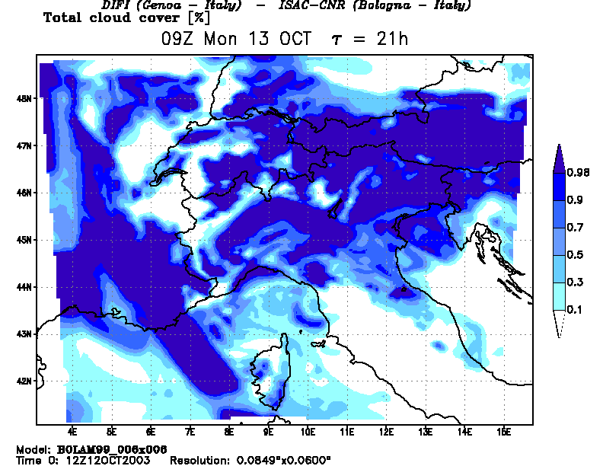  Figure 6: Cloud cover at 10 LT on the 13th October 2003. | 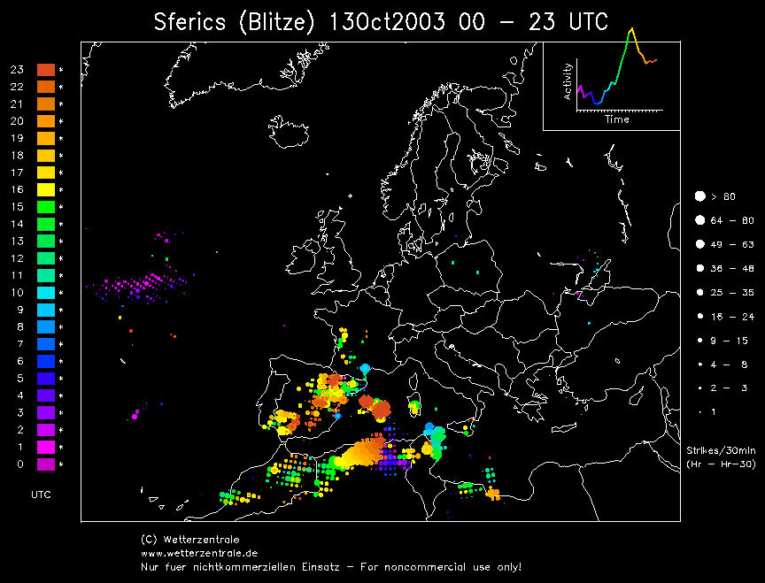  Figure 7: Lightning events on the 13th October 2003.

Identification of pollution sources (23rd June 2003)

The 23rd of June 2003 was a cloud free day (Figure 8) at the SCIAMACHY overpass in our region of interest and it was possible to identify the emissions of NO₂ from several cities or industrialized areas (see Figure 9). Only the area of Genoa and Zurich was partially covered with clouds. This could explain the relative low NO₂ column over Zurich and Genoa.

Figure 8: Cloud cover from the BOLAM analysis on the 23rd of June 2003. | 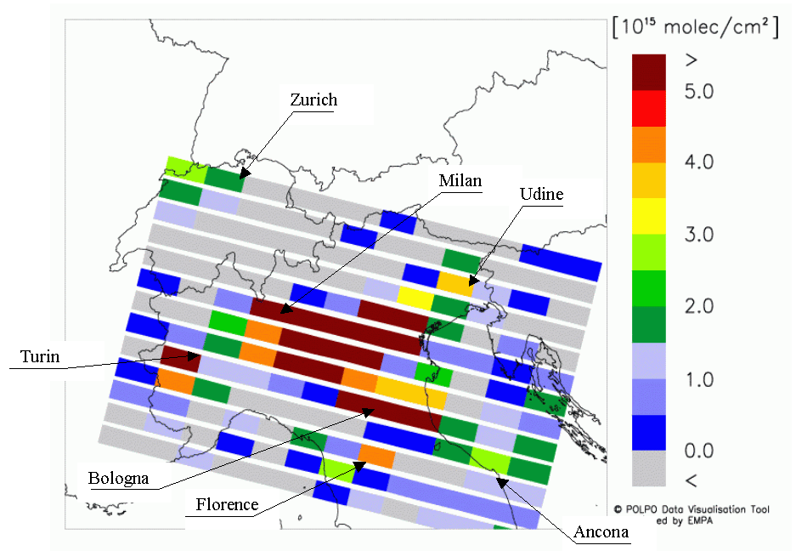  Figure 9: NO2 tropospheric column measured by SCIAMACHY on the 23rd of June 2003

Comparison with ground-based DOAS measurements (26th March 2003) Both SCIAMACHY and GASCOD gave a very high NO2 column in the lower troposphere for the 26th of March 2003. When converted to total column i.e. divided by the Air Mass Factor (equal to 1.25 at 10.30 LT) the NO2 column measured at the ground turns to be comparable with satellite observation (30x10¹⁵ molec/cm² versus 32x10¹⁵ molec/cm²). Such agreement let us conclude that horizontal distribution of NO2 was homogeneous in the Bologna area and this seems to be conformed also by the satellite picture since high similar values of NO2 tropospheric column are reported also in the surrounding of Bologna (Ferrara and Ravenna areas).

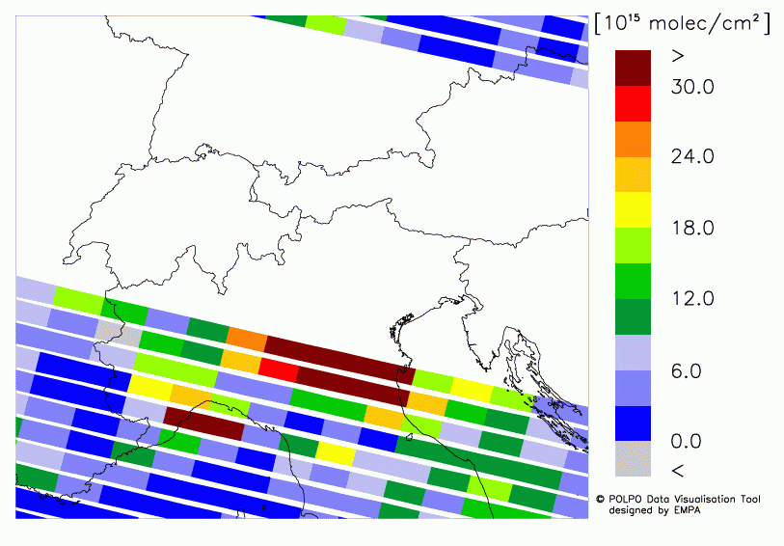
Figure 10: NO2 tropospheric column measured by SCIAMACHY on the 26th of March 2003.

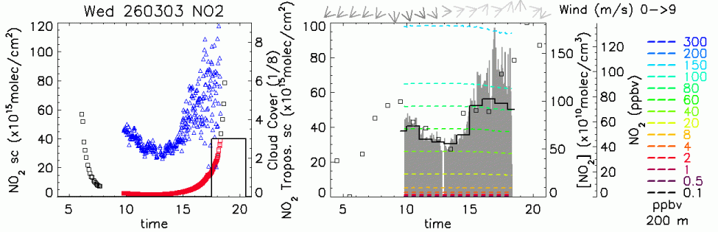
Figure 11: DOAS measurements of NO2 column in the PBL on the 26th of March 2003.

Detailed product description
The products of “Regional NO2” are available via the TEMIS web site as ascii data (gridded GOME/SCIAMACHY data), or gif images (satellite data within the region of interest and potential source region) or can be ordered (trajectory data). NO2 PBL columns measured in Bologna, meteorological parameter from BOLAM model and lightning maps from Wetterzentrale are provided as gif/jpg images.

Image of satellite data within the region of interest
The images covering the region of interest for every GOME/SCIAMACHY satellite overpass give a first idea about the availability of GOME/SCIAMACHY data and the overall pollution situation. The images are generated from the global NO2 vertical tropospheric column densities derived by KNMI with the combined modelling/retrieval/assimilation approach using the BIRA-IASB slant column NO2 retrievals.
The region of interest (ROI) is defined to be the Alpine area from 5°E to 14°E and from 44°N to 49°N. In order to exploit the full information content, the colour coding is not fixed but varies with the observed tropospheric NO2.

Gridded GOME/SCIAMACHY data
Based on the NO2 vertical tropospheric column densities and auxiliary data (error in the vertical tropospheric columns, cloud fraction, cloud top pressure, flag indicating the quality of the tropospheric retrieval, orbit and pixel numbers) provided by KNMI, ASCII files are generated. For the GOME/SCIAMACHY pixels located in the region of interest, the backward trajectories are taken into account in order to estimate the possible influence of ground near pollution.
Every 0.125° x 0.125° grid element is assigned to the respective GOME/SCIAMACHY pixel containing the centre coordinates of the grid element. In the generated ASCII file, every grid element is listed with its centre coordinates, the respective NO2 VCD and the auxiliary data specified above.
Furthermore, for the grid elements assigned to GOME/SCIAMACHY pixels in the region of interest (5°E to 14°E and 44°N to 49°N) the representativity of the pixel based on the calculated backward trajectories is given: for every of the 11 height levels, the flags “1”, “0” and “-“ indicate if
- “1” the trajectories show potential pollution,
- “0” the trajectories indicate no ground near influence,
- “-“no trajectories are calculated.

A level is defined to contain potential pollution if at least one trajectory from the level resides in a ground distance of less than 100 hPa (difference between trajectory height and height of the model ground in hPa). It should be noted that, in the ASCII file, every grid element contains the representativity flags of the respective GOME/SCIAMACHY pixel. Therefore, grid elements assigned to the same pixels indicate the same representativity flags.

No trajectories are calculated if
- GOME/SCIAMACHY pixel lies not in ROI,
- The flag fltrop provided by KNMI indicate the tropospheric retrieval to be not meaningful (-1).

ASCII files are generated containing the GOME/SCIAMACHY NO2 tropospheric vertical column densities on a 0.125° x 0.125° resolved grid. The domain covers 15°W to 25°E and 35°N to 60°N resulting in an array of 320 x 200 grid elements. The header lines of the file inform the user about the data source, the origin of the gridded data set, the grid resolution, the domain and the parameters given in the file. The header is followed by the list of parameters for every grid element.

The following parameters are included:

Parameter | Meaning | Unit
orb | Satellite orbit number | Number
pix | GOME/SCIAMACHY pixel number (in orbit “orb”) | Number
lon | Centre longitude of the grid element | °
lat | Centre latitude of the grid element | °
vcdt | Tropospheric vertical column density | 1e15 molec cm-2
sigvcdt | Error in the tropospheric vertical column density | 1e15 molec cm-2
flt | Flag indicating if the tropospheric retrieval is meaningful | 0: yes, -1: no
clfrac | Cloud fraction from FRESCO | 0 ≤ clfrac ≤ 1
cltpres | Cloud top pressure from FRESCO | hPa
repres | Representativity of the tropospheric NO2 column for ground near emission/pollution based on trajectories for each of the 11 levels starting with 900 hPa (left) in 50 hPa steps to 450 hPa (right) | 0: no ground contact  1: ground contact

Trajectory plots of potential source regions
For every satellite track over the region of interest (5°E to 14°E and 44°N to 49°N) with clear sky or overcast pixels and successfully retrieved NO2 vertical tropospheric column densities, the potential source region of the polluted air masses in the GOME/SCIAMACHY columns is visualized. The meaningful pixels are marked yellow. White pixels either have a not suitable cloud cover or the retrieval was marked as low quality for other reasons.
Trajectories arriving at 10 levels (900 – 450 hPa) are taken into account. These trajectories are checked in terms of ground distance in 4-hourly steps. The ground distance of the trajectories (precisely: the pressure difference of the trajectory to the model ground pressure) is colour coded. Red marks the most ground near trajectory points (ground distance < 50 hPa), green points have a ground distance 50-100 hPa and blue have a ground distance of 100-150 hPa. Points of trajectories with a higher ground distance are omitted. Pixels which are influenced by ground near air are marked by crosses indicating the starting points of the trajectories. No attempt has been made for resolution below pixel size, i.e., all starting points are marked if only one trajectory of the pixel reached ground contact. The height resolution is 50 hPa according to the choice of the levels.

NO2 PBL column in the Bologna area
The NO2 column amount in the PBL (42 m – 2165 m) is retrieved in the Bologna area using simultaneous measurements of NO2 slant column performed with two GASCOD spectrometer installed in Bologna and Mt. Cimone (see paragraph 1.1.2). The GASCOD spectrometers measure zenith sky scattered solar radiation in the Uv-vis spectral region. The DOAS technique (see Platt, 1999 and reference therein) is applied to retrieve the NO2 slant column amount from sunrise to sunset in the 436-460 nm spectral window. The instrument installed at Mt. Cimone is located outside the PBL for many days of the year (Petritoli et al, 2004) and in such days the measured NO2 column can be considered as purely stratospheric column. The instrument installed in Bologna, instead, is located within the CNR research area that is just in the Bologna outskirts not far from the downtown but not directly influence from a local pollution sources. It is also not far from the airport so that measured slant column can be considered a sort of average amount for the all city area. The high NO2 concentration in the Bologna area allows the instrument to detect NO2 column also with low Solar Zenith Angle (SZA) that is around midday. Thus in Bologna measurements are performed during the all day while at Mt. Cimone only during twilight and around midday fro the reference spectrum measurements. The Mt. Cimone slant column amount in periods between twilights and midday are interpolated according to the secant function with the boundary conditions given by the sunrise, sunset and midday values. The obtained slant column at Mt. Cimone are further interpolated at the time of Bologna measurements and the difference between Bologna and Mt. Cimone slant column is thus calculated. The PBL slant column obtained is converted in vertical column by using the AMF calculated with the PROMSAR model (Palazzi, 2003).

References

Palazzi E., Sviluppo di modelli a supporto della metodologia doas per la determinazione degli inquinanti in troposfera, Degree Thesis, University of Bologna, 2003.

Petritoli A., Bonasoni P., Giovanelli G., Ravegnani F., Kostadinov I., Bortoli D., Weiss A., Schaub D., Richter A. and F. Fortezza (2004), First comparison between ground-based and satellite-borne measurements of tropospheric nitrogen dioxide in the Po basin, J. Geophys. Res., Vol. 109, No. D15, D15307 10.1029/2004JD004547.

Platt U., Modern methods of the measurements of atmospheric trace gases, Phys. Chem Chem Phys., 1, 5409-5415, 1999.

Schaub, D., Weiss, A. K., Kaiser, J. W., Petritoli, A., Richter, A., Buchmann, B., and Burrows, J. P., A transboundary transport episode of nitrogen dioxide as observed from GOME and its impact in the Alpine region, Atmos. Chem. Phys. Disc., 4, 5103-5134, 2004.

Spichtinger, N., Wenig, M., James, P., Wagner, T., Platt, U., and Stohl, A.: Satellite detection of a continental-scale plume of nitrogen oxides from boreal forest fires, Geophys. Res. Lett., 28, 4579-4582, 2001.

Stohl, A., Huntrieser, H., Richter, A., Beirle, S., Cooper, O. R., Eckhardt, S., Forster, C., James, P., Spichtinger, N., Wenig, T., Wagner, T., Burrows, J. P., and Platt, U.: Rapid intercontinental air pollution transport associated with a meteorological bomb, Atmos. Chem. Phys., 3, 969-985, 2003.

Weiss, A. K., Petritoli, A., Schaub, D., and Bonasoni, P.: DUP-POLPO Case Study Collection, ESA, Frascati, 2002.

Wenig, M., Spichtinger, N., Stohl, A., Held, G., Beirle, S., Wagner, T., Jahne, B., and Platt, U.: Intercontinental transport of nitrogen oxide pollution plumes, Atmos. Chem. Phys., 3, 387-393, 2003.

Wernli, H. and Davies, H. C.: A Lagrangian-based analysis of extra-tropical cyclones. 1. The method and some applications, Q. J. Roy. Meteor. Soc., 123, 467-489, 1997

Tropical Ozone

Introduction
Tropical tropospheric ozone columns (TTOCs) have been determined with a convective-cloud-differential (CCD) method, using ozone column and cloud measurements from the Global Ozone Monitoring Experiment (GOME) instrument. GOME cloud top pressures, derived with the Fast Retrieval Scheme for Clouds from the Oxygen A-band (FRESCO) method, indicate that most convective cloud top levels are between 300 and 500 hPa, and do not extend to the tropical tropopause. The new GOME-CCD method takes this tropical transition layer below the tropopause into account, and uses above-cloud and clear-sky ozone column measurements to derive a monthly-mean TTOC below 200 hPa. This method is based on the convective-cloud-differential (CCD) method of [Ziemke et al., 1998] used on TOMS total ozone measurements over bright, high-altitude clouds in the tropical western Pacific to obtain an above-cloud stratospheric ozone amount. For TEMIS we use GOME measurements of cloud fraction and cloud top pressure to improve the original CCD method. The GOME instrument is able to determine these cloud properties by using measurements in the near-infrared wavelength region. By combining the cloud information with GOME ozone column measurements, monthly-mean values of the tropospheric ozone columns below 200 hPa have been determined. The GOME-TTOCs have been calculated on a 2.5° latitude by 5° longitude grid between 20°N and 20°S. The whole GOME period from July 1995 to the end of 2001 is covered.

Description of method and implementation

Retrieving total ozone from GOME measurements
The GOME instrument is a passive four-channel spectrometer and measures the direct solar irradiance and the solar radiance reflected by the Earth atmosphere and surface in the UV/VIS/NIR spectral range 240 to 790 nm. GOME scans the Earth surface in the nadir direction (across-track scan angle 32º) with a spatial resolution of 40x320 km² and a global coverage within 3 days.
The measurements that are needed to derive a TTOC with the GOME-CCD method are: total ozone column, cloud fraction and cloud top pressure. First the conversion of the raw GOME data into calibrated reflectance spectra (level 0-to-1 processing) is needed. The level 0-1 processor used for this study is based on the algorithm used by the off-line ESA/DLR GOME Data Processor (GDP) [Aberle et al., 2002]. However, several changes in the algorithms have been made to improve the level-1 quality, mainly with respect to the wavelength calibration and degradation correction [Schutgens and Stammes, 2002; Van der A et al., 2002, Van Geffen and Van Oss, 2003]. The cloud properties and total ozone columns are retrieved from the calibrated reflectance spectra, as described below.
GOME total ozone columns are retrieved from the ratio of the Earthshine and Sunshine spectra, utilizing the characteristic ozone spectral absorption features in a part of the Huggins ozone absorption band (325-335 nm). The total ozone algorithm used for this study is based on the algorithm used in the GDP level 1-2 processor [Spurr et al., 2002], but changes in the algorithm have been made to improve the retrieval of the ozone columns [Valks et al., 2003a].
The first step in the total ozone algorithm is the calculation of the ozone slant column density. This is the total amount of ozone per cm² along the average optical path through the atmosphere, and is determined by the Differential Optical Absorption Spectroscopy (DOAS) method [Platt, 1994]. The DOAS algorithm consists of a least-squares fitting of the ozone absorption cross-section, a Ring spectrum and a third-order polynomial. The Ring spectrum accounts for the Ring effect (the filling-in of solar Fraunhofer lines in the Earthshine spectrum), and the polynomial removes the slowly varying spectral structures resulting from Rayleigh and aerosol scattering and reflections at the ground surface. To account for the temperature dependence of the ozone absorption cross-sections, an effective ozone absorption cross-section is calculated daily, using temperature profiles from the European Centre for Medium-Range Weather Forecasts (ECMWF) model.
To convert the ozone slant column density into a vertical ozone column, the so-called air mass factor is needed. The air mass factors have been calculated with a pseudo-spherical version of the Doubling Adding model DAK [Stammes, 2000 and references therein], which describes the scattering and absorption processes that affects the average optical path of photons in the atmosphere. The air mass factor depends on the viewing scenario (solar and satellite viewing angle), surface height and albedo (derived from the Herman and Celarier [1997] and Koelemeijer et al. [2003] databases), cloud properties, and the ozone and temperature profiles. In the air mass factor calculations, absorption inside and below clouds is not accounted for. However, the resulting error in the retrieved ozone column is minimized by making the same approximation in the cloud top pressure retrieval with the FRESCO algorithm, such that the absorption by ozone is normalized to that of oxygen. The effect of aerosols has also not explicitly be taken into account, but if significant aerosol scattering occur in clear-sky conditions, the aerosol layer will be detected as a thin cloud layer and as such be taken into account.
The dependence of the air mass factor on the ozone profile is of particular importance. Here, a priori ozone profiles from the Fortuin and Kelder [1998] climatology have been used. This climatology includes monthly ozone profiles for 10º latitude bands, determined from ground-based ozone profile measurements. For cloud-free situations, the vertical ozone column can simply be calculated by dividing the slant column density by the appropriate clear-sky air mass factor (). However, in the presence of clouds, two air mass factors are needed: one down to the ground surface () and one down to the cloud top (). The vertical ozone column is then given by:

(6.1)

where the total air mass factor . The weighting factor w is the fraction of the photons that originates from the cloudy part of the pixel (). The cloud fraction f and the cloud top pressure have been determined with the FRESCO cloud algorithm, as described above. In the total ozone algorithm, the amount of ozone below the cloud top is called the ghost vertical column (), which cannot be detected by GOME and is derived from an ozone profile climatology. For the GOME-CCD method, this ghost column correction is not included, because the ozone column above the cloud top () is used:
(6.2)

Implementation of the FRESCO cloud algorithm
The cloud fraction and cloud top pressure are derived using the Fast Retrieval Scheme for Clouds from the Oxygen A-band (FRESCO) method (see section 2). Within FRESCO the cloud fraction is derived assuming a cloud albedo of 0.8, corresponding to an optically thick cloud, and this should therefore be regarded as an effective cloud fraction. Our cloud albedo choice has been optimised for ozone air mass factor calculations in the UV and does not significantly influence retrieved cloud top pressures over the oceans, but gives rise to a small positive pressure bias with thin clouds over land [Koelemeijer et al., 2002].
From the frequency distributions of cloud top pressures over the tropical Indian ocean and western Pacific as derived by FRESCO for January and July compared to the frequency distributions of the ISCCP-D2 cloud top pressures a bias of about -50 hPa on average has been derived. This bias in FRESCO cloud top pressures is consistent with the previous FRESCO studies [Koelemeijer et al., 2001, 2002] and is due to neglecting the absorption by oxygen within and below the cloud. For the GOME-CCD method, we have corrected the FRESCO cloud top pressure for this bias.

GOME-CCD method
Figure 6.A shows a schematic illustration of the GOME-CCD technique. In the first step, cloudy GOME measurements with cloud fraction f ≥ 0.8 and cloud top pressure p_{c} ≤ 350 hPa are used to determine the above-cloud ozone column (including the ozone column in the stratosphere and the tropical transition layer), as shown on the left of Figure 6.A. The cloudy GOME pixels are selected from tropical measurements over the highly convective eastern Indian Ocean and the western Pacific (70°E – 170°W), where the greatest frequency of high level clouds is found. The average pressures of tropical convective cloud tops are between 300 and 500 hPa. For the individual GOME measurements, the cloud top hardly ever exceeds 200 hPa. To be able to calculate a useful tropospheric ozone column, the above-cloud ozone column is calculated for a fixed pressure level of 200 hPa. To that end, a small correction has been made for the difference between the cloud-top level and the 200 hPa level (typically 0-2 DU), assuming a constant ozone volume mixing ratio. After this correction, the ozone columns above 200 hPa are monthly averaged for 2.5° latitude bands between 20°N and 20°S. Hereby, it is assumed that the ozone column above 200 hPa is independent of longitude in a given latitude band.

Figure 6.A Schematic illustration of the GOME-CCD technique for the tropics. Cloudy GOME measurements, which are used to determine the above-cloud ozone column, are shown on the left. Cloud-free measurements are shown on the right. The result is a tropospheric ozone column below 200 hPa.

The number of cloudy GOME pixels with f ≥ 0.8 and p_{c}≤ 350 hPa varies between 150-400 per month for each (2.5 degree) latitude band. Although this number is only about 1% of all the measurements of GOME, it is sufficiently large to provide an adequate statistical mean for ozone columns above 200 hPa. Because of the seasonal migration of the ITCZ, the region of tropical air shows a seasonal displacement as well. Periodically, sub-tropical air is present in the outer latitude bands (20-15°N or 15-20°S), resulting in a small number of deep-convective cloud tops and increased zonal variation in the derived ozone column above 200 hPa. In those cases, the region for the GOME-CCD analysis is limited to lower latitudes.
In the second step, cloud-free GOME measurements (f ≤ 0.1) are used to determine the total ozone column, as shown on the right of Figure 6.A. In the case of cloud-free pixels, GOME is able to detect both ozone in the stratosphere and in the troposphere. About half of the total number of GOME measurements in the tropics are cloud-free. In the case of cloud-free measurements, an efficiency correction is made for the reduced sensitivity of GOME for ozone in the lower troposphere. The retrieval efficiency of GOME for the TTOC below 200 hPa is usually higher than 90 percent. After the efficiency correction, the total ozone columns are monthly averaged on a 2.5º by 5º grid. In a last step, the ozone column above 200 hPa is subtracted from the gridded total ozone values, resulting in the monthly-averaged TTOC below 200 hPa.

GOME retrieval efficiency
The ability of GOME and other nadir-looking UV spectrometers (e.g. TOMS), to detect ozone changes in the atmosphere depends on the height where the ozone concentration is changed, the surface albedo, the presence of clouds and aerosols, the viewing geometry and the wavelengths used in the retrieval algorithm. For the GOME ozone retrieval wavelengths, 325-335 nm, most of the radiance seen by the satellite instrument is scattered from the middle and lower troposphere or reflected from the Earth surface. The sensitivity of GOME for ozone changes in the tropical stratosphere and upper troposphere (above about 6 km) is therefore close to 100 percent. For the lower and middle troposphere the situation is different. For low surface albedos (< 0.1, e.g. vegetation and oceans), part of the radiance measured by GOME has not passed through the lower troposphere, and therefore the sensitivity for ozone changes in the lower part of the troposphere decreases to 30 percent or less near the ground. Over highly reflecting surfaces, such as clouds, the radiance reflected from this surface will dominate the scattered radiance, and the sensitivity for ozone changes above the reflecting surface will be close to 100 percent, or even a little bit higher due to multiple scattering.

Figure 6.B Sensitivity of the GOME instrument for ozone changes as a function of height. GOME uses the 325-335 nm wavelength region to measure the ozone column. Sensitivity profiles for two low surface albedos (0.01 and 0.1) for a typical low-latitude situation (solar zenith angle = 20º) are plotted.

Figure 6.B shows the sensitivity profile for two low surface albedos (0.1 and 0.01) for a typical low-latitude situation (solar zenith angle = 20º). The shape of the GOME sensitivity profile is similar to that of the TOMS instrument [Hudson et al., 1995]. However, the sensitivity is slightly better due to use of the wavelength window 325-335 nm for the ozone column retrieval, which includes larger wavelengths than the main TOMS retrieval wavelength (317.5 nm). Figure 6.B shows that the sensitivity for ozone changes in the lower and middle troposphere clearly depends of the surface albedo. Surface albedos as low as 0.01 are found over land surfaces (e.g. vegetation), while albedos of 0.1 can occur over the tropical oceans.
In the GOME retrieval algorithm, the reduced sensitivity in the lower and middle troposphere for cloud-free situations is taken into account by the air mass factor. However, a systematic error is introduced in the retrieved ozone column, if the actual ozone profile in the atmosphere deviates from the a priori ozone profile (Fortuin and Kelder [1998] climatology) used in the air mass factor calculations. In that case, an additional correction for the reduced sensitivity needs to be made, which depends primarily on the surface albedo and the difference between the actual ozone profile and the a priori ozone profiles used in the retrieval algorithm.
An exact correction for the reduced sensitivity in the lower troposphere requires information on the actual ozone profile in the troposphere. Although the GOME-CCD method does not provide ozone profile information, the estimate of the tropospheric ozone column can still be improved by using an efficiency factor ε:

TTOC^{improved} - TTOC^{a-priori} = ε (TTOC^{GOME} - TTOC^{a-priori}) (6.3)

A look-up table of efficiency factors have been calculated using the GOME sensitivity profiles and ozonesonde measurements from the SHADOZ network [Thompson et al., 2003a], which serve as ‘true’ reference ozone profiles. The appropriate efficiency factor to be used in Eq. (6.3) is determined as a function on the surface albedo (derived from the Herman and Celarier [1997] and Koelemeijer et al. [2003] databases) and the difference between the retrieved GOME tropospheric ozone column and the a priori tropospheric ozone column (TTOC^{GOME} - TTOC^{a-priori}).
The retrieval efficiency for GOME tropospheric ozone columns below 200 hPa is generally higher than 90 percent. This relatively high efficiency is primarily due to the fact that in the GOME total ozone algorithm, a priori profiles from the Fortuin and Kelder [1998] ozone climatology are used. This climatology is based on actual ground-based and satellite ozone measurements and contains zonal mean ozone profiles for 10º latitude bands for each month of the year.

References
Aberle, B., W. Balzer, A. von Bargen, E. Hegels, D. Loyola and R. Spurr, GOME Level 0 to 1 Algorithms Description, Tech. Note ER-TN-DLR-GO-0022 (Issue 5/B), Deutsches Zentrum für Luft und Raumfahrt, Oberpfaffenhofen, Germany, 2002.
Fortuin, J.P.F., and H.M. Kelder, Ozone climatology based on ozone sonde and satellite measurements, J. Geophys. Res., 103, 31,709-31,734, 1998.
Herman, J.R., and E.A. Celarier, Earth surface reflectivity climatology at 340-380 nm from TOMS data, J. Geophys. Res., 102, 28,003-28,011, 1997.
Hudson, R.D., J.H. Kim and A.M. Thompson, On the derivation of tropospheric column ozone from radiances measured by the total ozone mapping spectrometer, J. Geophys. Res., 100, 11,137– 11,145, 1995.
Koelemeijer, R.B.A., P. Stammes, J.W. Hovenier, and J.F. de Haan, A fast method for retrieval of cloud parameters using oxygen A-and measurements from the Global Ozone Monitoring Experiment, J. of Geophys. Res., 106, 3475-3490, 2001.
Koelemeijer, R.B.A., P. Stammes, J. W. Hovenier, and J. F. de Haan, Global distributions of effective cloud fraction and cloud top pressure derived from oxygen A band spectra measured by the Global Ozone Monitoring Experiment: comparison to ISCCP data, J. Geophys. Res., 107(D12), 4151, doi: 10.1029/2001JD000840, 2002.
Koelemeijer, R.B.A., J.F. de Haan and P. Stammes, A database of spectral surface reflectivity in the range 335-772 nm derived from 5.5 years of GOME observations, J. Geophys. Res., 108(D2), 4070, doi: 10.1029/2002JD002429, 2003.
Platt, U., Differential optical absorption spectroscopy (DOAS), Air Monitoring by Spectroscopic Techniques, M. Siegrist, Ed., Chemical Analysis Series, 127, 1994.
Schutgens, N., and P. Stammes, Parameterisation of Earth’s polarisation spectrum in the ultra-violet, J. Quant. Spectrosc. Radiat. Transfer, 75, 239-255, 2002.
Spurr, R., W. Thomas and D. Loyola, GOME Level 1 to 2 Algorithms Description, Tech. Note ER-TN-DLR-GO-0025 (Issue 3/A), Deutsches Zentrum für Luft und Raumfahrt, Oberpfaffenhofen, Germany, 2002.
Stammes, P., Spectral radiance modelling in the UV-Visible range, in IRS2000: Current Problems in Atmospheric Radiation, edited by W.L. Smith and Y.M. Timofeyev, pp. 385-388, A. Deepak Publishing, Hampton (VA), 2000.
Thompson, A.M., J.C. Witte, R.D. McPeters, S.J. Oltmans, F.J. Schmidlin, J.A. Logan, M. Fujiwara, V.W.J.H. Kirchhoff, F. Posny, G.J.R. Coetzee, B. Hoegger, S. Kawakami, T. Ogawa, B. J. Johnson, H. Vömel and G. Labow, Southern Hemisphere Additional Ozonesondes (SHADOZ) 1998-2000 tropical ozone climatology: 1. Comparison with Total Ozone Mapping Spectrometer (TOMS) and ground-based measurements, J. Geophys. Res., 108 (D2), 8238, doi:10.1029/2001JD000967, 2003.
Valks, P.J.M., R.B.A. Koelemeijer, M. van Weele, P. van Velthoven, J.P.F. Fortuin, and H. Kelder, Variability in tropical tropospheric ozone: Analysis with Global Ozone Monitoring Experiment observations and a global model, J. Geophys. Res., 108(D11), 4328, doi: 10.1029/2002JD002894, 2003.
Van der A, R.J., R.F. van Oss, A.J.M. Piters, J.P.F. Fortuin, Y.J. Meijer and H.M. Kelder, Ozone profile retrieval from recalibrated Global Ozone Monitoring Experiment data, J. Geophys. Res., 107(D15), 4239, doi: 10.1029/2001JD000696, 2002.
Van Geffen, J.H.G.M., and R.F. van Oss, Wavelength calibration of spectra measured by GOME using a high-resolution reference spectrum, Appl. Opt., 42, 2739-2753, 2003.
Ziemke, J.R., S. Chandra, and P.K. Bhartia, Two new methods for deriving tropospheric column ozone from TOMS measurements: The assimilated UARS MLS/HALOE and convective-cloud differential techniques, J. Geophys. Res., 103, 22,115-22,127, 1998.

Detailed product description

With the GOME-CCD method, monthly-averaged ozone columns below 200 hPa have been calculated on a 2.5º latitude by 5º longitude grid for the tropical region (usually between 20°N and 20°S) from Jan. 1996 to June 2003. The images and data are available on the Internet at http://www.temis.nl/.

There is one ASCII data file for each month, called o3trop_YYYYMM.dat
The data file contains two fields: the TTOC field and the TTOC-error field, seperated by a blank line.
Each field consists of 16 rows (latitudes) and 72 columns (longitudes).
The latitude runs from 20ºS to 20ºN, the longitude from 180ºW to 180ºE.

Product Specification Table (ASCII)
Field name | Type | Unit | Description
TTOC | float | DU | Tropospheric ozone column (below 200 hPa)
TTOC error | float | DU | Estimated uncertainty in the tropospheric ozone column

Global Tropospheric Ozone

Description of method and implementation

The tropospheric ozone retrieval consists of three parts: the retrieval of total ozone columns and ozone profiles, the data assimilation of the ozone profiles and finally the construction of tropospheric ozone columns. These 3 steps are described below.

Ozone retrieval
Two types of ozone products are retrieved from GOME measured radiances:
The first set concerns ozone profiles, to be used in the chemical data assimilation for estimation of the stratospheric ozone column. The retrieval will be done with the OPERA algorithm [van Oss et al., 2002], which is selected by ESA to be further developed to become the official GOME ozone profile retrieval. The vertical resolution of the retrieved profiles is limited to about 5 km. Therefore, the retrieved ozone profile is a smoothed version of the real ozone profile, described by the averaging kernels [Van der A, 2003].
The second set concerns total ozone columns. For this set, the TOGOMI algorithm will be used [Valks and Van Oss, 2003]. TOGOMI is a validated, improved algorithm for retrieving ozone columns from GOME spectra that was developed at KNMI. As a novelty, the total column product will be companioned with averaging kernel information, describing the sensitivity of the retrieved column for variations in the vertical profile [Eskes and Boersma, 2003c]. This kernel information will be used in the tropospheric column estimate. Special attention is paid to the treatment of cloud information from the FRESCO algorithm [Koelemeijer et al., 2001] that will be part of the column product as metadata.

Chemical data assimilation
Ozone profiles retrieved from the GOME instrument will be assimilated in a state-of-the art chemistry-transport model. The model will provide additional information about ozone concentrations in the lower stratosphere and around the tropopause, for which the GOME instrument is less sensitive. The result of the assimilation is an accurate stratospheric ozone column, consistent with the profile measurements and model simulations.
The KNMI TM model is coupled off-line to ECMWF analyses or forecasts, and provides a realistic description of constituent transport. The TM model is the core of KNMI’s daily total ozone forecast [Eskes et al, 2003a], that was able forecast the September 2002 ozone hole splitting event almost 9 days in advance [Eskes et al., 2003b]. The assimilation system has been extended for assimilation of ozone profiles [Segers et al., 2004]. Incorporation of the vertical information in the ozone profiles improved the simulation of the stratospheric ozone distribution.
The profile assimilation system will be used to produce accurate stratospheric ozone columns. Special attention is paid to the definition of the tropopause, for which different algorithms are in use. A validation system with independent data (sondes, satellite limb measurements) is available, and will be used to provide realistic bias statistics with the assimilated stratospheric columns.

Tropospheric products
The aim of this service is to demonstrate the possibility to provide monthly two-dimensional tropospheric ozone data sets. Two types of tropospheric ozone columns are produced by subtracting the assimilated stratospheric columns from the retrieved total columns: first, an absolute column from surface to tropopause, that gives insight in the natural variability due to changes in tropopause heights, and second, a mean volume mixing ratio, that gives insight in the spatial and temporal distribution of enhanced ozone levels. The kernel information provided with the retrieved total columns will be used for proper treatment of the height dependence of the sensitivity of the instrument.

References

van der A, R.J., A. J. M. Piters, R. F. van Oss, and C. Zehner, Global Stratospheric Ozone Profiles from GOME in Near-Real Time, Int. J. Remote Sensing, 24, no. 23, 4969-4974, 2003.
Eskes, H. J., van Velthoven, P. F. J., Valks, P. J. M. and Kelder, H. M., Assimilation of GOME total ozone satellite observations in a three-dimensional tracer transport model, Q. J. R. Meteorol. Soc., 129, 1663-1681 (2003a).
Eskes, H., A. Segers, and P. van Velthoven. Ozone Forecasts of the Stratospheric Polar Vortex Splitting Event in September 2002. Accepted by Journal of Atmospheric Sciences, 2003b.
Eskes, H. J., and K. F. Boersma. Averaging Kernels for DOAS Total-Column Satellite Retrievals, Atmos. Chem. Phys., 3, 1285-1291, 2003c.
Koelemeijer, R.B.A., P. Stammes, J.W. Hovenier, and J.F. de Haan, A fast method for retrieval of cloud parameters using oxygen A-band measurements from Global Ozone Monitoring Experiment, J.Geophys.Res., 106, 3475-3490 (2001)
Oss, R. van, R.H.M. Voors, and R.D.J. Spurr. Ozone Profile Algorithm. In OMI Ozone Products, Algorithm Theoretical Baseline Document. Ed. P.K. Bhartia, NASA GSFC, Greenbelt, USA, p 53-74, 2002.
Segers, A.J., H. Eskes, R. van der A, P. van Velthoven. Assimilation of GOME ozone profiles and a global chemistry transport model using a Kalman filter with anisotropic covariance, Q. J. R. Meteorol. Soc., accepted for publication, 2004.
Valks, P., R. van Oss. TOGOMI Algorithm Theoretical Basis Document, KNMI, November 2003.

Detailed product description

General specifications
Specification
Region : | Global
Spatial resolution : | 1.25 x 1.25 degree
Time period : | 2000
Max. time delay : | off-line
Data format : | Image
Delivery frequency : | Monthly

The global tropospheric product is at the moment a demonstration product, data will not be delivered at the moment, but images are available.

Sulphur Dioxide

Introduction

Sulphur dioxide, SO₂, enters the atmosphere as a result of both natural phenomena and anthropogenic activities, e.g.:
- Combustion of fossil fuels
- Oxidation of organic material in soils
- Volcanic eruptions
- Biomass burning

Coal burning is the single largest man-made source of sulphur dioxide, accounting for about 50% of annual global emissions, with oil burning accounting for a further 25 to 30%. Sulphur dioxide reacts on the surface of a variety of airborne solid particles (aerosols), is soluble in water and can be oxidised within airborne water droplets, producing sulphuric acid. This acidic pollution can be transported by wind over many hundreds of kilometres, and is deposited as acid rain.

Changes in the abundance of sulphur dioxide have an impact on atmospheric chemistry and on the radiation field, and hence on the climate. Consequently, global observations of sulphur dioxide are important for atmospheric and climate research. In addition, SO₂ at high concentrations has negative effects on human health, in particular in combination with fog (smog).

Effects of volcanic eruptions may have an impact on air traffic, as such eruptions are important sources of ash (aerosols) and sulphur dioxide in the atmosphere. A near-real time retrieval of sulphur dioxide concentrations would enable monitoring of such events and can thus assist in aviation control. Off-line retrieval, on the other hand, is more suitable for monitoring anthropogenic pollution aspects.

SO₂ data and the Air Pollution Monitoring Service

The retrieval of SO₂ derived from measurements by satellite based instrument, such as GOME and SCIAMACHY, cannot make a unique differentiation between SO₂ related to anthropogenic activities and SO₂ from natural sources. For TEMIS, however, SO₂ from the first source falls under the Air Pollution Monitoring Service (“AMPS”), while SO₂ related to volcanic eruptions falls under the Support to Aviation Control Service (“SACS”).

The difference between these two Services lies on the one hand in the choice of the geographic regions used for monitoring the SO₂ concentrations, and on the other hand in the delivery time of the data: whereas SACS concentrates on a near-real time delivery of the data, AMPS is more of an archive service; but even for SACS an archive of data is both useful and necessary.

The SO₂ data products for both the Air Pollution Monitoring and Support to Aviation Control Services are therefore very much alike. To not unnecessarily duplicate the description of the SO₂ data products, the data formats, the data delivery, references, and other relevant aspects in the Service Reports of both Services [AD-5 and AD-6], the description is provided in a separate document: “Sulphur Dioxide Monitoring within TEMIS” [AD-7].

Aerosol from ATSR-2 and AATSR

Introduction

The TEMIS air pollution monitoring service provides information on the occurrence of aerosols over Europe with a spatial resolution of 0.1° × 0.1°, which results from regridding of the information obtained for each ATSR-2 pixel of 1 × 1 km². This original information can be made available on request for application on local scale, such as urban pollution or source assessment by inverse modelling. The information currently provided is the AOD at two wavelengths (0.55 µm and 0.67 µm). Other information available is the aerosol mixing ratio, which over Europe is assumed to consist of sea spray and anthropogenic aerosol (see below). Information on other types is explored on a research basis [Robles González, 2003], and is expected to become available as a service after further evaluation. The importance of aerosols for air pollution monitoring is reflected in the effect of fine particulate matter, which has been related to the occurrence of premature death for both short and long term exposure. In turn, relations for fine particulate matter, expressed as PM2.5, i.e. the total dry mass of all particles smaller that 2.5 µm, and AOD have been derived for certain areas in the USA. It has to be determined whether such relations apply for other areas as well. If so, those relations need to be quantified and their accuracy needs to be determined.

Description of method and implementation

Algorithms for the retrieval of AOD and derived parameters from ATSR-2 measurements have been developed by TNO and applied for a variety of locations that are representative for the occurrence of characteristic aerosol types [Veefkind 1999], [Veefkind et al. 2000], [Robles González et al., 2000], [Robles González, 2003]. The single view algorithm is applied over water surfaces and uses either the nadir or the forward view. The dual view algorithm is applied over land surfaces, which in general are brighter than water surfaces. The two views are combined to eliminate the effect of the land surface reflectance from the total reflectance received by ATSR at the top of the atmosphere (TOA). The actual retrieval is similar for both views. A radiative transfer model is applied to calculate the TOA reflectance (Doubling-Adding method at KNMI (DAK), see [Stammes, 2001]). This is done for several aerosol models and the results are stored in look-up tables (LUT’s). Using these, TOA reflectances are calculated and compared with the measured values. The error function, describing the difference between model and measurement, is minimized to find the most suitable aerosol model. This procedure is applied for all ATSR-2 wavelengths in the visible and NIR (0.55 µm, 0.67 µm, 0.87 µm, and 1.6 µm) and hence the optimization procedure determines the aerosol mixture that best fits the measurements over the applicable wavelength range. Thus in fact the parameters determined are the AOD at four wavelengths, the Ångström parameter describing the wavelength dependence of the AOD, the dominant aerosol types and their mixing ratio.
The aerosol types considered over Europe are marine aerosol (r_{eff} = 1 µm) [Shettle & Fenn, 1979] and anthropogenic aerosol (sulphate/nitrate water soluble, r_{eff} = 0.05 µm) [Volz, 1972], which are externally mixed. The vertical structure is described by the Navy Oceanic Vertical Aerosol Model (NOVAM) [de Leeuw et al., 1989]. This model appears to work well over Europe, as evidenced from comparison with sun photometer derived AOD values (cf. the TEMIS website). Other aerosol models have been implemented for areas such as south-east Asia, the Indian Ocean and Africa [Robles González, 2003]. These scientific results require further evaluation before they can be applied in the semi-operational algorithm. It is noted that the focus of TEMIS air pollution monitoring of aerosols was over Europe.
An important condition to retrieve aerosol properties from space-borne sensing is that no clouds are present. To accomplish this, three test are applied as described in [Robles González, 2003], i.e. a 12 µm gross cloud test, a reflectance test for 0.67 µm, and a reflectance ratio test (0.67 µm / 0.87 µm). These procedures are based on the work of [Koelemeijer and Stammes, 2001].
The scientific algorithms described above were combined in the semi-operational algorithm that was developed to provide the TEMIS output. The retrieval algorithm requires a level 1b GBT data product (from the (A)ATSR instrument provided by ESA) and delivers an output in ASCII and HDF format that can be used for further level-3 post-processing.

Detailed product description

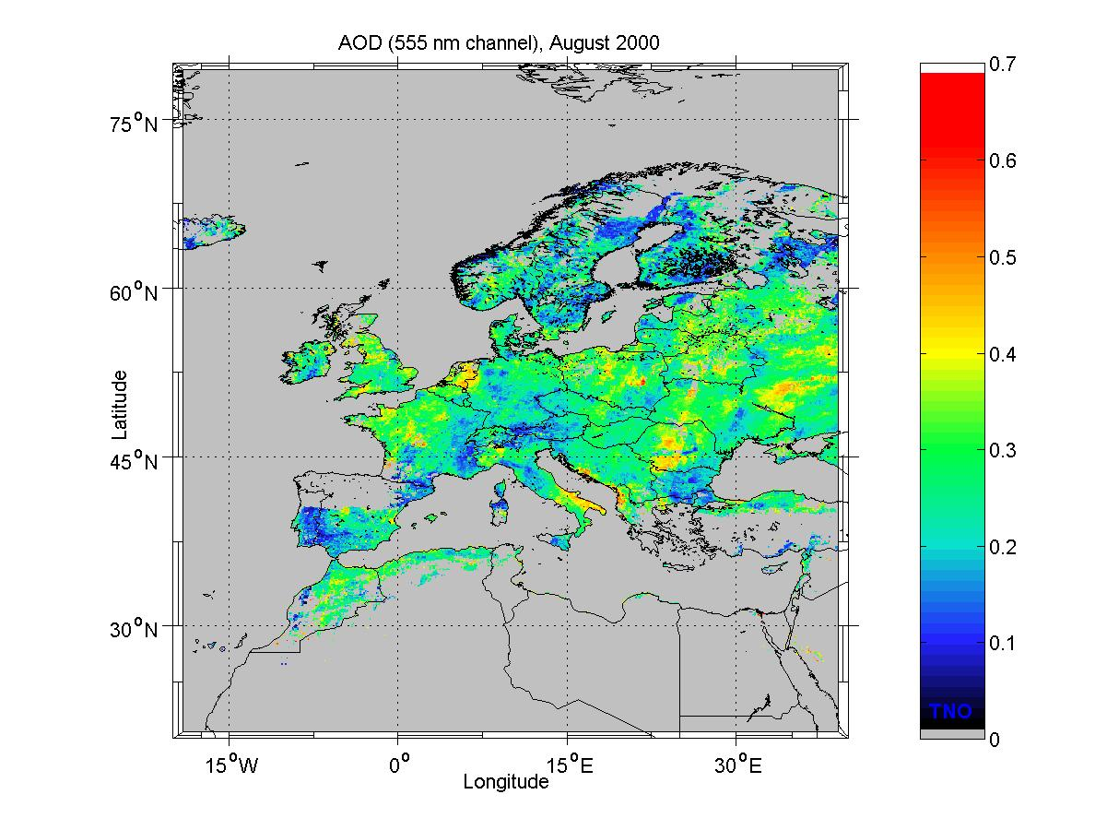
The products that have been delivered within the TEMIS project are maps of AOD at 0.55 µm and 0.67 µm with a resolution of 0.1° × 0.1°. The maps cover Europe and part of North Africa, as determined by the latitudinal boundaries (20N, 80N) and the longitudinal boundaries (20W, 40E). They are available as composites for each month of the year 2000. It is noted that the ATSR-2 overpass provides a snapshot of the situation at that particular moment, and the swath of 512 km implies that each snapshot is available only every third day. The clear sky requirement further limits the available data.. A further restriction is the solar zenith angle of maximum 81°, which put a limit to the amount of available data for the Northern part of Europe, in particular in the winter. In view of these restrictions, the maps cannot be considered as monthly averages; rather they are composites providing information on the spatial variation of aerosols, hot spots and regions with high aerosol loadings. On special request, single frames or maps over specific areas can be produced for a single overpass with high spatial resolution. The data are available as ASCII files with geographical coordinates and AOD. These data can be used to provide the maps presented on the TEMIS web pages. An example, showing the AOD over Europe in August 2000 is given in the figure, which was generated using a MATLAB script. Also HDF files can be produced with extra information on reflectances, transmissions, sun-satellite geometry. Validation results are given in the Service Quality Assessment Report with reference TEM/SQAR2/001.

9.4 References

Koelemeijer, R.B.A., P. Stammes, J.W. Hovenier, and J.D. de Haan (2001), A fast method for retrieval of cloud parameters using oxygen-A band measurements from the Global Ozone Measurement Instrument, J. Geophys. Res., 106, pp. 3475-3490

G. de Leeuw, K.L. Davidson, S.G. Gathman and R.V. Noonkester (1989).
Modeling of aerosols in the marine mixed-layer. SPIE Proceedings Volume
1115, "Propagation Engineering," pp. 287-294.

Robles González C. (2003), Retrieval of Aerosol Properties using ATSR-2 Observations and Their Interpretation., Ph. D Thesis, Utrecht University, Utrecht, The Netherlands.

Robles González C., J.P. Veefkind, and G. de Leeuw (2000), Aerosol optical depth over Europe in August 1997 derived from ATSR-2 data, Geophys. Res. Let., 27, (No. 7), pp. 955-958

Shettle, E.P. and R.W. Fenn (1979), Models for the Aerosols of the Lower Atmosphere and the Effects of Humidity Variations on Their Optical Properties, AFGL-TR-79-0214 Environmental Research Papers, #676, published by the Air Force Geophysics Laboratory, Hanscom AFB, MA 01731.

Stammes, P. (2001), Manual for the DAK program, Royal Netherlands Meteorological Institute, De Bilt, The Netherlands

Veefkind, J.P (1999), Aerosol Satellite Remote Sensing , Ph. D Thesis, Utrecht University, Utrecht, The Netherlands.

Veefkind, J.P., G. de Leeuw, P. Stammes, and R.B.A. Koelemeijer (2000), Regional Distribution of Aerosol over Land, Derived from ATSR-2 and GOME, Rem. Sens. Of the Env., 74, pp. 377-386.

Volz, F.E. (1972), Infrared refractive index of atmospheric aerosol substances, Applied Optics, 11, pp. 755-759.

Aerosol from GOME and Sciamachy

Aerosol retrieval algorithms have been developed at ISAC and applied to level-1B GOME data to obtain atmospheric aerosol columns over sea, under cloud-free conditions, by selecting measurements in the wavelength windows free of molecular absorption in the range (270-790 nm) [1,2]. The retrieval is performed by means of the AGP (Aerosol retrieval from Gome data Processing) processor that has been developed and optimised in collaboration with CGS.
The algorithms described for the aerosol retrieval from GOME data can also be applied to SCIAMACHY level-1C nadir-viewing data and has been implemented in the ASP (Aerosol retrieval from Sciamachy data Processing) processor. In particular, the spatial resolution of SCIAMACHY instrument increases the probability to meet cloud-free pixels. Moreover, the increased spectral range of the instrument (240-2380 nm) increases the possibility to obtain useful information from NIR spectral regions for certain aerosol types and over certain types of land surface as dark vegetation surfaces [3].
The main output of the AGP and ASP are the AOD and aerosol class as level 2 data related to the ground pixel.
Figure 10.1 shows the structure of the AGP with main phases of the processing for the aerosol retrieval. In the following we describe the method used for the implementation of this processor and the detailed description of the global aerosol product for the air pollution monitoring service of TEMIS.

Description of method and implementation

Level 1 Data pre-processing
To analyse Level 1 data for the aerosol retrieval an atmospheric model is used that take into account only the contribution of a clear sky atmosphere without considering any cloud presence over dark surface.
In the case of GOME data we make a selection of ground pixels above sea-ocean (‘water pixel’). Moreover, a selection of cloud-free ground pixels is carried out considering a threshold of 0.2 for the cloud coverage fraction (ccf). This high threshold is chosen to maintain the possibility to retrieve strong aerosol events with high AOD, like those related to plumes of desert dust. In this case the algorithm can discern the signal of desert aerosol class even in presence of 0.1 < ccf < 0.2. Of course the retrieved AOD are consequently overestimated due to the clouds residual presence.
As a first approach in the past we used ccf values in the AGP derived from ICFA, which are part of the level 2 GOME data. Since the ICFA algorithm suffers from errors induced by differences between actual and assumed cloud top pressures, we decide to improve our pixel selection using FRESCO [4, 5] ccf data (see Section 3) for the cloud-screening procedure.

Moreover, pixels whose spectra present Sun-glint phenomena are rejected. In the data processing also polar pixels (latitudes above ±70°) and pixels showing solar zenith angle greater than 70° are rejected, in order to consider the approximation of a plane-parallel atmosphere valid.

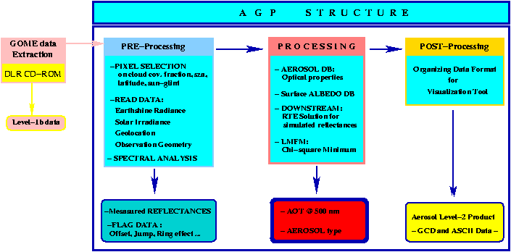

Figure 10.1 – Aerosol retrieval from Gome data Processing – AGP - scheme.

Aerosol clear sky retrieval method over ocean
In order to derive aerosol spectral features from nadir-viewing instruments, the Radiative Transfer Model (RTM) is employed to simulate different Top of Atmosphere (TOA) reflectance spectra related to the atmosphere loaded with different aerosol types over sea surface and computed by DOWNSTREAM [6], a RTM which is highly accurate and fast. The computed TOA reflectance, $R_{\text{sim}}(λ_{i})$, are compared to measured satellite reflectance, $R_{\text{meas}}(λ_{i})$, for each wavelength, $λ_{i}$, selected, taking into account the measurement errors, $σ_{\text{meas}}(λ_{i})$.
For GOME the following wavelengths have been selected for which gaseous absorption features are very weak (the gas transmittance is over 99.7%): 364, 373, 385, 394, 424, 754.4, 780 nm. Keeping the same criteria for SCIAMACHY the number of wavelengths has been extended in NIR spectral region considering the set: 364, 373, 385, 424, 754.4, 780, 858, 885, 1067, 1557, 1622 nm.
The comparison is performed until the best fit is obtained between the measured and simulated spectra of reflectance. The fitting is carried out by means of the Levenberg-Marquardt Fitting Method (LMFM) suited for non-linear models [7]. Then, the retrieval method is based on minimizing the following function,
$χ^{2}\left(\text{AOD}, \text{class}\right)=\sum_{i=1}^{N}{{\left[\frac{R_{\text{meas}}(λ_{i})−R_{\text{sim}}(λ_{i};\text{AOD}, \text{class})}{σ_{\text{meas}}(λ_{i})}\right]}^{2}}$, (10.1)

varying the AOD value at the reference wavelength of 500 nm for each aerosol class.

Table 10.1 – Microphysical properties of the aerosol class used in the retrieval over ocean

num | aerosol class | radius (μm) | sigma | refractive index at 500nm |  | reference
1 | Maritime | 3.3  0.16 | 0.35  0.4 |  | 1.53 – i 5.9E-3  1.5 – i 1.0E-8 | [8]
2 | Desert | 0.001  0.0218  6.24 | 0.328  0.505  0.277 |  | 1.53 – i 7.13E-3 | [9]
3 | Maritime polluted | 0.0285  0.0118  0.3 | 0.35  0.301  0.4 |  | 1.53 – i 5.0E-3  1.75 – i 0.45  1.138 – i 3.7E-9 | [9]
4 | Volcanic ash | Modified gamma |  |  | 1.50 – i 8.0E-3 | [10]
5 | Biomass burning | 0.581  0.0773 | 0.343  0.204 |  | 1.52 – i 0.015 | [11]

In Eq. (10.1) N is the number of wavelengths and class summarises the set of spectral optical properties of the aerosol, such as the extinction coefficient, single scattering albedo, and phase function.
The extinction coefficient is useful to calculate the AOD at the different wavelengths, starting from the AOD at the reference wavelength. All the spectral parameters are calculated from microphysical properties (size distribution and refractive index) assuming spherical particles (Mie theory) as indicated in [12]. Table 10.1 summarises the microphysical properties of the selected aerosol classes. In particular, the size distributions used are multi-modal normal size distribution by number, except for Volcanic ash for which a modified Gamma size distribution is employed. Moreover, Maritime, Desert, Maritime Polluted, and Biomass Burning are considered tropospheric aerosols, while Volcanic Ash is considered a stratospheric aerosol type, because the microphysical properties are typical of an ‘aged’ volcanic aerosol.
Other input needed by the RTM are sea-water spectral reflectivity (considered as Lambertian surface), Rayleigh scattering model, and vertical aerosol profile. All these quantities are set according to [1, 2, 14].
The retrieved parameter is the scalar quantity AOD at reference wavelength of 500 nm. As the fitting procedure is applied to each aerosol class, we obtain five values of the best-fit parameter AOD, and the corresponding minimum of chi-square values. Selecting the smallest fitting residual among the five available values, the corresponding parameters AOD and class are the resulting aerosol characteristic of the examined satellite ground pixel.

Aerosol retrieval methods over dark vegetation surface using SCIAMACHY
It is possible to extend the remote sensing of tropospheric aerosol over dark land. The technique can be assumed to be the same as used for the MODIS instrument [3]. In particular, from SCIAMACHY measured radiances over dark land in channel 8 (2265-2380 nm), it is possible to estimate the dark land surface reflectivity in the two visible channel (470, 660) nm and subsequently use this information in the algorithm for the aerosol retrieval. The main advantage is to derive directly from the instruments the measurement of the surface reflectivity in channel 8. The main disadvantage is the employment of only 2 channels in the visible range.

Another possibility is to use the Monthly Lambert Equivalent surface spectral Reflectivity (MLER) retrieved directly from GOME data, ignoring aerosols and assuming a purely Rayleigh scattering and ozone absorbing atmosphere, as described in [13].
In this case it is possible to use for the Aerosol retrieval from SCIAMACHY measurements channels related to the same spectral range of GOME. It is necessary to perform a spectral interpolation of MLER values at ASP wavelengths used for the aerosol retrieval. The MLER database is useful for SCIAMACHY ground pixels because they are binned per month in grid cells of 1° x 1°. The best surface reflectivity for SCIAMACHY ground pixel has to be computed from those MLER grid cells that affect the pixel.

References
[1] Guzzi R., Ballista G., Di Nicolantonio W., Carboni E., Aerosol maps from GOME data, Atmospheric Environment 35, 5079-5091, 2001.
[2] Torricella F., Cattani E., Cervino M., Guzzi R., Levoni C., Retrieval of aerosol properties over ocean using GOME measurements: method and applications to test case, J. of Geophy. Res. 104, 12085-12098, 1999.
[3] Kaufman Y. J., Tanre' D., Remer L. A., Vermote E. F., Chu A., and Holben B. N., Operational remote sensing of tropospheric aerosol over land from EOS moderate resolution imaging spectroradiometer, J. of Geophys. Res., 102, 17051-17067, 1997.
[4] Koelemeijer, R.B.A., P. Stammes, J. W. Hovenier, and J. F. de Haan, A fast method for retrieval of cloud parameters using oxygen A-and measurements from the Global Ozone Monitoring Experiment, J. of Geophys. Res. 106, 3475-3490, 2001.
[5] Koelemeijer, R.B.A., P. Stammes, J. W. Hovenier, and J. F. de Haan, Global distribution of effective cloud fraction and cloud top pressure derived from oxygen A-band spectra measured by GOME: comparison to ISCCP data, J. of Geophys. Res., in press, 2002.
[6] Levoni C., Cattani E., Cervino M., Guzzi R., Di Nicolantonio W., Effectiveness of the MS-method for computation of the intensity field reflected by a multilayer plane-parallel atmosphere, J. of Quantitative Spectroscopy & Radiative Transfer 69 (5), 635-650, 2001.
[7] Press W.H. et al., Numerical Recipes in Fortran: the Art of Scientific Computing, 2nd Edition. Cambridge University Press, Cambridge, UK, 1994.
[8] Shettle E. P. and Fenn R. W., Models for the aerosol lower atmosphere and the effects of humidity variations on their optical properties, Rep. Tr-79-0214 (U.S. Air Force Geophysics Laboratory, Hanscom Air Force Base, Mass., 1979).
[9] d'Almeida G. A., Koepke. P., and Shettle E. P., Atmospheric Aerosols. Global Climatology and Radiative Characteristics (Deepak, Hampton, Va., 1991).
[10] World Meteorological Organization, A preliminary cloudless standard atmosphere for radiation computation, WCP-112 (World Climate Research Program, Geneva, 1983).
[11] Dubovik O., et al., Variability of Absorption and Optical Properties of Key Aerosol Type Observed in Worldwide Locations, Journal of Atmpspheric Sciences, Vol. 59, pp 590-608, 2002.
[12] Levoni C., Cervino M., Guzzi R., Torricella F., Atmospheric aerosol optical properties: a data base of radiative characteristics for different components and classes. Applied Opticts 36 (30), 8031-8041, 1997.
[13] Koelemeijer, R.B.A.., et al., A database of spectral surface reflectivity in the range 335-772 nm derived from 5.5 years of GOME observations, Jof Geophys. Res., 108(D2), 4070-4083, 2003.
[14] Guzzi R., Barrows J., Cervino M., Levoni C., Cattani E., Kurosu T., Torricella F., GOME cloud and aerosol data products algorithms development. ESA Contract 11572/95/NL/CN, 1998.

Detailed product description

Global Aerosol Level 2 Product
The GOME/SCIAMACHY Aerosol Level-2 Product consists of the AOD at 500 nm and aerosol type data for each selected ground pixel. Daily data are collected in ASCII files. As header of these files there are 2 lines, which provide information about spectrum acquisition date and start time of the orbit.
Information for each pixel is given also on 2 lines. The first line gives information on ground pixel and on measurement (number, type, UTC time of acquisition, geolocation, and solar zenith angle at TOA related to the pixel centre). The second line contains information on the Aerosol retrieval: Aerosol class identifier number: 1-maritime, 2-desert, 3-maritime polluted, 4-volcanic ash, 5-biomass burning), Aerosol Optical Depth, and error on AOD.
Table 10.2 describes the meaning of all output parameters of the daily ASCII files. It is also possible to get this product as binary data in a special file format called GCD (GOME Codified Data).

Global Aerosol Level 3 Product
The Level 3 Product consist of a collection of the mean monthly values of the AOD and the monthly frequency of aerosol class as global maps with a resolution of (1/6)° x (1/6)°. At the moment we have produced GOME Aerosol maps in jpeg format that are present on the TEMIS web server.

Table 10.2 - Product Specification Table (ASCII) for Global Aerosol Product

Dataset name | Data type | Position | Unit | Description
Day datablock identifier | String | 1-10 | - | Acquisition date (#Day:YMMDD)
Line separator | Char | 11 | - | Unix line separator (line feed)
Orbit datablock identifier | String | 12-26 | - | Orbit acquisition time (#Orbit:YMMDDHHm)
Line separator | Char | 27 | - | Unix line separator (line feed)
Pixel number | Integer | 28-31 | - | GOME pixel sequential number in orbit
Pixel type | Char | 32 | - | Pixel type: (E)ast (W)est (C)enter
Acquisition time | String | 34-41 | - | UTC pixel acquisition time
Latitude 1 | Integer | 43-47 | degree/100 | Latitude of corner point 1 of the ground pixel
Longitude 1 | integer | 49-53 | degree/100 | Longitude of corner point 1 of the ground pixel
Latitude 2 | integer | 55-59 | degree/100 | Latitude of corner point 2 of the ground pixel
Longitude 2 | integer | 61-65 | degree/100 | Longitude of corner point 2 of the ground pixel
Latitude 3 | integer | 67-71 | degree/100 | Latitude of corner 3 of the ground pixel
Longitude 3 | integer | 73-77 | degree/100 | Longitude of corner 3 of the ground pixel
Latitude 4 | integer | 79-83 | degree/100 | Latitude of corner 4 of the ground pixel
Longitude 4 | integer | 85-89 | degree/100 | Longitude of corner 4 of the ground pixel
Centre latitude | integer | 91-95 | degree/100 | Latitude of centre coordinate of the ground pixel
Centre longitude | integer | 97-101 | degree/100 | Longitude of centre coordinate of the ground pixel
SZA | integer | 103-107 | degree/100 | Solar zenith angle
Line separator | char | 108 | - | Unix line feed
Aerosol class | integer | 109 | - | Aerosol class identifier
Optical depth | float | 111-121 | - | Aerosol optical depth
Optical depth sigma | float | 123-133 | - | Aerosol optical depth error

